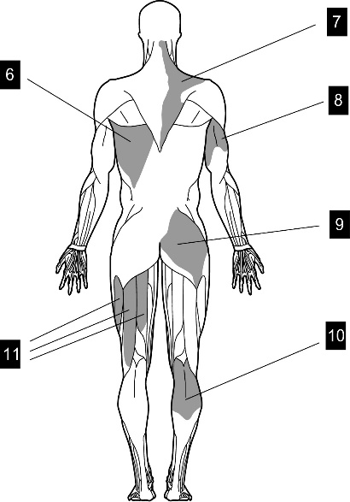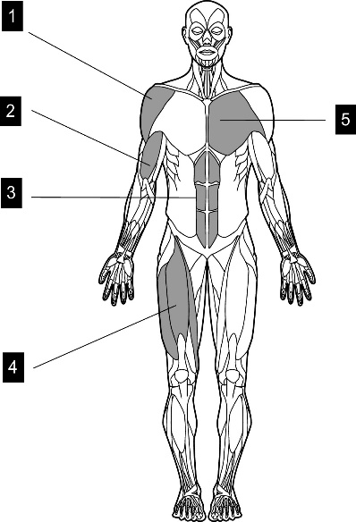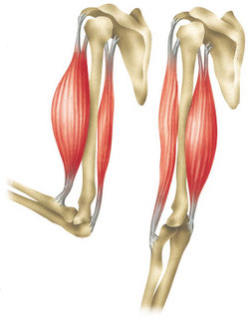C

|  |  |
| --- | --- |
| **Muscle Contractions** | |
| **Term** | **Description** |
| **Isotonic** | Muscle action where the muscle changes length – causes movement. |
| **Isometric** | Muscle action where the muscle stay the same. Eg. Balances. |
| **Concentric** | Isotonic contraction where muscle shortens. |
| **Eccentric** | Isotonic contraction where muscle lengthens. |

**Antagonistic Pairs:**

When one muscle contracts, the other relaxes, producing movement.

**Examples:**

-Biceps and triceps.

-Hamstrings and quadriceps.

**Agonist:** The Prime mover! The muscle that is CONTRACTING to make the movement happen.

**Antagonist:** The lazy one of the pair! The muscle that is RELAXING, does the opposite of the agonist.

**RED - BASIC RECALL – REMEMBER YOUR ACRONYMS, DEFINITIONS AND KEY POINTS (1-2 MARK Q’S)**



**Muscle fatigueches of Exercise).MUSCULAR SYSTEM**

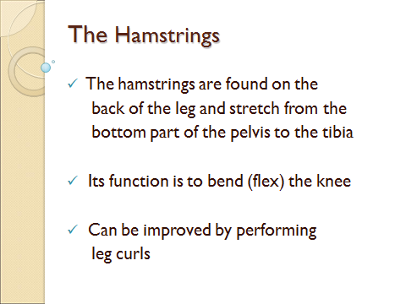

**AMBER – DESCRIBE & EXPLAIN – USE SPORTING EXAMPLES TO ADD DETAIL TO YOUR ANSWERS (2-4 MARK Q’S)**

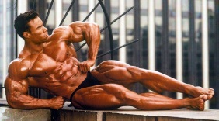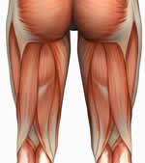

(1) Deltoid (2) Bicep (3) Abdominals (4) Quadriceps (5) Pectorals (6) Latissimus Dorsi (7) Trapezius (8) Tricep (9) Gluteals (10) Gastrocnemius (11) Hamstring

**GREEN – EVALUATE AND JUSTIFY – COMPARE AND CONTRAST AND USE EXPLAIN REASONING (6-9 MARK Q’S)**

[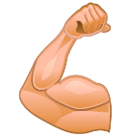](https://www.google.co.uk/url?sa=i&rct=j&q=&esrc=s&source=images&cd=&cad=rja&uact=8&ved=0ahUKEwiDmaWp6LfRAhXIwBQKHTWlBOAQjRwIBw&url=https://muscle-growth.org/&bvm=bv.143423383,d.ZGg&psig=AFQjCNHnaplSk3UqgIBWPiJ-z-cCvznrJg&ust=1484145859811060)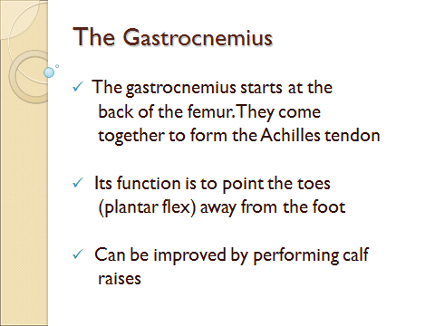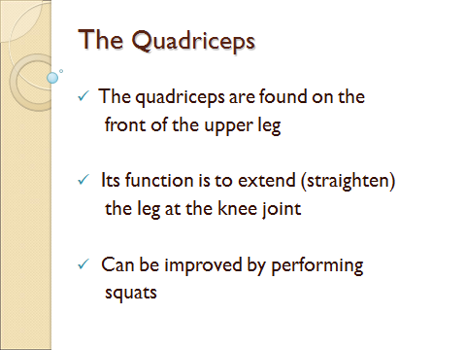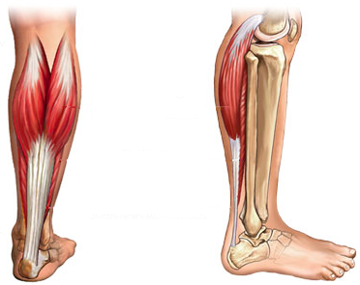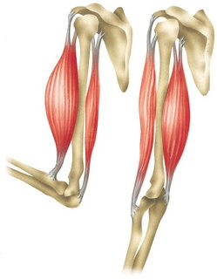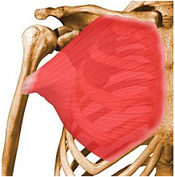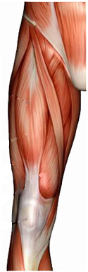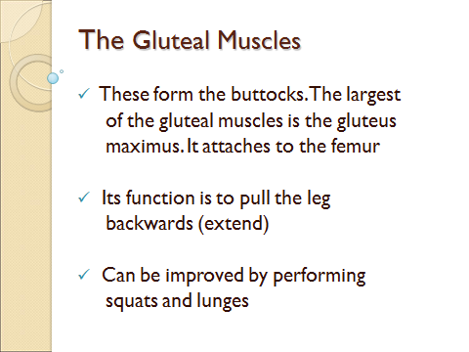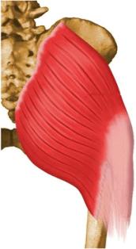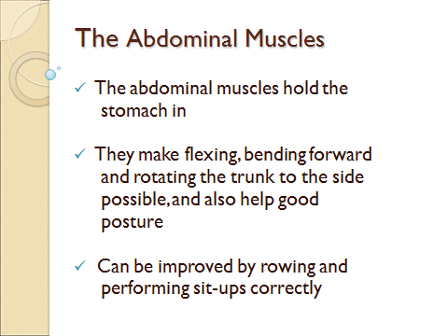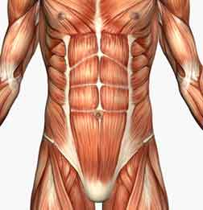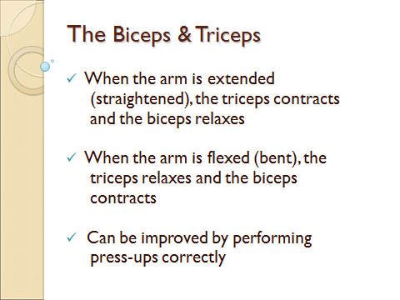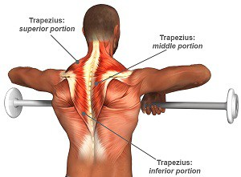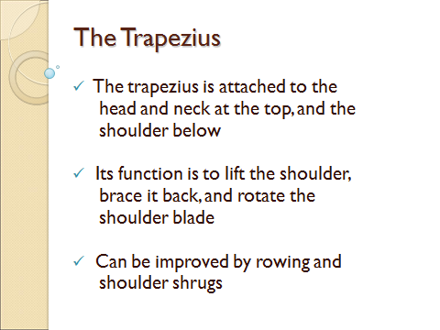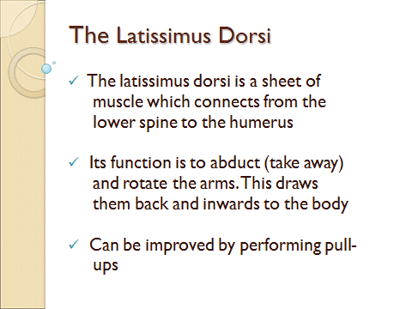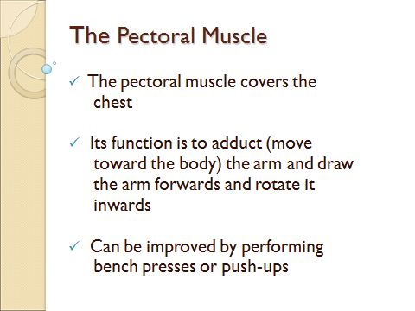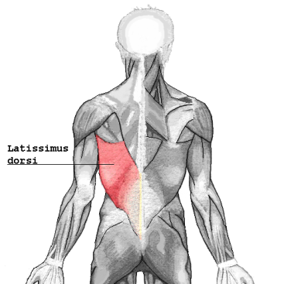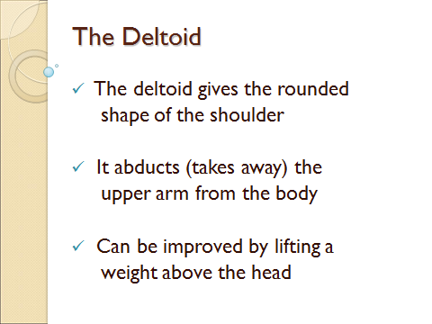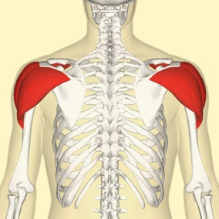

**Muscle fatigue**

**Heart Rate increases to deliver Oxygen to the working muscles**

**Muscle cramps**

**Change body shape –**

**Either by losing weight or gaining muscle**

**Hypertrophy - Your muscles will increase in size and strength**

**Muscle fatigue**

**DOMS if you train at a high intensity**

**Your muscles ache**