Skeletal System
Functions of the skeleton
Remember the acronym:
Scary Skeletons Make Many People Petrified
Function | Description
Support | Bones keep us upright and support muscles and organs.
Shape | Skeleton gives us our height and build.
Mineral Storage | Bones store minerals such as calcium and phosphorus.
Movement | Muscles attach to and pull on bones to produce movement. Bones act as levers.
Protection | Bones protect vital organs – eg Cranium protects brain, ribs protect heart and lungs.
Production of red blood cells | Inner marrow of bones produces red and white blood cells. Red cells carry oxygen, white cells fight infections.
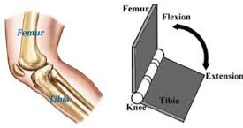
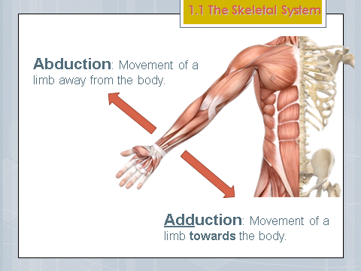
The Skeletal System
Joint Actions
Flexion | Decreasing the angle at a joint (bending)
Extension | Increasing the angle at a joint (straightening)
Abduction | Taking a limb away from the body (abduct)
Adduction | Bringing a limb back towards the body (Add)
Rotation | Turning a limb along its axis (circular)
Plantar flexion | Pointing toes (P for Point)
Dorsiflexion | Toes towards knee

Hinge joint – allows flexion and extension. E.g. knee and ankle joints.
Hinge Joint – allows flexion and extension. E.g. Elbow and knee joints.

Ball & socket joint – allows rotation, abduction and adduction, flexion and extension. E.g. shoulder and hip joints.
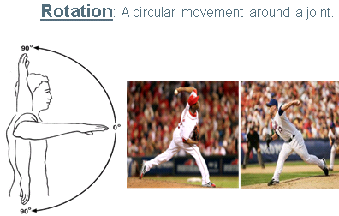

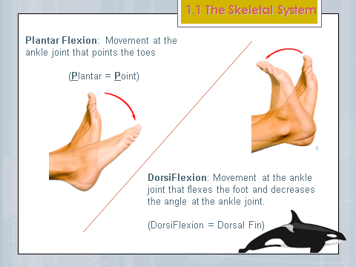

Joint terms
Key term | Description
Joint | Place where 2 or more bones meet.
Synovial joint | Type of joint. Contains synovial fluid.
Cartilage | Covers ends of bones. Reduces friction.
Synovial fluid | Lubricates the joint.
Capsule | Tough tissue surrounding joints.
Ligaments | Connects bone to bone. (L for Link)
Tendons | Connects bone to muscle. Remember MR T and his muscles! (T for tendon)
Dislocation | When bones at a joint separate from their normal position.
Bursae | Fluid filled bag that helps reduce friction.

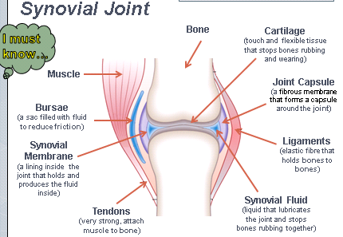

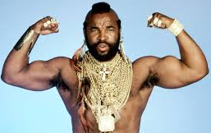
Remember MR T and his muscles! (T for tendon)

