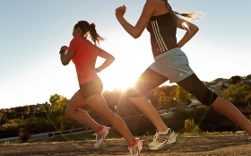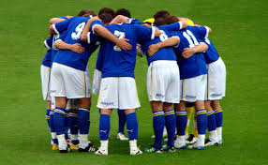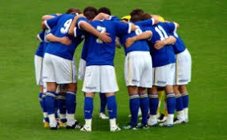

|  |  |
| --- | --- |
| **TERM** | **DEFINITION** |
| **Health** | A state of complete physical, mental and social well-being and not merely the absence of disease or infirmity. |
| **Fitness** | The ability to meet the demands of the environment. |
| **Well-being** | Physically, mentally and socially comfortable, happy and healthy. |
| **Mental Health & Well Being** | A state of well-being in which a person realises their potential, is able to cope with the normal stresses of life, can work productively and fruitfully and is able to make a contribution to their community. |
| **Physical Health & Well Being** | When a person has all their body systems work well and they are free from illness and injury. |
| **Social Health & Well Being** | Basic human needs (food, clothing & shelter) are being met and an individual is socially active. They experience little stress in social situations and have friends and a support network. |

|  |  |
| --- | --- |
| **BENEFITS OF EXERCISE** | |
| **Term** | **Benefits** |
| **Physical** | Lose weight, improved fitness, improved body systems, reduces illness, avoid obesity. |
| **Mental** | Reduces stress, releases serotonin, control emotions, improved self-esteem and body image. |
| **Social** | Make friends, teamwork and communications skills, cooperation. |

**Health & Fitness**

|  |  |
| --- | --- |
| **ENERGY USE, DIET & NUTRITION** | |
| **Term** | **Description** |
| **Calories/ kilocalories** | Units of energy found in food and drink. |
| **Balanced diet** | Consuming the right amount of calories to deal with energy needs. Consuming from different nutrient groups. |
| **Dehydration** | Excessive loss of body water interrupting the function of the body. |
| **Hydration** | Having enough water to enable normal functioning of the body. |
| **Rehydration** | Consuming water to restore hydration. |

|  |  |  |
| --- | --- | --- |
| **SOMATOTYPES** | | |
| **Term** | **Characteristics** | **Suited Sports** |
| **Endomorph**  **(Do for Donut)** | Round, pear shaped, high body fat, wide hips, narrow shoulders. | Rugby prop, shot put, sumo wrestling. |
| **Mesomorph**  **(M for Muscle)** | Muscular, powerful, strong, low body fat, narrow hips, wide shoulders. | Weight lifting, rugby backs, sprinters, swimmers. |
| **Ectomorph**  **(T for Tall + Thin)** | Tall and thin, low body fat and muscle, narrow shoulders and hips, long arms and legs. | Marathon runners, high jumpers, long jumpers, tennis players. |

|  |  |
| --- | --- |
| **SEDENTARY LIFESTYLE** | |
| **Term** | **Description** |
| **Sedentary** | Inactive. |
| **Sedentary lifestyle** | Irregular physical activity or no physical activity at all. |
| **BMI** | Body Mass Index (Weight divided by height squared. |
| **Serotonin** | A feel good chemical released during exercise. |
| **Obesity** | Large fat content, BMI over 30, 20% or more above ideal height and weight. |
| **Overweight** | 25-30 BMI |
| **Correct weight** | 20-25 BMI |
| **Underweight** | Less than 20 BMI |

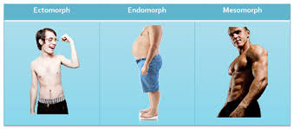

|  |  |  |
| --- | --- | --- |
| **NUTRIENT GROUPS (x6)** | | |
| **Nutrient group** | **Job in the body** | **Foods** |
| **Fats (macro)** | Energy source at low intensities, 25-30% of diet, carries vitamins. | Sugary foods, meat, cheese. |
| **Carbohydrates (macro)** | Main energy source, 55-60% of diet. Simple and complex. | Potatoes, bread, pasta. |
| **Proteins (macro)** | Growth and repair. 15-20% of diet. | Meat, eggs, fish, dairy products. |
| **Vitamins (micro)** | Organic substances that help body systems and general health. | Fruit and vegetables. |
| **Minerals (micro)** | Inorganic substances that help body processes. | Fruit and vegetables, milk. |
| **Water** | More than half of the human body, controls temperature, body functions. | Water, fruit, vegetables. |

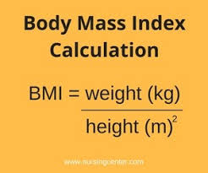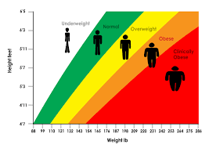

|  |  |
| --- | --- |
| **FACTORS AFFECTING WEIGHT** | |
| **Height** | Taller people tend to need more calories. |
| **Age** | After age 25 calories needs start to fall. |
| **Gender** | Men tend to need more calories than women. |
| **Exercise** | More active people require more calories. |
| **BMR (Basal Metabolic Rate)** | How fast your body burns calories at rest. Varies from person to person. |

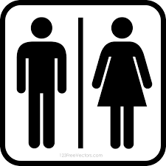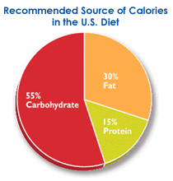

**Daily Calorie Requirements (Adults)**

**Males: 2500kcal Females: 2000kcal**

quantities. Remember **MICRO**scopic (small).

**Macronutrients**: Foods needed in larger quantities. Remember **MACRO** is a **BIG** shop!

**Micronutrients**: Foods needed in smaller quantities. Remember **MICRO**scopic (small).