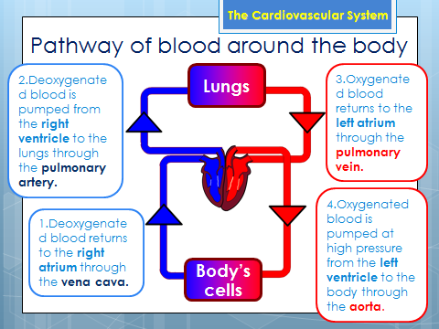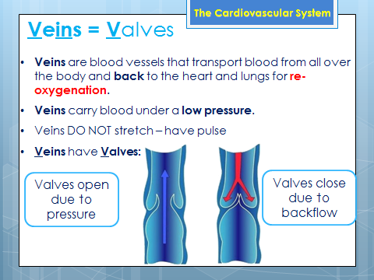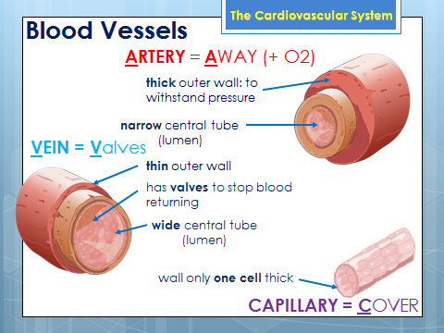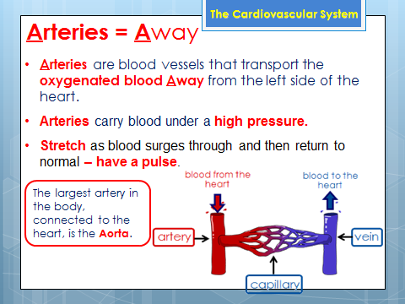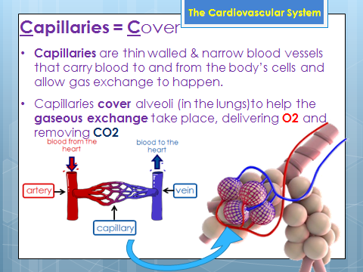

**CARDIOVASCULAR**

**SYSTEM**

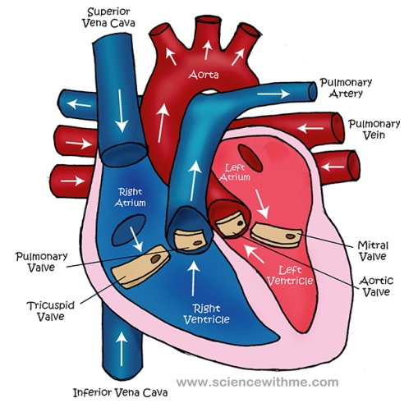

**IMMEDIATE:**

**LONG TERM:**

**Heart Rate increases to deliver Oxygen to the working muscles**

**Bradycardia – Decrease in your resting heart rate.**

**Cardiac Hypertrophy – Your heart will increase in size and strength.**

**Redistribution of blood during exercise:** When exercise begins, the body alters its priorities. At rest, high % of blood is directed to organs and during exercise the blood is redirected to voluntary muscles.

**Vasoconstriction:** Narrowing of internal diameter of a blood vessel to restrict the flow of blood. The arteries constrict during exercise so that less blood is delivered to inactive areas.

**Vasodilation:** Widening of internal diameter of a blood vessel to increase the volume of blood travelling through it. The arteries dilate during exercise so that more blood is delivered to active areas, increasing their O² supply.

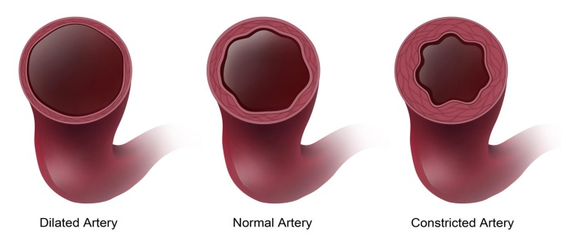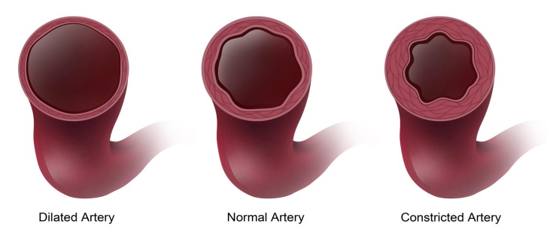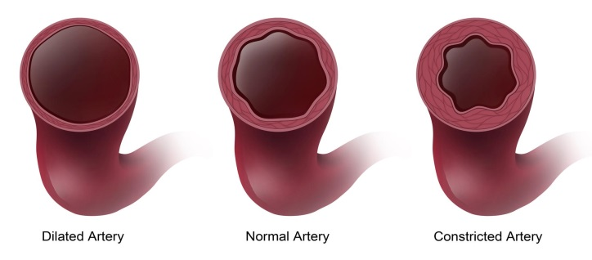

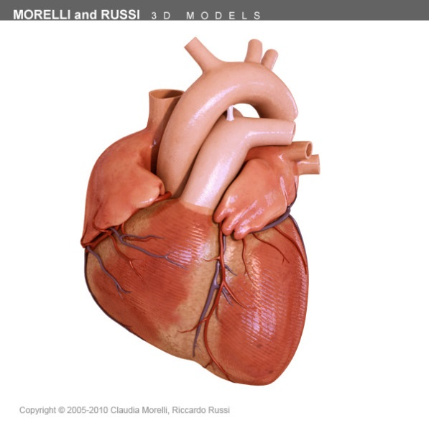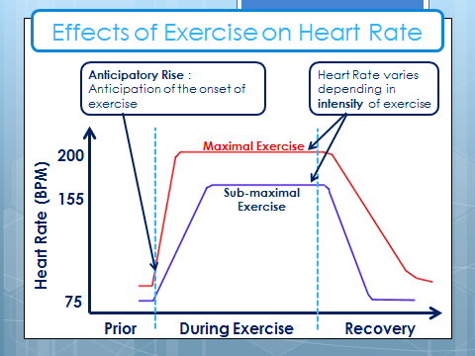

Vasodilation (widening)

Vasoconstriction (narrowing)

