**CRITICAL STUDY FRAMEWORK KS4** *(1)*

**CONTENT**

* This photograph is called “Days on the Cotton Candy No1.” and shows a bizarre, abstract portrait image of a women standing in a bath, in a room which has a range of different washing and cleaning apparatus, shooting out cotton candy type clouds from a blower. These appear to hang still within the room. Maleonn the photographer describes his prints as ‘huge labyrinths with many entrances and exits’, which means that there are many different interpretations that you can take from his prints, where the meaning is hidden, not obvious and needs to be explored. The title of this photograph has immediate associations with the circus or theme parks, childhood ‘cotton candy’ being the sweet naughty but nice indulgence that children love as it magically melts away into sugary nothingness on the tongue. It is a fun, whimsical, fantastical image which toys with reality, harking back to the innocence and wonder we connect to our childhoods, turning life upside down.

**MOOD**

* Days of Cotton Candy No 1 makes me feel slightly apprehensive and disturbed. Although the image is quite bright and open it feels like I am intruding on the dreams of the photographer as it feels like a private joke. The woman is smiling and the clouds of ‘cotton candy’ give the scene a playground like feel, an childish dream which makes no sense and should not be taken too seriously
* The fact that the image is well balanced with the focus being centrally biased and colour brightly dotted around suggest that there is nothing complex going on here.
* Being 23.5” x 35.25” the scale of the work is impressive and bold.

**FORM**

* The colours in this piece are bright and dotted around the bottom of the image with the top third being white light and cotton candy clouds
* The photograph shows a utility type room in slight perspective with the main focus, the woman, centrally placed within the frame. There are obvious leading lines directing us to look at her from the angle of her arm with the blower, to the edges of the room.
* How big is the work?

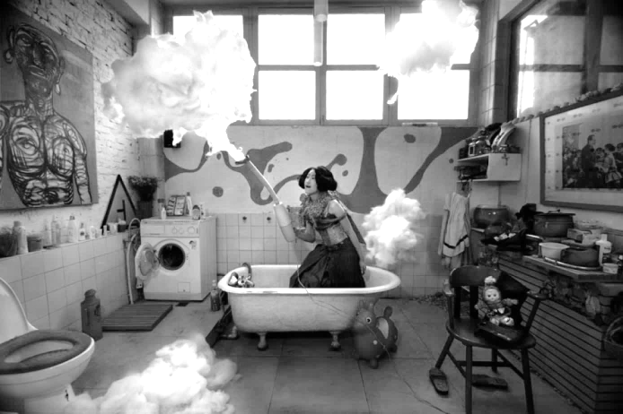

I am looking at

Maleonn’s series ‘Cotton

Candy’ because I am

interested in creating a

surreal playful tone in my

portraits project. I want to

experiment with changing

people’s reality and

perspective so that the

everyday norm is lost

forever from everyday

scenes and situations. I

also want to try to mimic

his use of selective strong

colour and sense of

mischief in my work.

**CONTEXT**

* Days on the Cotton Candy No1 was made in 2005 by the photographer Maleonn, his real name Maliang, a Chinese artist born in 1972 in Shanghai? This photograph is one of a series called Cotton Candy created for an exhibition at Kasia Kay Art Projects.Maleonn is a creative fine arts photographer who brings drama into every photograph he produces.
* Many photographers based in China and Asia generally were experimenting with colour and abstract and bizarre imagery during the millennium years. Their works seem to connect to similar themes of dreams, déjà vu and reality being turned on its head.

Another artist whose

work merges reality with

fantasy is Liu Bolin who

literally paints himself

into the background of

his photographs. Very

bright and vibrant work

testing our perceptions.