Music Basics – Staff and Clef One

I need all of you to be able to identify a few basic musical symbols as we will be using these regularly in class.

Stave/Staff
- The staff is used to place notes on. Without the staff the notes would be unreadable.

Clefs

A clef is like a key on a map. It helps us work out the pitch name of a note when it is placed on a staff.
There are a fair few clefs but I want you to remember these two:

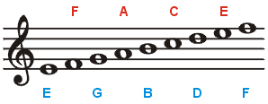
The squiggle on the left
is the Treble Clef.

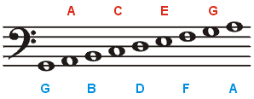
Again the thing that looks like
a sad face is the Bass Clef.

As well as knowing what the symbols are called I also need you to memorise the pitch names of each note.
Hopefully I will have talked you through this before you actually see it.

