Lentil Burgers with Guava Chutney

Ingredients & Directions

One Large Head of Iceburg
Or other large leaf lettuce
1 Small Cabbage (any variety)
Mixed Herbs & Spices of Choice
4 Cups of Lentil
4 Large Tomatoes
½ Cup of Sauerkraut
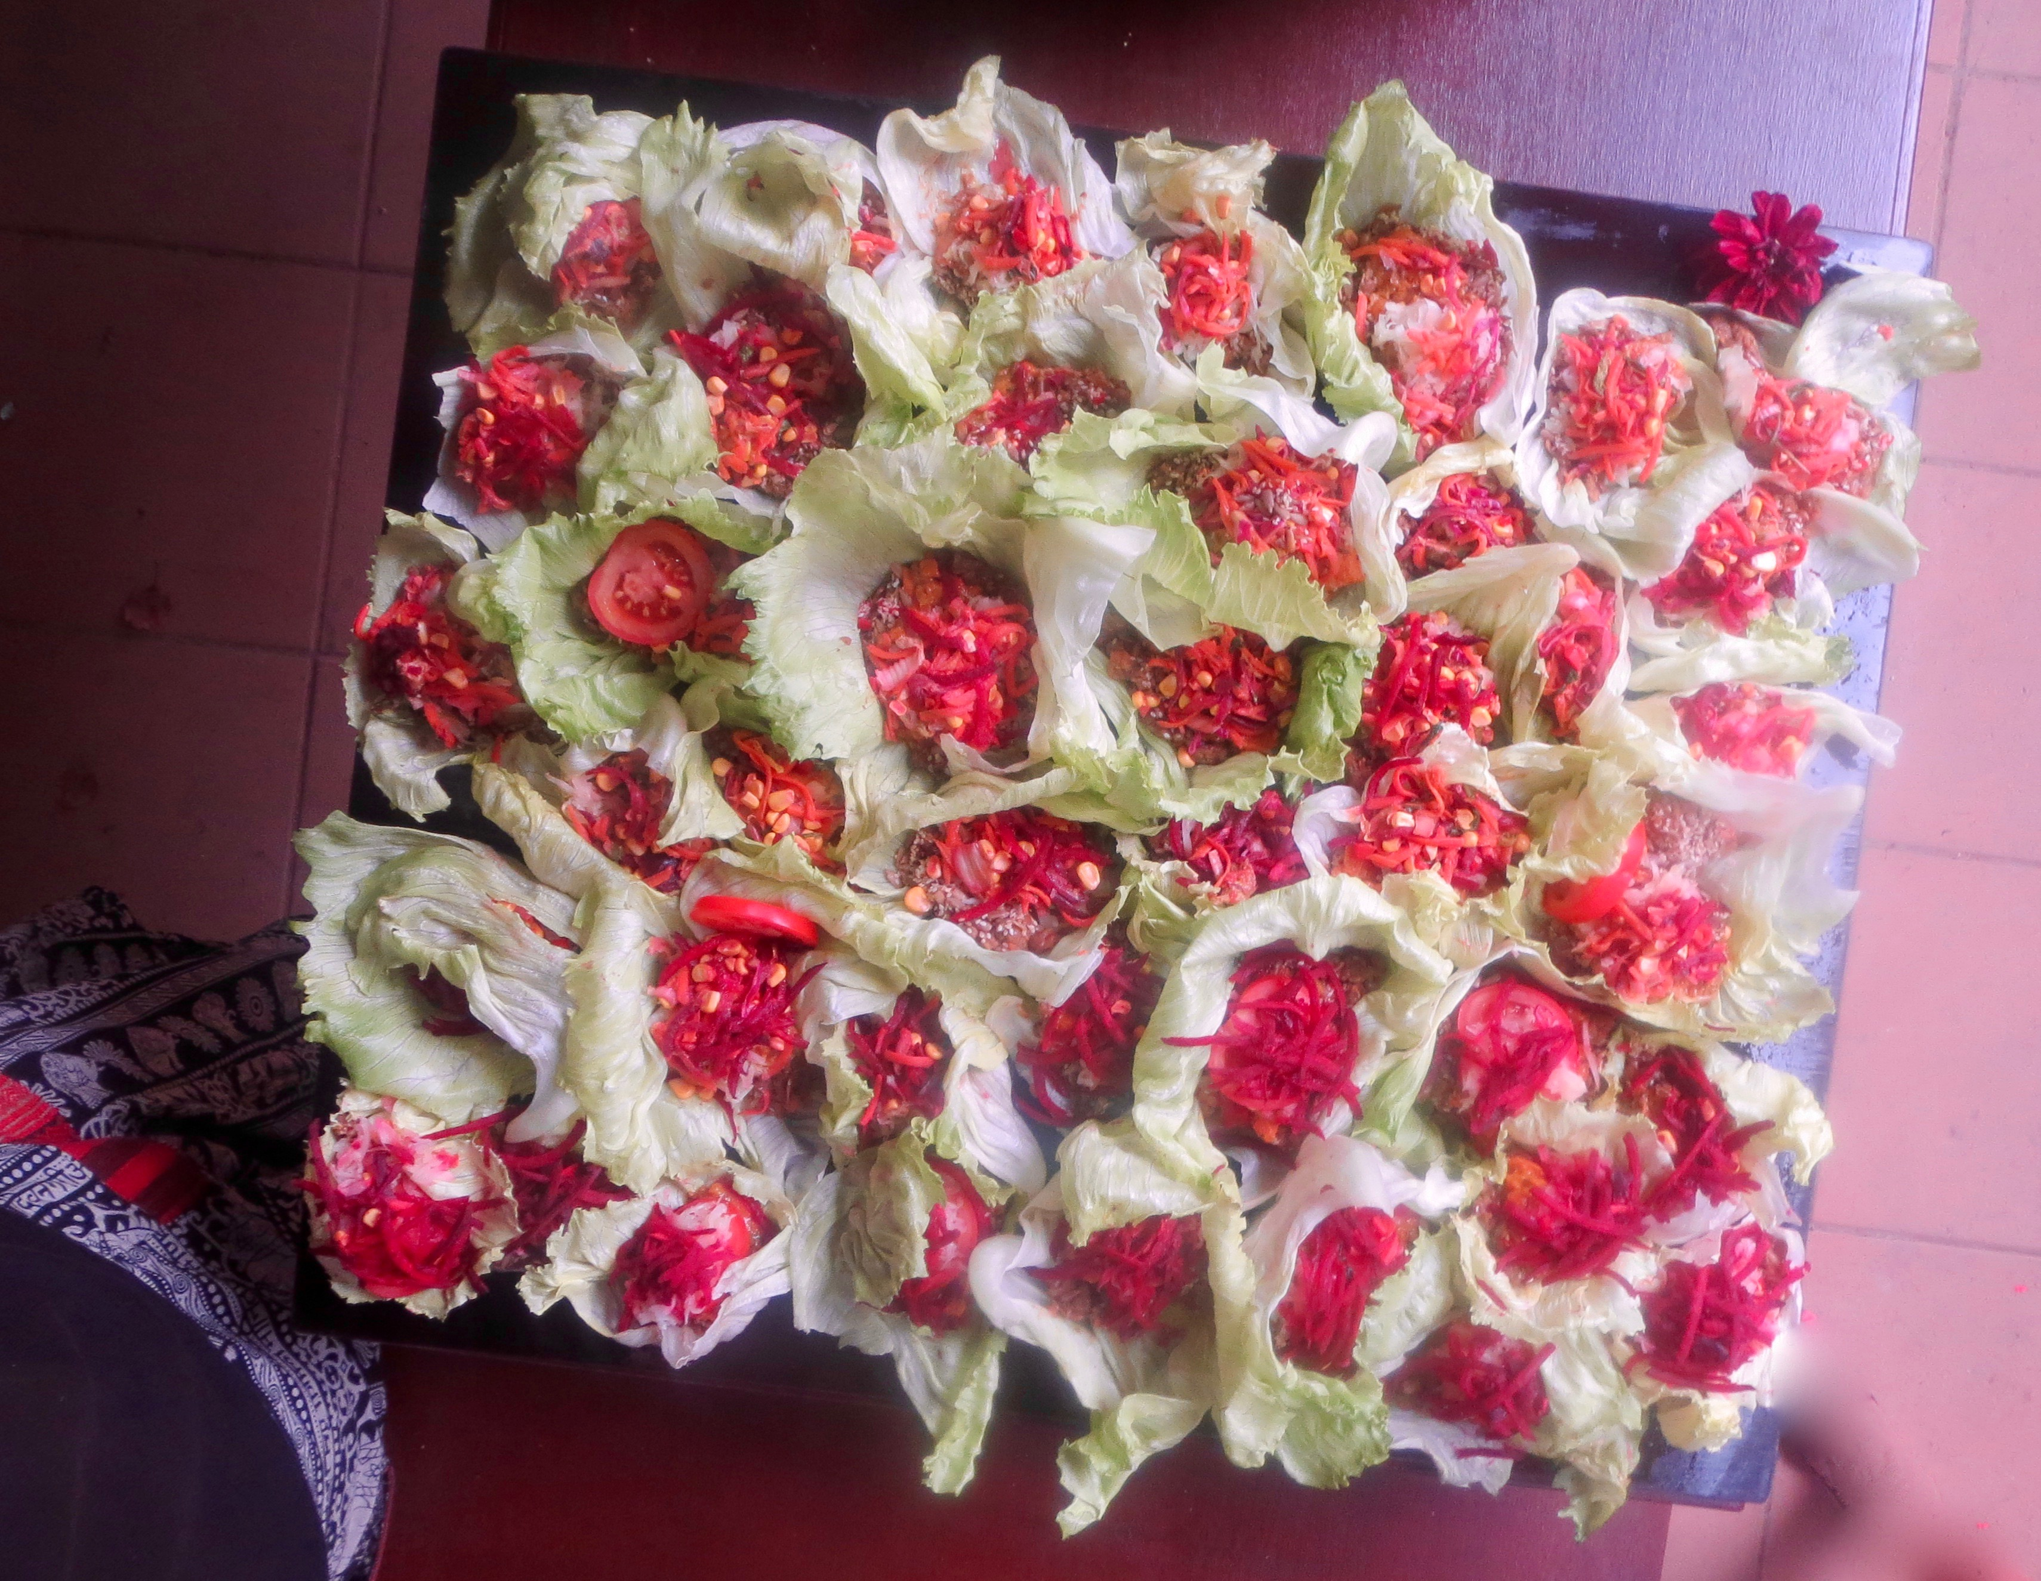
1 Large Beet

1. Cook lentils until soft, then
refrigerate to cool
2. Shred Cabbage, Carrots, Beet
3. Mix lentils with cabbage, carrots
& add seasoning
4. Slice tomatoes
5. Layer your ingredients

Lettuce

Tomato

Bean Mix

Shredded Beets & Sauerkraut. Make a lovely presentation!

Dress with Guava Chutney –a fruity sauce that can be used to dress a variety of dishes:

Sautée variety of spices, with cubed guavas, mangos &/ or other fruits in enough water to cook until soft. Mix with fennel seed, cumin, dates, a dash of apple cider vinegar, salt & sugary to suit taste. Blend to creamy consistency –Serve!

