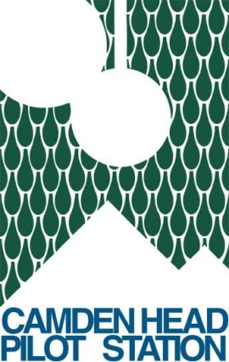

Known Shipwrecks in the vicinity of the Camden Head Pilot Station.

The Camden Haven area has a long maritime history due to fishing, and timber. It also situated alongside the main coastal route of the eastern seaboard.
There are several known shipwrecks in the near vicinity of the Camden Head Pilot station. A brief review of each will follow.

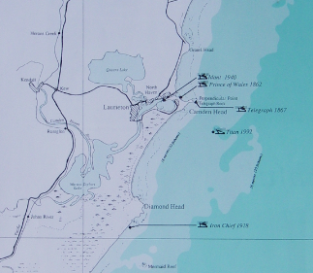
Figure 1: Approximate location for known shipwrecks around Camden Haven
1862: Prince of Wales - Off Pilot Beach
1867: Telegraph - Off Perpendicular Point,
1888: Emu - North of Crowdy head
1928: Iron Chief - South of Diamond Head
1940: Idant - River
1992: Titan - South of Camden Head

- Prince of Wales
The PS Prince of Wales was built in Britain in 1861 and was part of the Australasian Steam Navigation Company which considered it to be a superior vessel.
She left Sydney for Brisbane on the 2nd October 1862 with a cargo of horses, rum, ale, brandy, wine, tobacco, 12 passengers and 11 crew.
At 3pm the following day she grazed rocks northwest of Mermaid Reef off Crowdy Head and with water pouring into the hold, was beached at Camden Haven. All the passengers and stores were safely offloaded.
The next day, the PS Diamantina found the Prince of Wales to be a total wreck but a boat that was sent ashore capsized in the reef causing the drowning of the engineer of the Prince of Wales and two seamen of the Diamantina. The Prince of Wales eventually broke in two and today nothing remains visible apart from the wreck mound in 3m of water some 50m offshore.

- The SS Telegraph
The Telegraph was built in Glasgow, Scotland in 1854 and was a 367 ton iron paddle steamer. She was owned by the Australasian Steam Navigation Company (ASN) and left Sydney at 5pm on the 8th October 1867, with about twenty passengers, and a full general cargo. The weather was reported to be flair and the Telegraph kept a moderate distance off the land until it was passing inside of the Mermaid Reef. A witness to the disaster, a Mr Phillips stated that between nine and ten o'clock on the morning of the 9th October whilst he was below decks, he experienced a shock as the vessel were breaking in two and settling down. He immediately rushed on deck and found that she was stuck fast on a rock, from the amidships forward off Perpendicular Point, approximately three-quarters of a mile from the shore. The fore and amidships compartments immediately filled with water to a depth approximately five feet of the deck. The boats were lowered and all of the passengers, together with their luggage were safely transported to the beach north of Point Perpendicular, close to the remains of the wreck of the steamship Prince of Wales. After the landing of the passengers and as much as possible of the cargo including sum valuable sheep, were brought ashore.
Today the site is named Telegraph Rock and the wreck is often visited by scuba divers.

- SS Emu
The Emu, a wooden single screw steamship of 165 tons gross, was built in Shortland (Auckland) New Zealand by Robert Stone in 1874. It had an overall length of 120.8 feet, breadth of 22.3 feet and depth of 7.8 feet, the vessel was schooner rigged.

A fine wooden vessel with a "clipper bow" (Figures 2 and 3), she was employed in the coastal trade under command of Norbert James Ivaney. At the time of her loss in 1888, the steamer was on a voyage from the Richmond River laden with timber for Sydney.
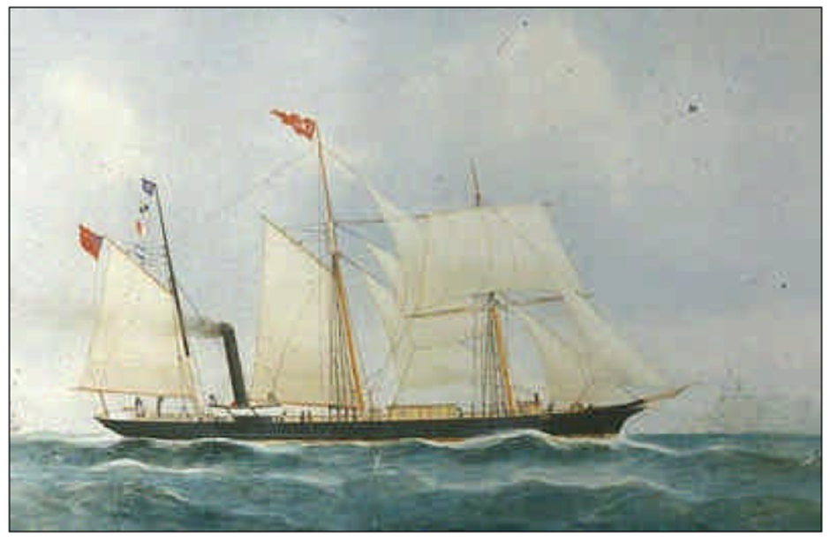
Figure 2: Painting of the SS Emu by William Forster.

With nine hands onboard, the voyage went well until near Seal Rocks when a sleety gale set in. The heavy south-east weather caused the vessel to spring a leak, lose all sail and seek safety in Crowdy Bay. While riding at anchor with 60 fathoms (110 meters) of cable out, it parted around 9.30 am, sending the Emu ashore to become a total wreck. When beached, the sides of the vessel rapidly broke open, partly due to the heavy load of timber onboard. The Emu was said to be lying "one mile north of Crowdy Head, on the beach, and full of water". Fortunately, there was no loss of life with the wrecking of the ship. A later Marine Board inquiry into the disaster found no fault in the captain.

During an investigation in 1994, the wreck was located and the boiler and engine remains were found to lie in the shallow surf zone off Crowdy Beach at high tide, and exposed at extreme low tides. The co-ordinates of the remains being (E31º50’ 02.78" S 152 º 44' 09.72" in WGS84 datum). A white painted wooden peg marks the location of the wreck which can be found located against the vegetation line of the dunal area opposite the site, and approximately 1.3km north along the beach from the Crowdy Head Surf Life Saving Club.
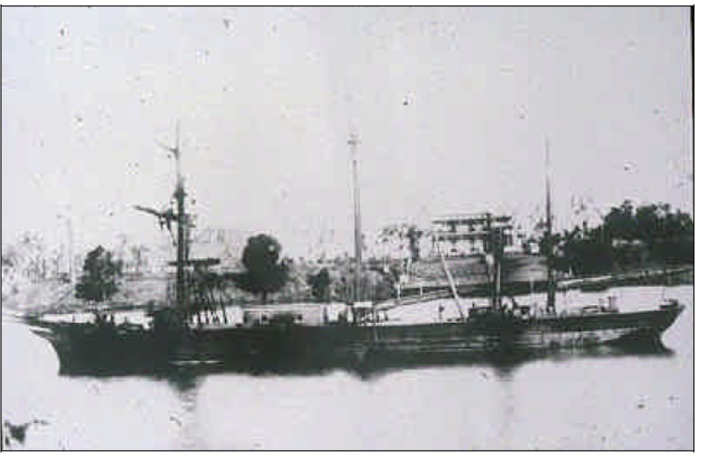
Figure 3: Original photograph of the SS Emu

- The SS Iron Chief
The Iron Chief was a 2720 ton steel screw steamer, built in Sunderland England in 1916. It had a length of 88.3m and a beam of 13.1m.

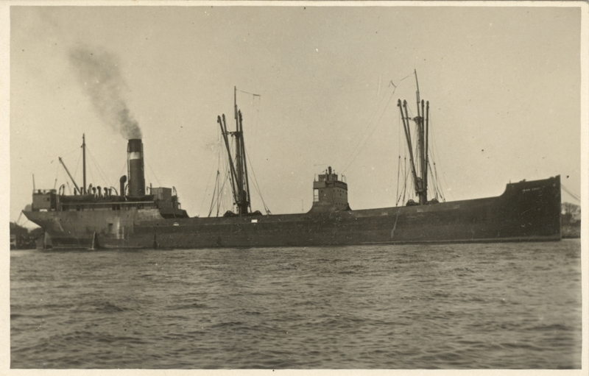
Figure 4: Steamship Iron Chief.

She was wrecked after running aground near Diamond Head on the 1st April 1928 while on a voyage from Port Stephens to Coffs harbour.
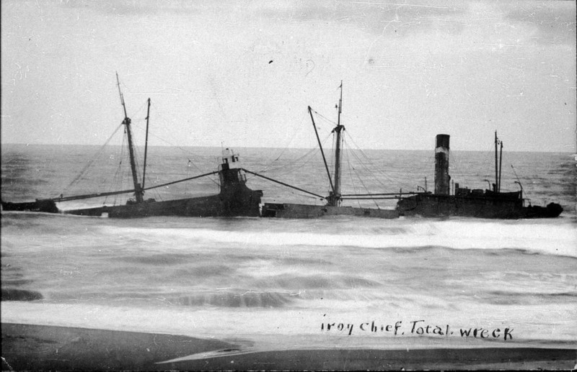
Figure 5: Wreck of the SS Iron Chief
The owner at the time was Interstate Shipping and the Master was R.J. Barron
The story of the stranding of the steamer Iron Chief (2,720 tons) on Mermaid Reef on April 1 last, and the sub- sequent loss of the vessel, was told by the master and members of the crew before a Commonwealth Court of Marine Inquiry. The charge laid against the master, Captain Eric John Barron, was that he failed to navigate the vessel with due caution was investigated.
Captain Barron, said that the vessel left Port Stephens at 1 o'clock on the afternoon of April 1 bound with a cargo of sleepers for Coffs Harbour. The weather that afternoon was showery, with a following sea. Towards evening the sky became cloudy, but visibility was fair. He kept close inshore to escape the influence of the strong sea from the north, and to obtain the benefit of a corresponding current working in an opposite direction along the shore. Crowdy Head light was abeam at 8 o'clock, at which time the chief officer took a bearing from Diamond Head, then in sight, to the north of Mermaid Reef. This bearing indicated that the vessel would clear Mermaid Reef by a good mile.
About an hour later the Captain was on the bridge again, the weather was threatening and Crowdy Head light was obscured. He could see the Middle Brother on the coast, but was unable to see the location of the reef. It was while he was looking through his glasses and giving an order to change course that the vessel struck the outer edge of the reef.

- The Idant
The Idant was a wooden coaster steamer of 121 tons, built in 1918 in Newcastle and being some 28m in length. She ran into the northern breakwater of the Camden Haven and later sank on the 13 March 1940. She was refloated and proceeded upriver with all pumps operating at full pressure but again took too much water and sank opposite the old boatshed on the southern bank of the Camden Haven River. The crew of 8 were all saved.
All the remains today are the boiler and scattered remains in approximately 3m of water.
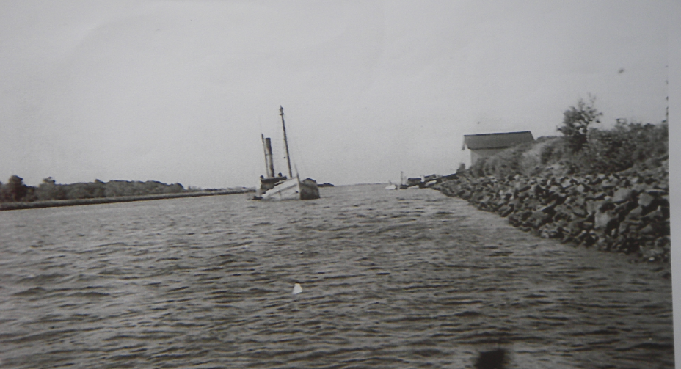
Figure 6: The sinking of the Idant in March 1940.

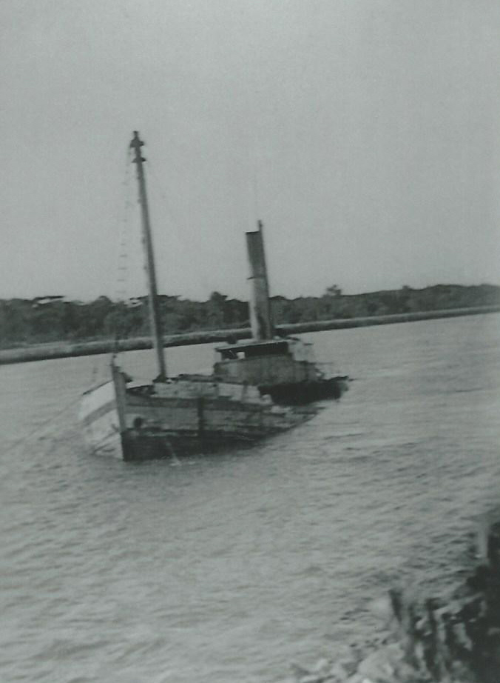
Figure 7: Another view of the Idant sinking in March 1940.
- Titan
The crane barge Titan, was built in Australia and completed in 1919.
Whilst under tow by the former research ship Rapuhia, it left Sydney at 17h00 on the 22 December 1992, bound for Singapore. Titan was unmanned.
Around 22h50 on the 25th December, the towing line parted and the barge upturned. It was towed to a position of Camden Head where attempts were made to salvage her. Unfortunately after assessing the situation over several days, she was deemed unsalvageable and it was decided to undertake a controlled sinking at 21h00 on the 29th December.
A detailed Maritime Investigation was undertaken and a detailed report compiled Titan Investigation Report.pdf
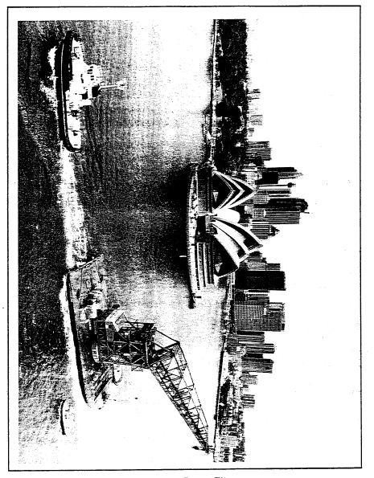
Figure 7: Crane Barge Titan leaving Sydney. (Photo courtesy of John Fairfax Group, Pty Ltd).

© 2016 by Camden Haven Community College Inc. All rights reserved

