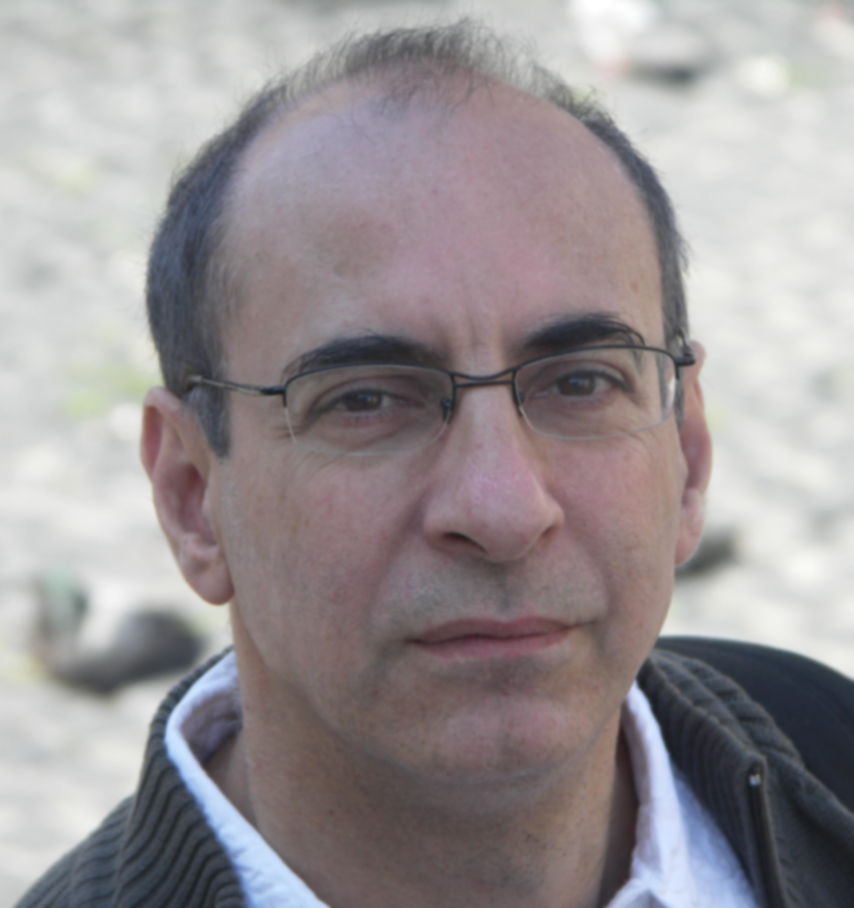
Dr. AMGAR Gilbert
77 avenue du général de Gaulle
78600 - Maisons Laffitte - France
Phone + 33 (0)1 39 57 75 12
Cell + 33 (0)6 62 54 29 60
Email: gilbert.amgar@orange. fr
Date of birth: 12-20 1956

Specialist Anti-Aging Morphological medicine

Dr Gilbert Amgar, is a practitioner since 1984
- DIU of Anti-Aging Morphological medicine (2009 ) , Aesthetic physician
- Consultant for different cosmetic companies and associations, staff training
- President of the French Society of Self Regenerin
- Member of the European Aesthetic and Dietetic Association
- Medicalcert certified trainer
- Teacher for 'Diplome universitaire de pathologie et therapeutique chirurgicale du cuir chevelu Paris V"
- Cosmetic Workshops as expert and trainer for Q-Med, Anteis, Stylage, RegenLab, Selphyl, Inex Aesthetic, Mycells, Mene & Moy, Surgi Concept ..

Speaker in international congress

2008 Skin rejuvenation with P.R.P.
- Euromedicom (Paris), AFME Congres (Paris), AAWC (Paris), EMMA (Paris), Jornadas Mediterrancas ( Barcelona)
2009 Biometrology, skin parameter
- IMCAS (Paris), Congres de médecine morphologique et anti age (Paris)
2010 Objective parameters for TCA peelings, PRP in dark circle
- AMME Congres (Nîmes), Occuloplastic congres ( Bordeaux ), IMCAS (Paris)
2011 Objective evaluation of PRP for skin revitalization
- AMME Congress (La Rochelle), AFME Congress (Paris),National congress on aesthetic medicine and dermatologic surgery (Moscow), EMMA (Paris), IMCAS (Paris ), Aesthetic medicine congress (Jerusalem )
2012 PRP and hair growth, digital measurement for hair, pre op evaluation, PRP recent evolution
- anti aging World congress (Monaco), AFME congress (Paris), international meeting in aesthetic and dermatologic medicines (Paris), IHSMC (Paris)
2013 Digital measurement for hair evaluation, Objective evaluation of PRP for Androgenic Alopecia
- IMCAS (Paris), Anti aging World congress (Monaco) , IHSMC (Paris)

Clinical researches
- PRP and skin evaluation
- PRP and Hair growth
- Digital measurement

Publications
- « Prise en charge du Xanthélasma en radiofréquence » - Revue AFME - 2008
- « Utilisation du Plasma riche en plaquettes dans l'esthétique du visage » - Revue AFME - 2008
- « Gestion du cerne creux avec le plasma riche en plaquette » - revue AFME 2009
- « Actualité du Plasma riche en plaquette en 2011 » - revue SFME - 2011
- « Using objective criteria to evaluate cosmetic effects of platelet rich plasma” - PRIME Dec 2011
- « Evaluation objective du peeling au TCA sur le visage » - Revue AFME - 2012
- « Platelet Rich Plasma : A therapy for hair growth» - PRIME Jun 2013

- Dedicated expert for public cosmetic magazines ( Rajeunir, Anti Age Magazine, Perfect Beauty, Votre Beauté, Santé Magazine)
- Dedicated expert for medical revues (AFME, SFME, Prime)

TV programmation
- 2009 : 66 Minutes - M6
- 2011 : Magazine de la santé - LA 5

