Clinical Governance Bulletin
Spring 2018

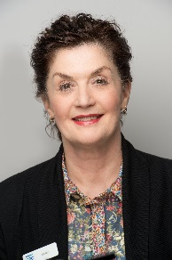
Welcome to our first clinical newsletter …. or should that be your newsletter?
We hope that you will find the content both interesting and informative. We would also urge you to consider contributing to future editions; either in the form of articles or any constructive feedback about services that you wish to share with your peers. Please email your contributions to elizabeth.orr@cbchealth.co.uk
Liz Orr
Quality & Governance Manager

What patients have to say…
“The doctor was amazing. In fact he waited after the end of his shift to meet me at the walk-in centre“
“The doctor was excellent. Very thorough. Very informative”
“I spoke to the doctor on Christmas morning. She explained everything to me in detail and gave me supportive advice””

Management of INR >8  It is not unusual to be contacted by the haematology lab with an INR result > 8 in the out-of-hours period. The specific treatment for this condition (when there is no evidence of bleeding) is oral Vitamin K.  Vitamin K can safely be administered to patients who are not actively bleeding, and supplies are available in the GatDoc drugs cupboard. Administering Vitamin K at home or at the PCC avoids unnecessary attendances at A&E and relieves some of the pressure on the ambulance service.  The Vitamin K protocol is based on the Cumbrian model which covers a large rural area. |  | Policy Update  A major behind the scenes review of policies and procedures is almost complete and will culminate in the publication of a new quality system covering all CBC services. The system will be held on a SharePoint site which all staff will be able to access via a unique log in. The well-established GatDoc website and the policies held there have formed the basis for this review; GPs accessing this refreshed system will already be reasonably familiar with the content.  You will be contacted with log in details as soon as the SharePoint site goes live.

CBC’s Clinical Directors
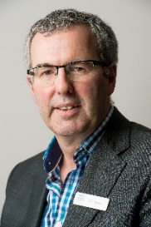  Dr Jerry Warwick qualified at Newcastle University in 1988. After qualifying Jerry completed his completed GP training in the North East and after a period working in Australia, he became a GP principal in Low Fell, Gateshead. Jerry was instrumental in establishing GatDoc out-of-hours co-operative in 1994. Jerry lives locally with his wife and family and continues to work as a GP in and out-of-hours.  Jerry.warwick@nhs.net | 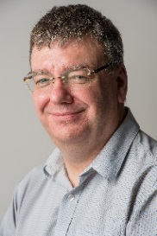  Dr Bill Westwood qualified at Aberdeen University, BSc (hons) in 1983; and MB, ChB in 1986. After qualifying Bill started work as a GP in Gateshead and after a period of time as a rural GP on the Isle of Skye he returned to work in Gateshead. He is a partner at Bewick Road Surgery and also chairs the Gateshead and South Tyneside Local Medical Committee. Bill is one of the founding Directors of CBC and has a special interest in primary care IT.  Bill.westwood@nhs.net
Jerry and Bill are readily available to give advice and support to clinicians working across CBC services. Jerry chairs CBC Board and Governance Board, and plays a lead role in supporting the management of clinical concerns and overseeing the management of complaints. Bill is CBC’s named Caldicott Guardian and in addition to chairing the local LMC, Bill also represents CBC as Chair of Gateshead Care Partnership Board

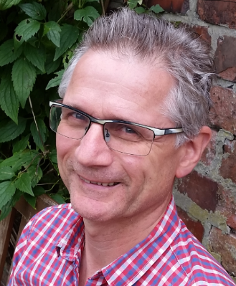
Independent Management of Complaints & Clinical Audit

Dr Gerard Reissmann is engaged by CBC as the independent clinician responsible for clinical audit and supports CBC Governance Board in the scrutiny of all aspects of clinical governance. Formerly a partner in Ethel Street Surgery in Benwell from 1990 – 2006, Gerard has a portfolio career combining locum work, out of hours work and teaching 1st and 2nd year medical students on the Medicine in Society course. Gerard has also sat on the Newcastle and North Tyneside LMC for around 30 years
‘One of my interests in teaching has always been how doctors make decisions in a fast moving, technically complex and human /emotional environment. As the late GP Prof Kieran Sweeney describes it, “‘medicine is not solely a technical activity and pursuit. It is about understanding and being with people at the edge of the human predicament.” One of my favourite reads and re-reads, and which I refer to often in my undergraduate teaching, is Daniel Kahneman’s “Thinking Fast and Slow” book, about our biases and heuristics and how we are blind to our blindness’s. If you read it, I promise you would be surprised by much of the research about human behaviour which can at first feel counter-intuitive.
I amazed at how speedily GPs make decisions that in the main are good and safe. This is under-valued by others and sometimes ourselves. It was this that made me interested in the work on quality and complaints and clinical audits at CBC Health.
I have two main parts to the job here. The first part involves doing the audits for the GPs. This means looking at consultations with the notes and for phone calls, also the audio recording. I use an RCGP tool and try and give enough clinical detail of the cases people saw, so that the feedback can be formative and help positive change. I have been impressed and humbled by the high quality of care overall. I hope that the feedback is useful for Appraisals too. On a small number of occasions, I work more closely with Jerry Warwick to decide on whether a GP needs to reflect more formally on an aspect of a case. Again, I would hope that this process would be useful in discussing with an Appraiser how each of us reflects and learn.
Dr Gerard Reissmann

Feedback is intended to help but I know there is a fine line between this and criticism. Feedback would always be better face to face and I am always happy to discuss the audits with individuals. We are presenting the audit results to individuals in a more positive way and any feedback on the style of these would be helpful
The second part of the role is to cast a clinical eye over the complaints that the organisation receives. I work closely with Kate Watson on this. Overall the numbers are small, but all need proper investigation and a quick response. I am very appreciative of the speed with which most GPs have responded. It makes the job a lot easier as complainants are happier with a quicker response. There are usually lessons from any complaint and I will try and share some of these in future bulletins.’

OOH Home Visit Analysis  A sample review of 100 GatDoc home visits was undertaken  in July 2017 and the finding are as follows:  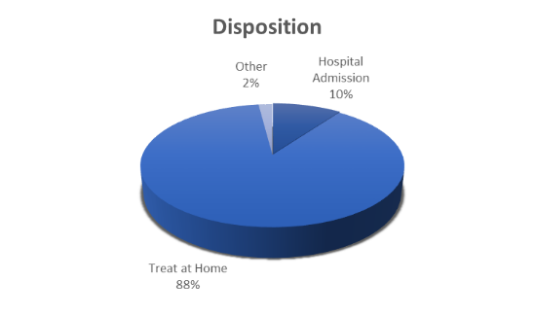  - Two third of patients sampled were female and over 90% of the acute cases analysed involved patients in the seventh, eighth and ninth decades of life. | CBC is committed to continuously improving service delivery processes and supporting clinicians to deliver the highest quality of service for patients. To this end, a series of snapshot analyses are currently being carried out looking initially at out-of-hours activity. Outcomes will be shared in future clinical governance bulletins as they become available.
- All cases were appropriately triaged for home visit, based mainly on acute illness, immobility, frailty, end of life or confirmation of death. Only three visits were made on the basis of patient choice.

- 58% of visits took place in the patient’s own home and 88% of patients were treated where they were seen. 70% of hospital admissions came from own residence cases.

- GPs provided support for clinicians and care home staff in 16% of cases, 60% of which were acutely unwell, and all of whom were treated at home.

- 10% of cases resulted in hospital admission.

- Confirmation of Death cases represented a small proportion (4%) of overall cases.

In consultation with Gateshead’s Community Services clinicians, it was considered that in around a quarter of cases, the home visit may have been equally effectively undertaken by a nurse practitioner (UCT) or palliative care team.

Fabulous Facts
GatDoc | ExtraCare
13,341 Cases handled  11,462 Telephone assessments  1,855 ECC referrals  1,433 Home visits undertaken  56 GPs covered GatDoc sessions, providing  18,915 hours of cover over 3,265 sessions  (April to December 2017) | 8,867 Extra GP appointments available  2,713 Extra Nurse appointments available  1,478 Additional GP hours  678 Additional Nurse Practitioner hours  27 GPs covered ExtraCare sessions, providing 4,336 service hours over 798 sessions, which equates to around 26,000 additional 10-minute GP appointments
‘Was not brought’

‘Was not brought’ is the more appropriate terminology for ‘did not attend’ when the patient is a child.

When a child is not brought to a PCC appointment, clinicians should be mindful that this may be symptomatic of other child safeguarding concerns. Neglect (includes failure to seek appropriate care for an unwell child) is the most common reason for a child to be placed on a child protection plan.

When a child is not brought to the PCC clinicians should endeavour to contact the carer of the child to determine the reasons for the non-attendance. There should be a low threshold for completion of a ‘cause for concern’ form. Please highlight the non-attendance to the child’s GP practice.

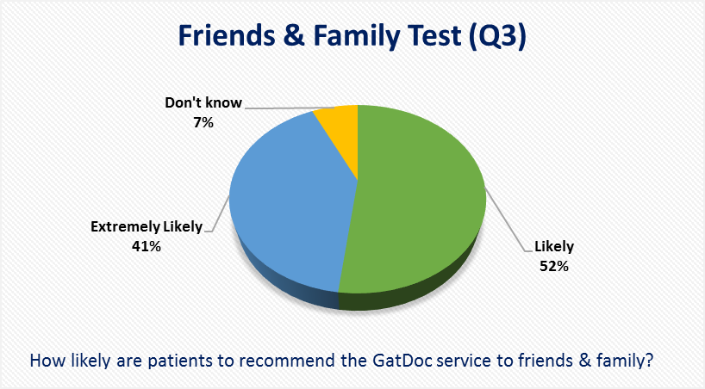
Patient Feedback
85% of GatDoc patients rated their telephone assessment as good or better, and 85% thought that their home visit was good or better.
Those visiting the centre(s) rated their experience at 98% good or better; and 23% thought their experience was excellent.

