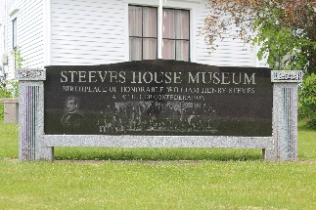
MEMBERSHIP & DONATION FORM

Submit your completed form with your payment in person during the summer season, by appointment in the off season, or by mail to: 40 Mill Street, Hillsborough, NB E4H 2Z8. Cheques can be made payable to Heritage Hillsborough Inc. If you can’t print the form, completed forms can be emailed to steevesmuseum@nb.aibn.com. If you would prefer to pay by credit card email us or call 506-734-3102. Note: calling is only reliable during the summer season, but email works year-round.
CONTACT INFORMATION
Name________________________________________________________________________________
Address______________________________________________________________________________
City_____________________________ Province___________________ Postal Code _______________
Home Phone_________________________________ Cell Phone _______________________________
Email________________________________________________________________________________
MEMBERSHIP
Membership grants free year-round entry to the Steeves House Museum for one year starting on the date payment is received and provides you with notice of our events via our email newsletter. Note: membership fees are not eligible for tax receipts.
I am registering for:
Individual Membership: $10
Family Membership: $25 Number of family members ___________________
Life Membership: $100
DONATIONS
As a non-profit organization the Museum relies on private donations to help keep it alive and thriving. Donations go towards the museum’s activities, which include: programs, events, publications, repairs, cataloging, and exhibitions. Your donation will help preserve Canadian history and improve the local community.
Enclosed is my tax-deductible gift of $_____________________________________________________
Please keep my donation confidential

Thank you for your support!
Steeves House Museum / Heritage Hillsborough Inc.
steevesmusuem@nb.aibn.com www.steeveshousemuseum.ca

