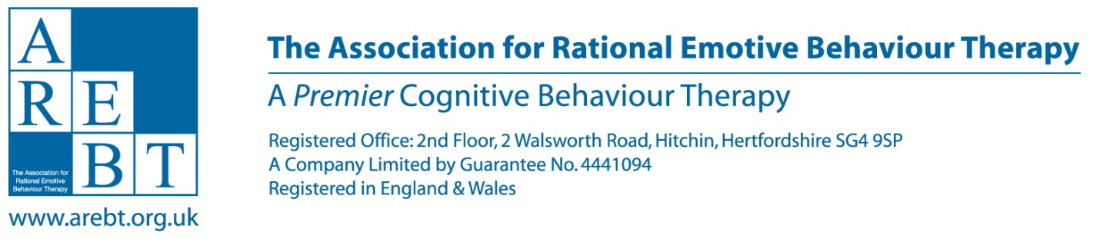

Minimum criteria for application as REBT supervisor.

SECTION ‘A’ [criteria to be met by all applicants].

[1] Minimum three years experience as an accredited REBT practitioner.

[It is the intention of the Association to encourage robust criteria for AREBT supervision. However in the interest of not creating onerous criteria, the Association is willing to accept applicant’s current accreditation status as proof the applicant is abiding by its codes of practice and CPD as a REBT practitioner. In the event it turns out the applicant is not maintaining these requirements then re-accreditation and supervisor accreditation may be refused].

Plus, at least one of the following criteria:

SECTION ‘B’

[a]. AEI supervisor certificate.

[b]. A postgraduate diploma in clinical supervision from a UK university.

[c]. Accredited as a BABCP supervisor.

In addition, upon application, the applicant will need to demonstrate:

[i]. A minimum of 12 hours REBT supervision work in the past year…and
a minimum of 4 hours REBT supervision of their work as a supervisor in the past year.

[ii]. The application will need to be supported by at least one supervisee whose REBT work you have supervised.

[iii]. The application will need to be supported by at least one supervisor of your work as a REBT supervisor.

*If none of the above QUALIFICATIONS [a to c] apply, generic skills will be considered:

SECTION ‘C’ [Required generic skills]

[i]. A minimum of two years REBT supervisor experience.

[ii]. At least three different supervisees, and…..

[iii]. Have carried out a minimum 24 hours per year [in the two years immediately prior to application] work as a REBT supervisor…and…

[iv]. A minimum of 4 hours per year [in each the two years immediately prior to application] supervision of their work as a REBT supervisor.

[iv]. Ideally a balance between peer, group, and one-to-one experience.

[v]. The application will need to be supported by two supervisees whose REBT work you have supervised.
[vi]. The application will need to be supported by at least one supervisor of your work as a REBT supervisor.

Accreditation will cost £90. Reaccreditation will take place every five years and the first re-accreditation will take place at the same time as practitioner accreditation takes place in that year thereby ensuring from that point on practitioners and supervisor re-accreditation coincides.

SECTION ‘D’

RE-ACRREDITATION CRITERIA.

Re-accreditation will be £45.

*[i]. Re-accreditation applicants must demonstrate a minimum of 20 hours per year as a REBT supervisor,
*[ii]. A minimum of 6 hours per year CPD directly related to REBT supervision , and
*[iii]. A minimum of 4 hours per year supervision of their work as a supervisor.

*The Association does not wish to impose an unnecessary burden on applicants, and it wishes to promote high quality REBT supervision. Accordingly the 20 hours work as a REBT supervisor, and the 6 hours CPD relating to REBT supervision, will NOT be in addition to the criteria for ‘normal’ CBP requirements for supervision and CPD as an accredited AREBT, or dual accredited AREBT/BABCP therapist.

*HOWEVER the 6 hours per year of supervision of their work as a supervisor WILL be in addition to the criteria for ‘normal’ CBP requirements for supervision and CPD as an Accredited AREBT, or dual accredited AREBT/BABCP therapist.

Once accredited the applicant will be entitled to use the post-nominal – SAREBT.

NB. From the date of publication of this information on the association's website only accredited AREBT supervisors will be permitted to call themselves such.

