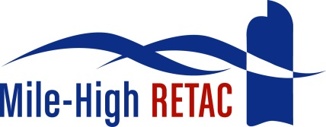

Mile-High Regional Emergency Medical and Trauma Advisory Council (MHRETAC)
AED Request Guidelines

The following guidelines were developed by the MHRETAC SMART/CPR Committee to assist you with your request for funding from the Mile-High RETAC.
- The MHRETAC AED Request Application and the AED/Defibrillator Medical Authorization must be completed and submitted.
- Requests will be reviewed and approved by the MHRETAC SMART/CPR Committee which is held the second Tuesdays at 1:30pm.
- Once the requests are approved by the MHRETAC SMART//CPR Committee, it will be submitted to the MHRETAC Board of Directors meeting which is held on the 3rd Thursdays in January, March, May, July, September and November
- The grant process is on-going throughout the year
- Each request must demonstrate a brief financial need statement
- Each request must provide a benefit to the service your agency provides
- Questions –contact Shirley Terry at shirleyterry@comcast.net
- Notice of approval or denial will be communicated within one week following the MHRETAC Board of Directors Meeting and vote

See the attached MHRETAC AED Request Application, MHRETAC AED/Defibrillator Medical Authorization, C.R.S. 13-21-108.1 (2015) and AED Donation Agreement.

January 18, 2016

