Please join us for the upcoming Lunch Time Research Seminar featuring our Faculty Sabbatical Returners.

DATE: Thursday, February 20, 2020
TIME: 12:15-1:45PM
ROOM: 4E26 of SSW Bldg. 525 W. Redwood Street, Baltimore, MD 21201
**Pizza and refreshments will be provided** please RSVP by 2/17 to tbrown@ssw.umaryland.edu

Title: “Findings and Developments from Sabbatical Research”
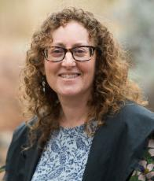

Corey Shdaimah LL.M., PhD
Daniel Thursz Distinguished Professor of Social Justice
Academic Coordinator, MSW/JD & MSW/MPP Dual Degree Programs
University of Maryland, School of Social Work
Title: Inclusion, Intersectionality and Legal Consciousness in Law-like University Practices
During my sabbatical, I began work on a proposal with colleague Chrysanthi Leon of University of Delaware to examine how students and administrators make meaning of identity and inclusion in university accommodation policies. We focus on three identity categories that have been targets of inclusion within higher education: students with disabilities, educationally disadvantaged students, and international students. Study sites include large public, medium and small liberal arts colleges, religious universities and community colleges from three politically liberal geographical regions with relatively high immigrant and religious, ethnic, and racial minority populations in order to elicit “information-rich” accounts. We use the critical discourse around inclusion and diversity in higher education and theories of intersectionality, legal mobilization, and legal consciousness to frame inquiry into how diversity and inclusion policies and practices function as law-like systems in the microcosm of higher education.
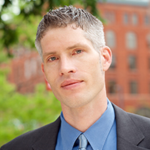

John Cagle, Ph.D.
Associate Professor
Title: "Emerging Research in Hospice and Palliative Care."
Discuss the underutilization of hospice, supportive care for dementia patients, innovations in advance care planning, and how the national opioid crisis is impacting end of life care.
Dr. Cagle is an associate professor at the University of Maryland, School of Social Work with a substantive interest in improving care at the end of life. As a translational health services researcher, his efforts focus on identifying effective models of care and support for dying patients and their families – and implementing those models in routine clinical practice. His research is informed by nearly a decade of clinical work as a hospice social worker. Dr. Cagle has expertise on the assessment of risk for substance misuse in hospice care, providing compassionate end-of-life care to patients when there is a history of substance misuse or addiction in the home, mitigating risks for medication diversion, and ensuring safe disposal of scheduled medications after a hospice death at home. As principal investigator (PI), he recently led an interdisciplinary team of researchers to conduct a large national survey of hospice providers to understand the challenges of providing care during the national opioid crisis. Furthermore, he has given national presentations on substance use disorder within the context of hospice and palliative care for the American Academy of Hospice and Palliative Medicine (AAHPM) and National Hospice and Palliative Care Organization (NHPCO). Dr. Cagle also has extensive experience with rigorous clinical trials, both as an interventionist and as a PI.
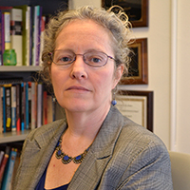

Joan K. Davitt, PhD, MSS, MLSP
Associate Professor & Hartford Geriatric Social Work Faculty Scholar
University of Maryland
School of Social Work
Title: The Impact of Racism on the Well-being of Older Adults of Color: Developing a Theoretical Framework
Joan Davitt is an Associate Professor & Hartford Geriatric SW Faculty Scholar at the University of Maryland, School of Social Work. Dr. Davitt has worked for over 30 years in the field of gerontological social work as a practitioner, teacher, and research scholar. Dr. Davitt has broad social work experience with a focus on advocacy and policy practice. Her research interests focus on the intersection between policy and practice and the impact on older adults’ ability to age in place in community with a particular focus on disparities in access to and outcomes of community based care. Dr. Davitt’s research has been supported by the National Institute on Aging, the Centers for Medicare and Medicaid Services, the John A. Hartford Foundation, the New York Community Trust, and the Andrus Foundation among others. She was a Health & Aging Policy/APSA Congressional fellow from 2012-2013, a 2005-2007 John A. Hartford Foundation Faculty Scholar, and is a fellow of the Gerontological Society of America. Dr. Davitt’s scholarship has been published in a wide variety of peer-reviewed journals including those in social work, medicine, nursing and gerontology.

