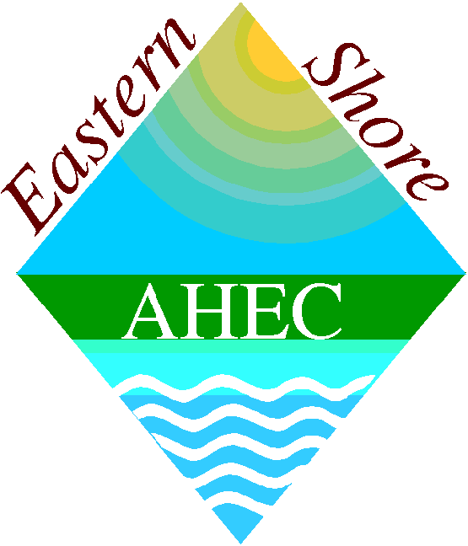
Geriatric Assessment Interdisciplinary Team (GAIT) Training

2018 REGISTRATION FORM

First Name_____________________ Last Name______________________________________________

Male □ Female □ (For roommate assignments – You may need to share a room with another student)

Address_________________________________City___________________ State_____ Zip___________

Telephone_______________________________

Non School E-mail______________________________ School Email____________________________

University Name & Campus ___________________________ Discipline__________________________

Do you need overnight accommodations for this GAIT Project? □ YES □ NO
Will share a room with _____________________________________________

Do you have special dietary needs? □ YES □ NO If yes, please specify__________________________

Have you ever attended a GAIT? □ YES □ NO If yes, please specify ________________________

Which GAIT Training Project do you wish to attend?

Space is limited so please register early.
Full attendance is required, i.e., all day (8 am-5 pm)

□ Tuesday, March 20th at University of Maryland Shore Medical Center at Easton, MD
Topic: Palliative Care

□ Wednesday, April 25th at Talbot Hospice in Easton, MD
Topic: Hospice Care

□ Tuesday, May 1st at Chesapeake Woods Center in Cambridge, MD
Topic: Dementia Care

RETURN COMPLETED FORM NO LATER THAN 3 WEEKS PRIOR TO GAIT SESSION TO:

Lisa Widmaier, MEd
GAIT Coordinator
Eastern Shore AHEC
814 Chesapeake Drive
Cambridge, Maryland 21613

TELEPHONE: 410-221-2600 FAX: 410-221-2605 E-Mail: esahecgait@esahec.org

Training materials, hotel, and meals are provided at no cost.
A travel stipend is also provided to help defray gas expenses.

University of Maryland Shore Medical Center at Easton
219 S. Washington Street
Easton, MD 21601
Tuesday, March 20, 2018
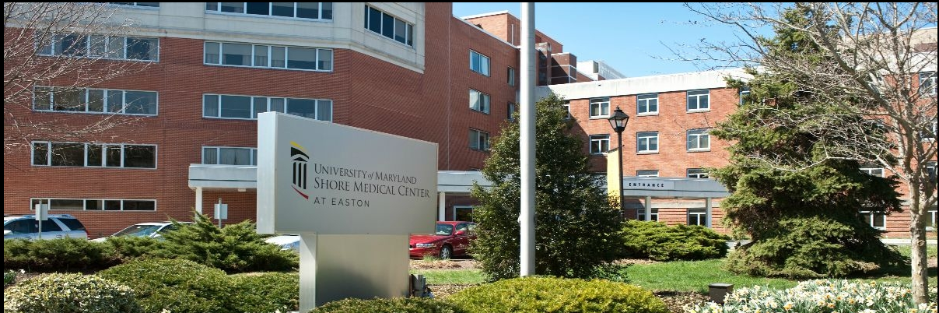
With 112 licensed beds, and a 20-bed acute inpatient rehabilitation center, University of Maryland Shore
Medical Center at Easton serves primarily Caroline, Dorchester, Queen Anne’s and Talbot counties; its
secondary service area includes Kent County. Its Emergency Department serves as many as 40,000 patients a
year.

Talbot Hospice
586 Cynwood Dr.
Easton, MD 21601
Wednesday, April 25, 2018
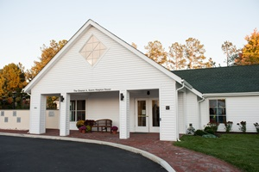
Talbot Hospice is a model for community based hospice care at the end of life. Since 1981 we have cared for
patients and their families with dignity and respect. We offer comprehensive hospice care in your home, in nursing
facilities and at Hospice House. We provide nurses, spiritual support, a bereavement center, family services and
compassionate well trained volunteers. "We Celebrate Life Every Day."

Chesapeake Woods Center
525 Glenburn Avenue
Cambridge, MD 21613
410 221-1400
Tuesday, May 1, 2018
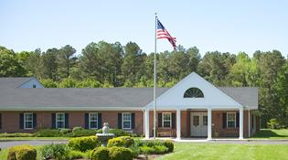

Located in the historic town of Cambridge on the Maryland Eastern Shore, Chesapeake Woods is situated at the
end of a tree- lined residential street. The Center’s Transitional Care Unit offers clinical and rehabilitative care
for those requiring a short stay. Long Term Care is also offered and the Center has a secure Homestead Unit for
those needing dementia care.

