GAIT: Geriatric Assessment Interdisciplinary Team
Atlantic General Hospital 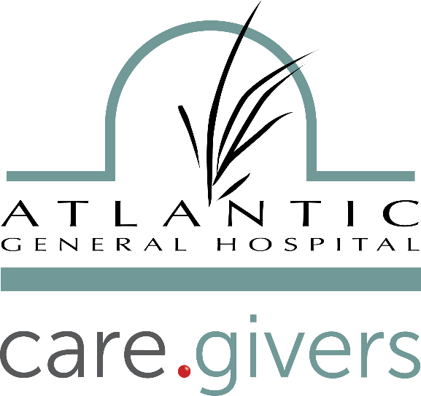
9733 Healthway Drive
Berlin, MD 21811
An independent, not-for-profit hospital and health system with a focus on improving the health of the community
Date: Monday
March 18, 2019
8:00 am – 5:00 pm
NICHE
Nurses Improving Care for Health System Elders
Overnight accommodations available for Sunday night, if requested.
Continental Breakfast & Lunch will be provided at the facility.

**REGISTRATION DEADLINE IS March 4, 2019**
First Name____________________________ Last Name_______________________________ Male Female
Mailing Address_________________________________________ Phone_______________________
School Email ___________________________ Non School Email _____________________________
University/Campus__________________________________ Department______________________
Do you need a hotel room? YES NO
I will share a room with ________________________________________________________________
Special Dietary Needs? Yes - Please specify ________________________________________ No
Have you ever attended a GAIT? Yes – Please specify _________________________________ No
RETURN TO:
Randy Holliday, GAIT Coordinator
Eastern Shore AHEC
814 Chesapeake Drive Cambridge, MD 21613
Phone: 410-221-2600 Fax: 410-221-2605 Email: rholliday@esahec.org

