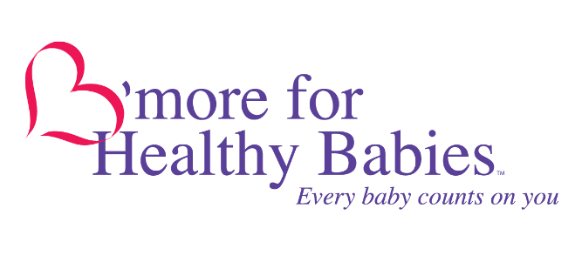

Bernard C. “Jack” Young
Mayor

SLEEP SAFE: #NotOneMoreBaltimore Social Media Kit (Part II)

Earlier this year, we shared the devastating news that six babies in Baltimore City died in six weeks while sleeping. All of these babies were in an unsafe sleep environment–they were sleeping in a bed or on a couch, with an adult or child. Our hearts are still broken for the families who had to endure these tragedies but, we have some hopeful news: the rate of sleep-related infant deaths has slowed down. Thank you for helping us spread the safe sleep message. Still, too many of Baltimore’s babies are dying in their sleep, so it is more important than ever to keep speaking up for Baltimore’s babies.

As more and more people turn to social media for health information, we are up against rampant misinformation, but we can continue to use our collective voices to reach as many families as possible with evidence-based safe sleep information. This updated toolkit features sample text, graphics, and videos that you can take directly, or use as inspiration for your own social media posts. Just remember to use #NotOneMoreBaltimore for your safe sleep messages.

We are also excited to include the recently updated version of our classic SLEEP SAFE video. The new version still shares the powerful stories of moms of babies who died in their sleep, but now includes better explanations of safe sleep environments and the addition of our DON’T SMOKE message. We have heard from many families that watching this video impacts their choices about how their baby sleeps, so please help us make sure as many families as possible see it by sharing it.

Together, we can keep every baby safe during sleep and make sure more families are celebrating their babies’ birthdays, first steps, and first days. Whether a mom, family member, doctor, nurse, teacher, social worker, community leader – every baby counts on you.

Sample Facebook Posts
www.facebook.com/bmoreforhealthybabies

- In 2018, 13 babies in Baltimore City died while sleeping. None were in a safe sleep environment. These tragedies can be prevented.

For safe sleep information, videos, and support, visit update.healthybabiesbaltimore.com. #NotOneMoreBaltimore
[Graphic: SLEEP SAFE: Alone. Back. Crib. Don’t Smoke.]

- Babies are more likely to suffocate when they sleep with another person in a bed or on the couch. It’s the biggest reason why babies die during sleep. Always put babies to sleep alone, on their backs, in a crib, and in a smoke-free home. At first, your baby may have a tough time not being next to you, but if you stick to a safe sleep routine, your baby will get used to it. And you will probably sleep better, too!

For safe sleep information, videos, and support, visit update.healthybabiesbaltimore.com. #NotOneMoreBaltimore
[Graphic: SLEEP SAFE: Alone]

- Babies are less likely to choke when sleeping on their backs. Your baby may seem uncomfortable on their back at first, but if you stick to putting them on their back for every nap and every night, soon it will feel natural for them.

For safe sleep information, videos, and support, visit update.healthybabiesbaltimore.com. #NotOneMoreBaltimore
[Graphic: SLEEP SAFE: Back]

- Your baby should always sleep in a crib, never on an adult bed or couch or with pillows, cushions or stuffed animals. Your baby could be suffocated in these soft materials. Your baby also could become trapped in between cushions on a couch or get stuck between the bed and the wall. These tragic situations occur all too frequently in Baltimore City.

If you can’t afford a crib for your baby, call HealthCare Access Maryland at 410-649-0500 to get a free one. update.healthybabiesbaltimore.com #NotOneMoreBaltimore
[Graphic: SLEEP SAFE: Crib]

- Keep smoke away from your baby – no cigarettes, marijuana, or vaping in your home. Smoke in the home makes it harder for babies to breathe well. Many babies who die in their sleep are living in homes with smoke.

For safe sleep information, support, and resources, visit update.healthybabiesbaltimore.com. #NotOneMoreBaltimore
[Graphic: SLEEP SAFE: Don’t Smoke]

- Did you know that if you smoke even one cigarette a day while pregnant, your baby is twice as likely to die from SIDS? The more cigarettes you smoke, the higher that chance is. The good news is, the risk gets smaller when you smoke less or quit.

For help quitting smoking, call 1-800-QUITNOW.
[Graphic: SLEEP SAFE: Don’t Smoke]

- In 2018, 13 babies died in their sleep. So far in 2019, 3 babies have died while sleeping. All of these babies were in an unsafe sleep environment.

Safe sleep can feel hard at first, but with practice, both you and your baby will get used to it. Your baby will be safer and you will sleep better. For more safe sleep information, support, and resources, visit update.healthybabiesbaltimore.com. #NotOneMoreBaltimore
[Graphic: SLEEP SAFE: Flyer]

Sample Tweets
@bmoreforbabies

- In 2018, 13 babies in Baltimore City died while sleeping. None were in a safe sleep environment. These tragedies can be prevented update.healthybabiesbaltimore.com #NotOneMoreBaltimore
[Graphic: SLEEP SAFE: Alone. Back. Crib. Don’t Smoke.]

- Babies should always sleep alone and in a crib. At first, your baby may have a tough time not being next to you, but if you stick to a safe sleep routine, your baby will get used to it. And you will probably sleep better, too! update.healthybabiesbaltimore.com #NotOneMoreBaltimore
[Graphic: SLEEP SAFE: Alone]

- Babies are less likely to choke when sleeping on their backs. Your baby may seem uncomfortable on their back at first, but if you stick to putting them on their back for every nap and every night, soon it will feel natural for them. update.healthybabiesbaltimore.com #NotOneMoreBaltimore
[Graphic: SLEEP SAFE: Back]

- Families who need a safe place for their baby to sleep can get a free crib. To learn more, call HealthCare Access Maryland at 410-649-0500. update.healthybabiesbaltimore.com #NotOneMoreBaltimore
[Graphic: SLEEP SAFE: Crib]

- Never smoke, vape, or use weed in a home with babies, young children, or pregnant women. Smoke in the home makes it harder for babies to breathe well. You can go outside, but your baby can’t. update.healthybabiesbaltimore.com. #NotOneMoreBaltimore
[Graphic: SLEEP SAFE: Don’t Smoke]

- If you smoke just one cigarette per day while pregnant, your baby is twice as likely to die from SIDS. The good news is, the risk gets smaller when you smoke less or quit.

For help quitting smoking, call 1-800-QUITNOW.
[GRAPHIC: SLEEP SAFE: Don’t Smoke]

- In 2018, 13 babies died in their sleep. So far in 2019, 3 babies have died while sleeping. None were in a safe sleep environment.

Babies should always sleep ALONE, on their BACKS, in a CRIB, and in a SMOKE-FREE home. update.healthybabiesbaltimore.com #NotOneMoreBaltimore
[Graphic: SLEEP SAFE: Flyer]

GRAPHICS
Use these with the corresponding sample posts, or create your own captions (6 Total)

SLEEP SAFE: Alone. Back. Crib. Don’t Smoke.
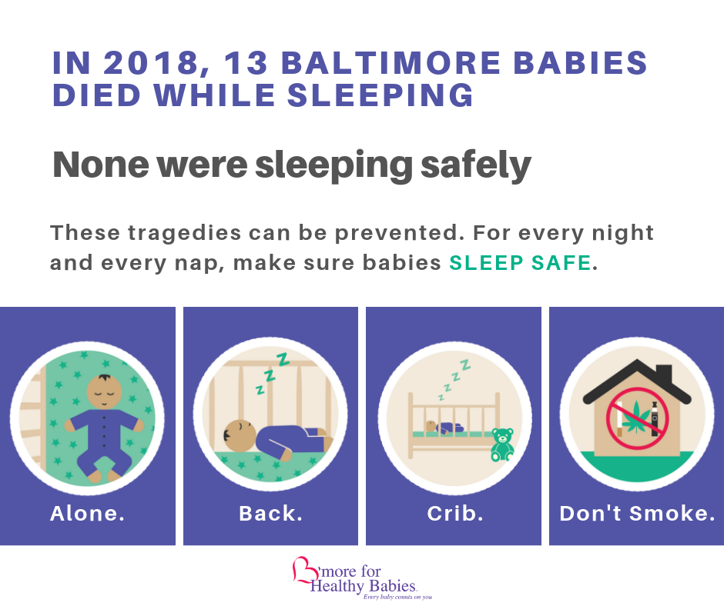

SLEEP SAFE: Alone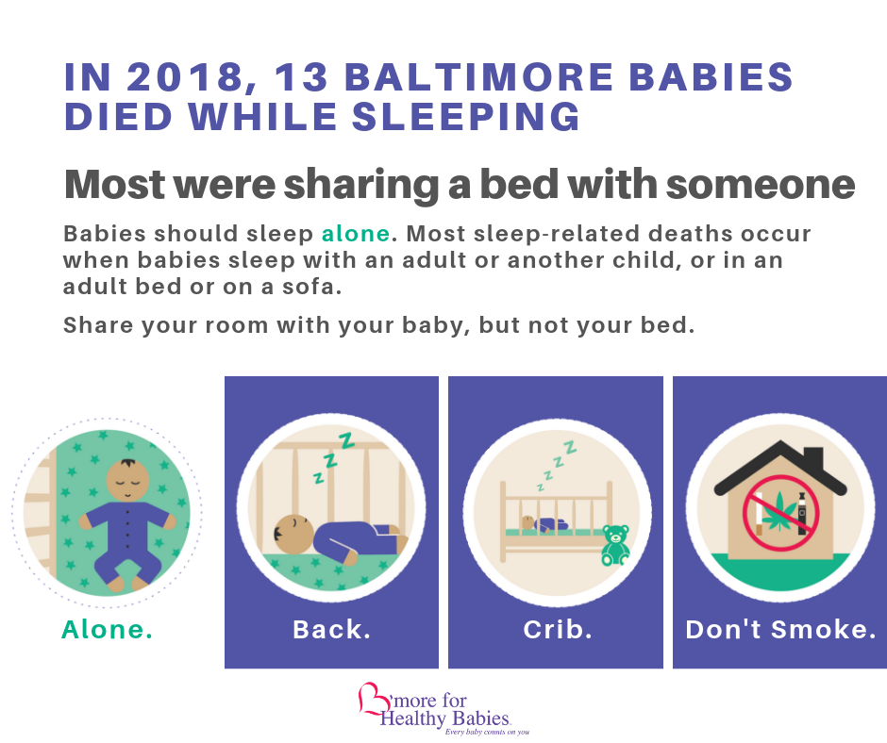

SLEEP SAFE: Back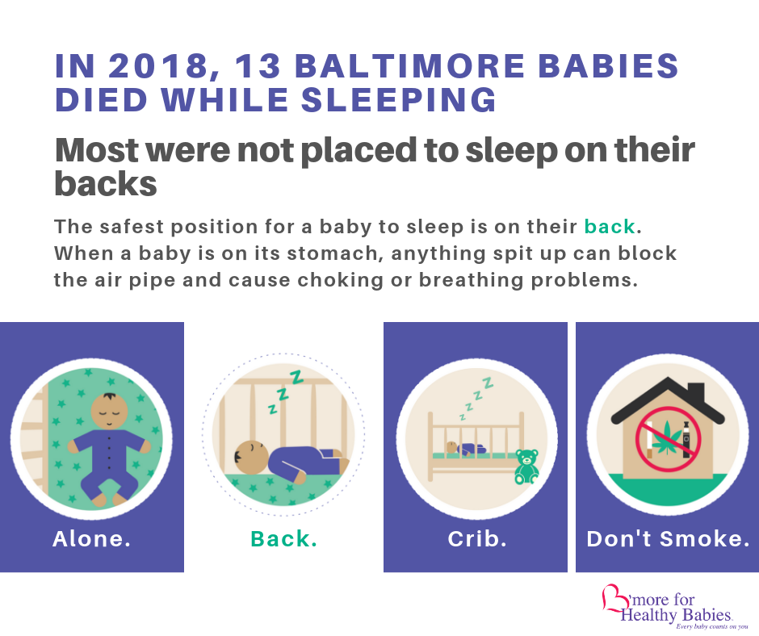

SLEEP SAFE: Crib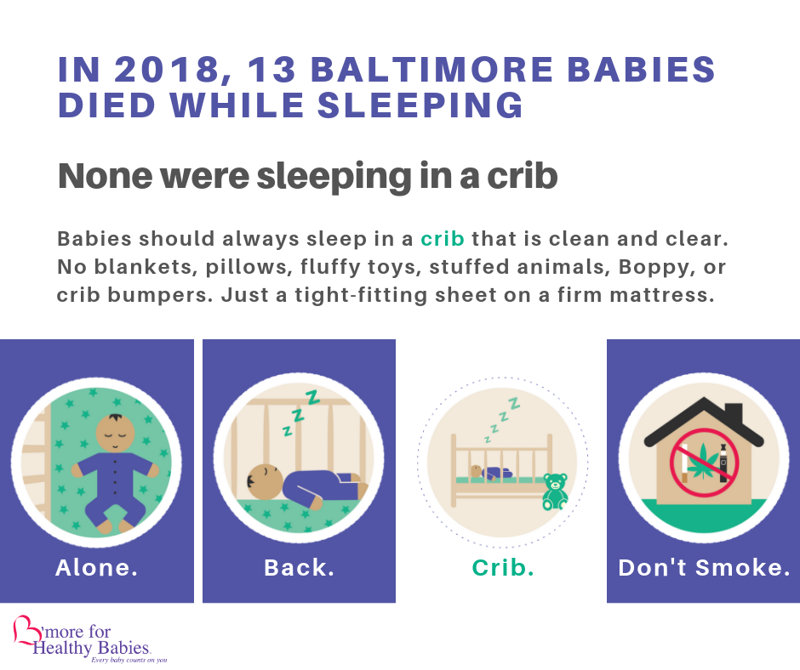

SLEEP SAFE: Don’t Smoke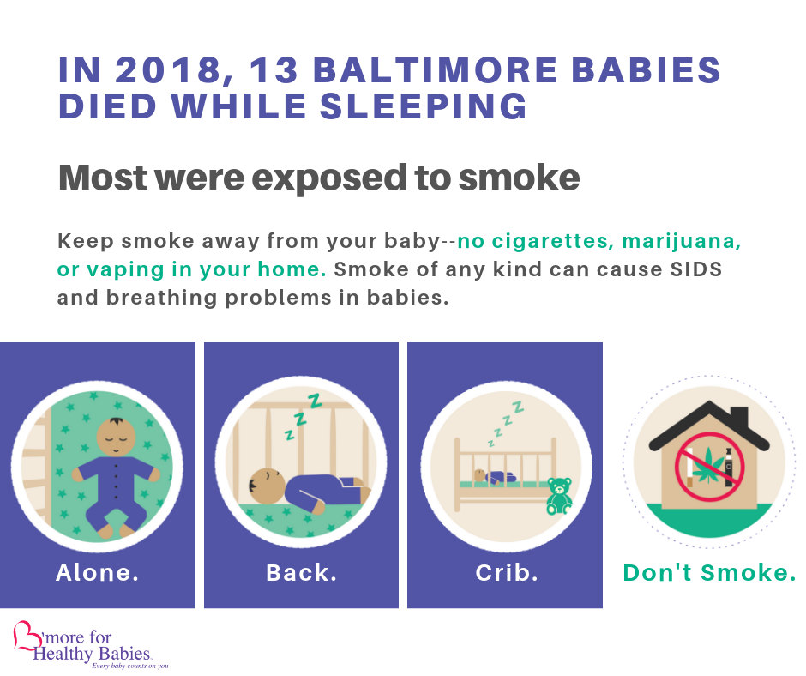

SLEEP SAFE: 2018 Sleep-Related Death Flyer

