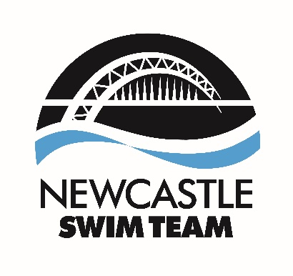

All forms must be returned to the Club Secretary and Club Administrator on secretary@newcastleswimteam.co.uk and admin@newcastleswimteam.co.uk by Wednesday 19th February 2020. Nominees, Proposers and Seconders need to be members of the club. Nominees are required to send an outline of what strengths and skills they can add to the committee in order to send this out to the membership.
Newcastle Swim Team
Committee Nomination Form 2020
Name of Nominee:
Nominated Committee Position:
Name of Proposer:
Name of Seconder:
Tick to confirm Proposed Member’s willingness to stand

