The Household Cavalry Foundation

The Household Cavalry Foundation has been set up to care for the men, families, horses and heritage of Britain’s Senior Regiment. Whether caring for soldiers injured on operations or providing relief to retired veterans and their dependants, the Household Cavalry Foundation aims to provide an umbrella of support to its Regimental family.

The Foundation is in place to provide succour to five charitable aims;

· Soldier Welfare: To provide support to, and promote the efficiency of, serving members of the Household Cavalry. Whether to relieve distress or hardship, assist those injured on training or in peacetime, or encourage sport, adventure training, team building or charitable endeavour, the Household Cavalry Foundation is there to care for all men serving both home and abroad.

· Casualty Welfare: To provide financial support to injured soldiers and their families, including those who have lost their lives on active service, through the Household Cavalry Operational Casualties Fund.

· Veterans Welfare: Relieve past members of the Household Cavalry and their dependents who are in need, hardship or distress, or those who have become seriously ill, or have broader welfare needs.

· Horse Welfare: To provide and support, financial or otherwise, to organisations and individuals involved in the welfare of our horses such as the Horse Trust.

· Maintain the Fabric of the Household Cavalry: To ensure the maintenance of our operational and ceremonial heritage and ethos, museums and archives, regimental property, and recruiting.

Monies raised for The Household Cavalry Foundation is to help the wounded soldiers, their families and also the horses – their care not only while they are actively serving in The Cavalry but also their care once they retire from their “duties”. No soldier or horse is ever forgotten by The Household Cavalry.

Operational

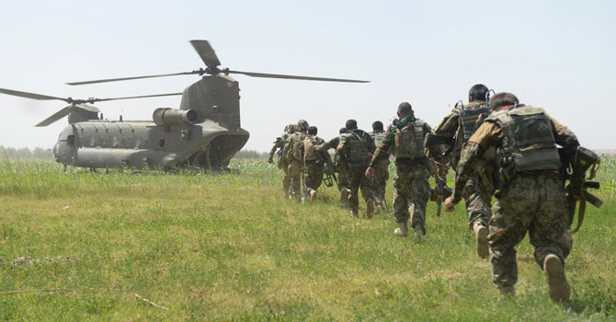

Training
Training for the operational role is conducted at Bovington in Dorset where soldiers are taught to drive a car before moving on to a Scimitar light tank. They learn how to drive the Scimitar and how to operate communications equipment before joining the Household Cavalry Regiment at Windsor.
Whilst serving at HCR, soldiers will have their communication and signals skills developed, and will attend driving and maintenance courses, in order to prepare them for tasks relevant to their future role as reconnaissance soldiers.

Recent Operations
The Household Cavalry Regiment has recently returned from an operational tour in Afghanistan. This was the fifth time that Household Cavalry soldiers have been deployed onto the ground in Helmand since the beginning of operations there in 2004.
Regimental Headquarters were based in the Helmand’s provincial capital Lashkar Gah as part of the Brigade Headquarters, while elements of Headquarters Squadron ran the administration and resupply for over 1,000 troops in Camp Bastion.
B Squadron HCR formed the Brigade Reconnaissance Force, ready at a moment’s notice to deploy onto the ground to protect both the local population and our own troops by disrupting enemy activity and their supplies.
The remaining Household Cavalrymen were spread across Helmand, as Forward Air Controllers, Afghan Police Mentors and Liaison Officers with our international allies. D Squadron, Household Cavalry Regiment, remains part of 16 Air Assault Brigade and forms the armoured element of the Air Assault Task Force, one of the UK’s high readiness contingent capabilities.
HCR has recently been one of the most frequently deployed units in the British Army.

Horses

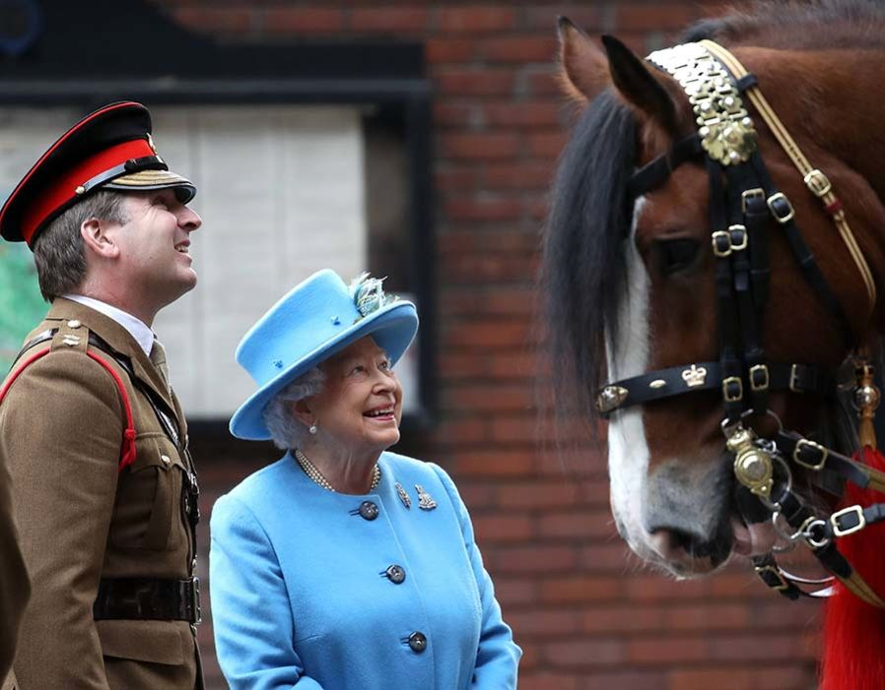

Horses remain at the heart of the Household Cavalry's ceremonial role and we are committed to providing support to organisations and individuals caring for our retired horses to ensure their needs are met.

Support for retired horses includes: .

- Working with specialist equine charities to benefit the welfare of retired Household Cavalry horses.

- Veterinary treatments in exceptional circumstances and livery fees subject to approval from the equine committee.

- Charitable retirement provision

- Emergency admission, transport or veterinary checks of horses, based on application for funding from the approved charity where the retired horses are placed.

Veterans
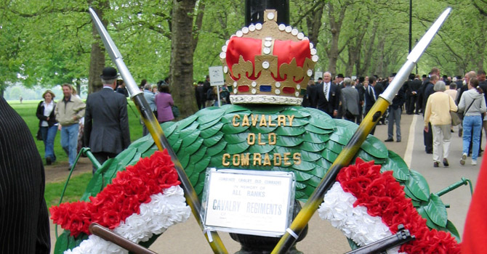

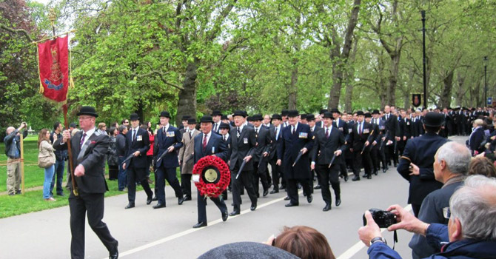

We support past members of the Household Cavalry and encourage a strong link with our veterans to ensure they remain an integral part of our Regimental family.

Support includes:

- Relieving past members and their dependants who are suffering hardship and distress.

- Supporting those who have become seriously ill or have broader welfare needs

Heritage

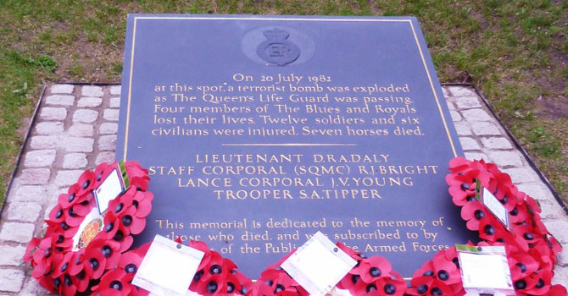

Unique history, heritage, traditions and Regimental ethos lie at the heart of the Household Cavalry identity. The Household Cavalry Foundation are committed to preserving this heritage by providing funding for:

- Preservation and maintenance of our museums, archives and other regimental property.

- Continuing tradition through documenting Regimental events as they happen today.

- Protecting the Regimental reputation and ethos

