

**Aetna Medicare Telesales Product Training 2018**

Let’s get your agents Ready to Sell for 2018 AEP by completing this online, interactive course.

This training should not take more than an hour to work through.

**Participants**: The telebrokers that will be offering Aetna Medicare Advantage products must complete this national product training.

This training will not satisfy any requirement for field agents.

**Specifications**: Internet Explorer 11 is the browser that supports the full functionality of the training.  If you prefer Google Chrome, Firefox or Safari, please load IE 11 for the short time needed to take the course.

**Logging in and registration:**       <https://www.teachmeaetnamedicare.com/>

Agents should be ready with their National Producer Number (NPN) to register.  Here is the link to look it up if needed:

<https://www.nipr.com/PacNpnSearch.htm?_ga=1.29820093.346681796.1394554090>

The agent should make note of the password so they can return to the training when they want to.

First: Click "Register Now"

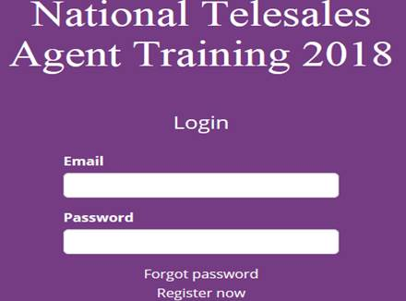

**Next:** Choose your organization from the drop down list. This step is necessary to record the successful completion of the training. Gordon Marketing partners with Senior Market Sales for Aetna MAPD so choose SENIOR MARKET SALES

