DISTREE EMEA 2017:
Future connections, today - ADAM elements.
Monaco, February 21st, 2017 – A new year and great new ways to get attached, ADAM elements will be showcasing a range of intelligently designed gadgets including the MEKA Life 360 and the iKlips Wizard.

The camera to picture freedom: MEKA 360 Life Camera
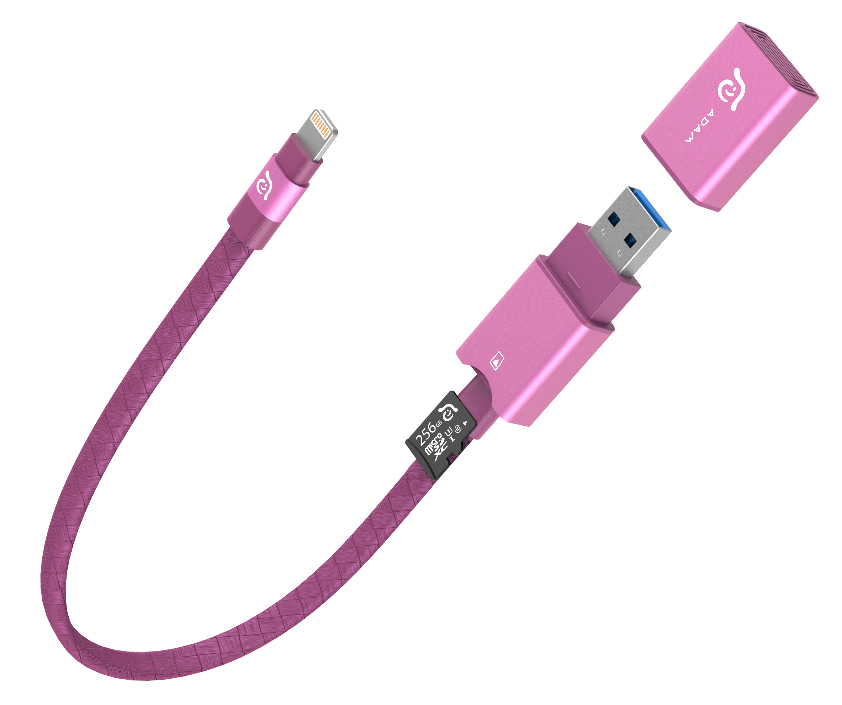
MEKA 360 Life Camera
MEKA is a life companion. MEKA caters to your lifestyle: whether you are a wildlife explorer, an up and coming snowboarder, travel blogger, or simply someone who likes to capture every picture-perfect family moment. MEKA is engineered to perfection, it’s equipped with twin f/2.0 fisheye lenses. So you can shoot magnificent shots even in low light. Enjoy three recording modes and real-time 360 stitching. Your photos and photos will be Facebook and YouTube ready in a snap. Share every single detail of your experience with the rest of the world. Expand the possibilities with our iKlips Wizard (Lightning to USB Type-A with microSD reader) and our CASA CO3 (Q3.0 car charger for USB Type-A and Type-C).

The all-in-one iOS card reader: iKlips Wizard
iKlips Wizard: Flexible on-the-go iPhone/iPad card reader for expanded storage
iKlips Wizard takes the iKlips series to a whole new level. It allows you to expand your iPhone or iPad’s memory up to 256GB and instantly view footage from your GoPro, DSLR, drone, or 360 camera. It also serves as a USB-to-Lightning adapter. Sharing and transferring files between all your iOS, macOS, Windows, Android, Linux, and smart TVs come naturally. Intuitive file management with our signature iKlips App. 3.0. Precisely engineered with premium materials for integration into the iOS family. Smooth and cool to the touch aluminum body combined with its durable braided flat cable provide a high-strength amor against damage. It’s equipped with a magnetic cap and an ADAM plate for versatile on-the-go storage.

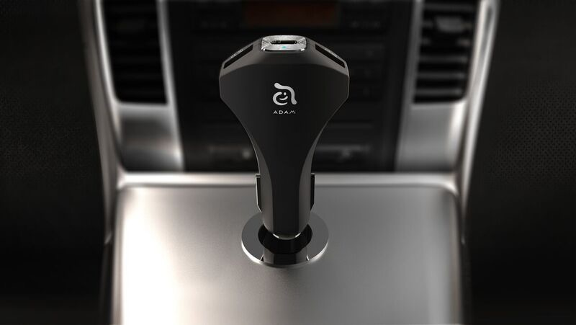
High quality car charger with USB-C and USB-A ports: CASA CO³
CASA CO³: All-in-one car charger with a sleek design
With the CASA CO³, ADAM elements makes sure that your devices never run low on battery. The intelligently designed car charger features a USB-C and two dual USB ports that enable users to charge mobile devices while driving. For those among you who are seldomly travelling with just one device, this means that neither your iPhone, iPad nor your MacBook will be left behind on the road – all can be charged simultaneously. Moreover, CASA CO³ is equipped with QuickCharge 3.0 technology, allowing it to charge each device up to 4 times faster than conventional car chargers. To prevent dangers such as overheating, shorting-circuits out or high currents, the CASA CO³ features multiple protective failsafe designs and high quality electronics. With its slick exterior made from a black polycarbonate blend, the car charger fits perfectly in any vehicle.
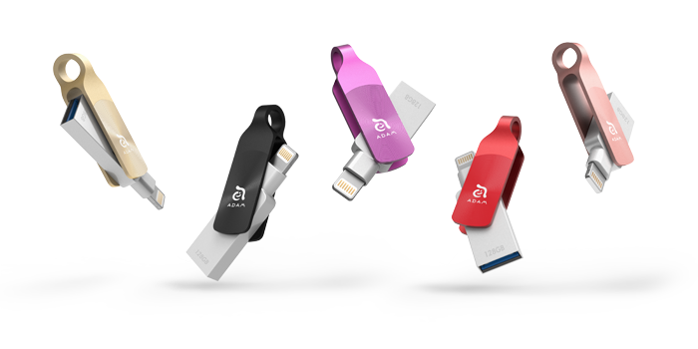
Lightning and USB combined in an elegant design: iKlips DUO+
iKlips DUO+: Advanced flash storage and file transfer solution for iOS devices
Many users frequently struggle with the storage limitations of their iPhone and iPad. The iKlips DUO+ thus makes for an ideal companion that not only extends the available storage on either iOS device by up to 128 GB, but thanks to its Lightning / USB-A dual interface also enables users to effortlessly move, copy and share data with their desktop computers. This way, they can take their entire HD movie collection with them on flights or record hours of 4K video without running out of memory space. The iKlips DUO+ is fully MFi-certified by Apple and thus adheres to strict performance and manufacturing standards. Thanks to its compact design, iKlips DUO+ is compatible with even the thickest iPhone cases. It comes in five different colours and three storage sizes – 32GB, 64GB and 128GB.

ADAM elements will be at DISTREE EMEA 2017 in the Discovery Area SU7.

About ADAM elements
ADAM elements is a leading supplier of intelligent lifestyle solutions. The Taiwan-based company develops mobile and information and communication products, including mobile devices, peripherals for smart devices, smart wearable products and smart lifestyle equipment. In order to perfectly complement this high-quality hardware, the company also develops software applications, allowing a seamless and complete user experience. ADAM elements is active in several Asian, European and South American markets, and is an authorised dealer for various smart mobile devices from international brands.
Press contact
Adam Elements Co., Ltd.
2f., No. 85, Sec. 3, Keelung Rd., Da’an Dist.
Taipei City 106, Taiwan (R.O.C.)
Glade Norman
Email: glade@adamelements.com

For more about ADAM elements products, please visit www.adamelements.com.

