Title: BOOKEEN is exhibiting at DISTREE EMEA Monaco - innovative e-Readers

Dear sir,

We are delighted to invite you to visit our stand #K9 during DISTREE EMEA exhibition that will take place february 6-9 in Monaco: http://www.distree-emea.com/

We would be happy to welcome you and introduce you our new e-Reader: The BOOKEEN SAGA

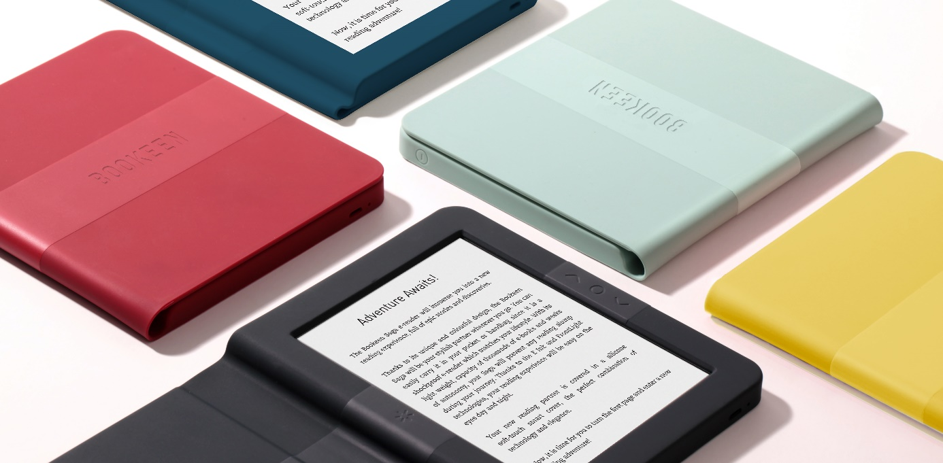

The BOOKEEN SAGA E-Reader has been awarded by the Janus price of Design 2017 from the French Design Institute and selected by the Design Observatory 2017

------------------------------------------

Adventure Awaits!

The Bookeen Saga e-reader will immerse you into a new reading experience, full of epic stories and discoveries.

Thanks to its unique and colourful design, the Bookeen Saga will be your stylish partner wherever you go. You can easily carry it in your pocket or handbag since it is a shockproof e-reader which matches your lifestyle. With its light weight, capacity of thousands of e-books and weeks of autonomy, your Saga will prevent any reading slump during your journey. Thanks to the E Ink and FrontLight technologies, your reading experience will be easy on the eyes day and night.

Your new reading partner is covered in a silicone soft-touch smart cover, the perfect combination of technology and elegance.

Now, it is time for you to turn the first page and enter a new reading adventure!

------------------------------------------

To arrange a meeting, feel free to contact us contact@bookeen.com

https://bookeen.com/pages/bookeen-saga
www.bookeen.com

