VIPER GAMING launches VIPER VP4100 M.2 2280 PCIe Gen4 x 4 SSD delivers the fastest transfer rates
Features Phison E16 series controller, PCIe® 4.0 with Hypersonic transfer speeds, heavy-tasking capabilities for enthusiastic acceptance.
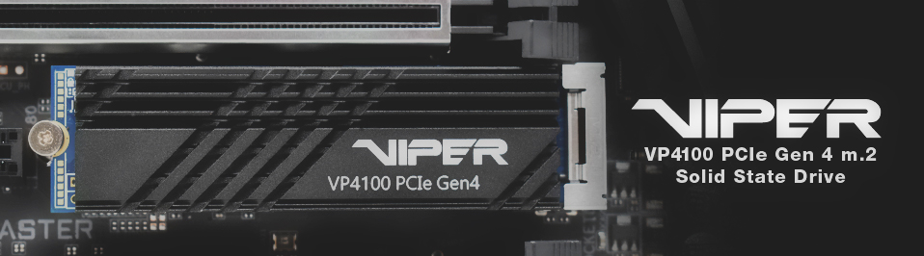
FREMONT, CALIFORNIA — Sep 10th, 2019 — VIPER GAMING, a trademarked brand of PATRIOT and a global leader in performance memory, solid-state drives (SSDs) and flash storage solutions, is releasing their new PCIe 4.0 SSD, the VIPER VP4100 M.2 2280 PCIe Gen4 x 4 SSD.

VP4100 M.2 2280 PCIe Gen4 x 4 SSD is an excellent M.2 SSD choices for hardcore gamers, PC enthusiasts, content creators, and video rendering professionals who are looking into blazingly fast startup times and instantaneous access for superior productivity. VIPER VP4100’s blazing transfer speeds empower the user to access and get back into their games faster while accelerating the overall responsiveness of the system. The VP4100 is ten times faster than the traditional SATA III SSD speeds and deliver remarkable sequential Read speeds of up to 5GB/s and Write speeds of up to 4.4GB/s. The drive also provides up to 800K random Read and Write IOPs for massive throughput. 4K Aligned random Read and Write optimizes the SSD for multi-threaded and data-intensive applications for when the system is accessing multiple applications at once.

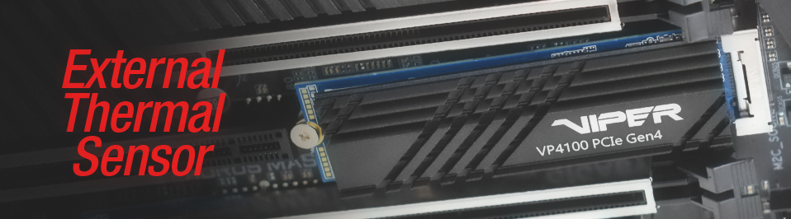
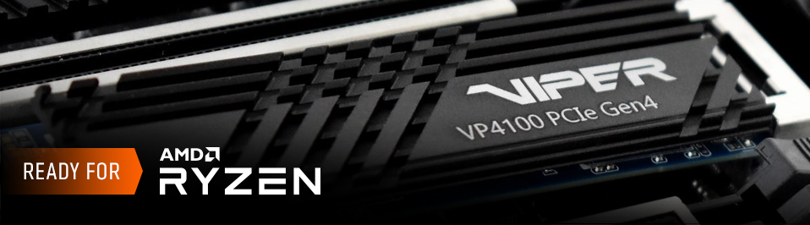“The PATRIOT VIPER VP4100 M.2 2280 PCIe Gen4 x 4 SSD has been designed to deliver unparalleled performance on the latest 3rd Gen AMD Ryzen™ Desktop Processors and X570 motherboards allowing PC enthusiasts and video creators to take full advantage of the Phison PCIe 4.0 controller and the 3rd Gen AMD Ryzen™ Desktop platform,” said Roger Shinmoto, the Vice President of PATRIOT and VIPER Gaming.

Traditional NVMe SSDs have a performance restriction to maintain a workable operating temperature which can limit read and write data transfer speeds. To address this issue, the VP4100 M.2 SSD has been designed with an External Thermal Sensor to monitor internal temperatures and prevent the risk of overheating. Aiming to decrease performance drops, VP4100 features a built-in military-grade aluminum heatshield for providing exceptional thermal dissipation under the heaviest of workloads. Designed with a durable aluminum, asymmetrical and tilted thermal fin aesthetic gives the VP4100 the striking edge to any build. Its slim and compact 3mm height fits perfectly in any PCIe slot, allowing more space for various connections. Backed by VIPER GAMING’s 5-year warranty, the VP4100 delivers one of the most reliable choices in high-performance class M.2 PCIe Gen4 x 4 SSDs available today.

Features Highlights
- Built with the latest Phison E16 PCIe Gen4 x 4 NVMe controller to unlock ultra-fast sequential Read and Write speeds.
- Compatible with the latest 3rd Gen AMD Ryzen™ Desktop Processors and X570 motherboards.
- Onboard thermal sensor to provide additional protection under intense workloads.
- Delivers the perfect combination of overall performance, ultra-fast transfer speeds, and enhanced multitasking capabilities.
- Built on a 10-layer PCB to guarantee excellent signal integrity for ultra-stability.

Pricing and Availability
PATRIOT VIPER VP4100 M.2 2280 PCIe Gen4 x 4 SSD is expected to be available at major retailers for a suggested retail price of $599.99 for 2TB, and $ 399.99 for 1TB.
For more product information:
- Product Page: Click here

Product Marketing Assets:
- Click here

About VIPER GAMING
VIPER GAMING is a trademarked brand of PATRIOT, a global leader in performance memory, SSD and flash storage solutions. VIPER GAMING was established in 2007 by unveiling their well-known line of computer memory which has since become synonymous with elite performance and reliability among gamers worldwide. In 2015, VIPER GAMING expanded its product categories to include gaming keyboards, headsets, and mice. Offering entry, mid-level and high-end solutions all with rich feature sets, VIPER GAMING award-winning peripherals provide gamers everywhere the best price-for-performance and reliability that enable gamers to dominate in their sport.

About PATRIOT
PATRIOT is a leading manufacturer of high performance, enthusiast memory modules, SSDs, flash storage, gaming peripherals, and mobile accessories. Founded in 1985 and headquartered in Fremont, CA, USA, PATRIOT is committed to technology innovation, customer satisfaction and providing the best price for performance on the market. PATRIOT products have become world renown for their extreme performance, reliability, and innovation. PATRIOT sells its products through original equipment manufacturers, retailers, e-tailers and distributors throughout the world with operations in North America, South America, Asia, and Europe. All company and/or product names may be trade names, trademarks and/or registered trademarks of the respective owners with which they are associated. Features, pricing, availability, and specifications are subject to change without notice.
Follow us
Facebook: https://www.facebook.com/vipergamingpatriot
Twitter: https://twitter.com/patriot_viper
Instagram: https://www.instagram.com/patriot_viper
YouTube: https://www.youtube.com/patriotviper

