Elegant Modularity: Aiptek unveils the future of the Pico Projector
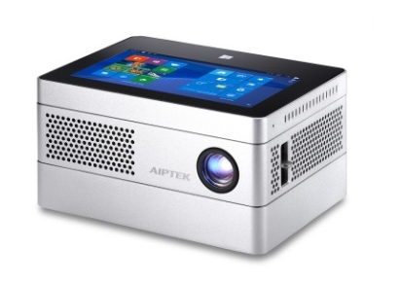
Global Aiptek Corporation, the world-leading Pico projector designer and manufacturer, will showcase its latest innovation at the DisTREE –iBeamBLOCK.
iBeamBLOCK represents the next generation, whilst ushering in the future design direction of the Pico Projector. The design concept is inspired by the iconic LEGO toy block. The device is an exemplar that delivers an intrepid blend of functionality and convenience for users.
“iBeamBLOCK is a creative convergence of three essential devices for the modern lifestyle” says Frank Sheu, CEO, Global Aiptek Corporation. “We’re delighted to fuse what was previously autonomous devices and execute the concept to produce a stylish and refined package that will surely excite both our business and consumer customers.”
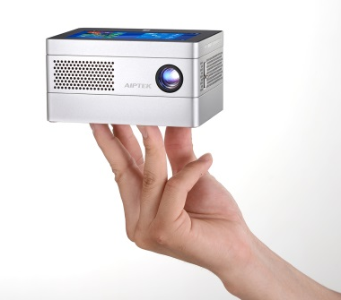
iBeamBLOCK is formed by stackable and configurable component ‘blocks’ that comprises of three layers – A Windows 10 tablet, DLP projector and a Power Bank. The exterior housing features a sleek and elegant metallic finish.
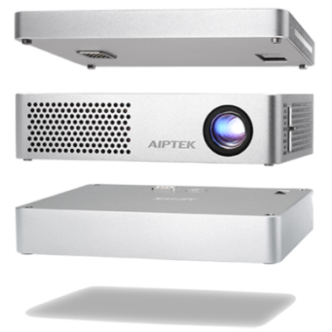
Headlined by the 4.5” multi-touch screen Windows 10 tablet built with IPS LCD technology, it provides crystal clear images and a smooth responsive navigational experience. Powered by Intel Z3735F Quad Core 1.33GHZ CPU, mobile apps for Windows 10 seamlessly delivers the capabilities of a mobile office and providing on-the-go productivity such as business presentations. A fully integrated suite of wireless and wired connectivity options such as Wi-Fi, Bluetooth, SD card slot and full size USB and micro USB ports maximises convenience for the user.
Positioned beneath the tablet, the powerful projector component block features RGB LED and DLP technology. Capable of displaying 400 sensual lumens of brightness at a native HD resolution of 1280 x 720P. With a short throw ratio of 1.2, the projected screen size can beam content up to 120 inches (305 cm) with bright, vivid, sharp and delivers precise colour tones for cinema quality familiarity. The projector is powerful as it is intuitive, a HDMI port and auto-keystone technology ensures a unified connection and a perfectly aligned image under all conditions.
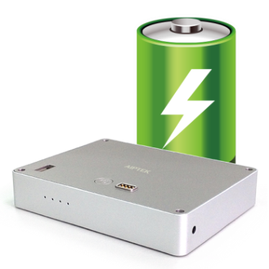
Underpinning the iBeamBLOCK is the formidable high capacity power bank component. A built-in 13,200 mAH (3.7V) rechargeable battery, supports two hours of continuous projection. The powerbank can also function as a charging source for mobile devices that feature a micro USB port.
Magnetic pogo pin connection technology allows for the perfect unison between the stackable component blocks. Users can customise their device by interchanging block components for a true DIY experience based on their requirements for a computing system, whether it is delivering a business presentation or watching the latest blockbuster movie.
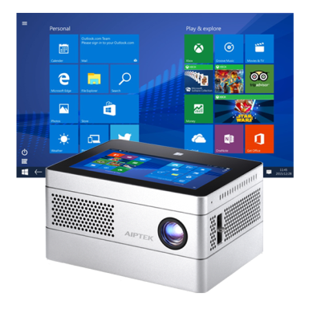
With dimensions of only 4.9 x 3.7 x 2.5 inches weighing at 1.87 lbs, iBeamBLOCK conveniently fits into a purpose designed carry case available for separate purchase, for on the go portability.
The future-proof driven design approach of iBeamBLOCK presents endless possibilities for users. Future plans to create an ecosystem featuring a spectrum of new component blocks with cutting edge technology that is designed to work harmoniously together, ensures the device continues to meet the needs and deliver a superior user experience for customers.
It will have an SRP of USD699 and will be available in the middle of Oct.

