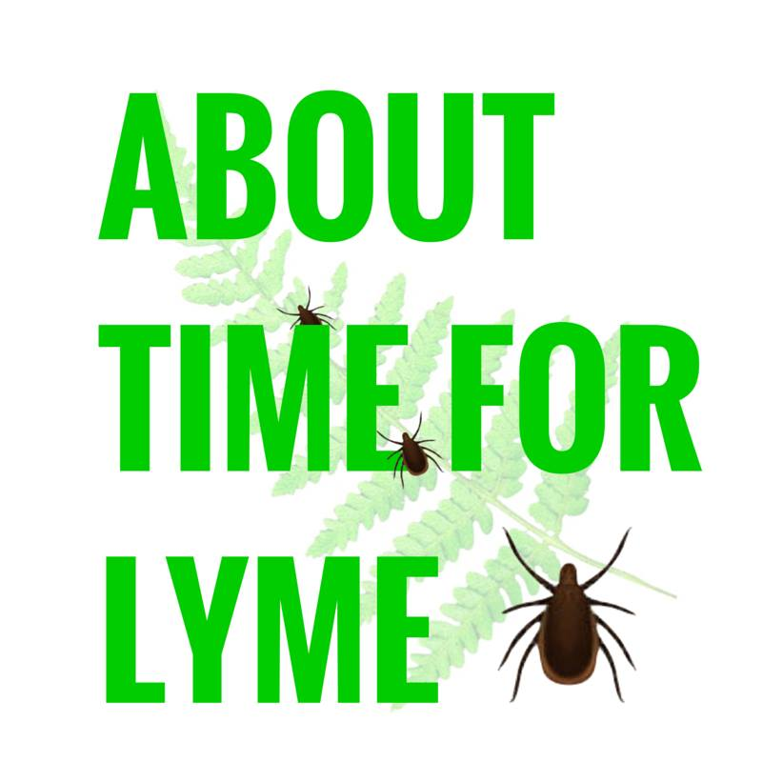

Statement for APPG Meeting 23/1/18

About Time for Lyme’s aim is to increase awareness and education of the growing problem of tick-borne diseases in the UK. We are based in The New Forest, but our work covers the whole of the UK.

In tackling the problem of Lyme disease, the challenge we all face is two-fold. On the one hand we must find a way forward for the many thousands of patients who are already affected, whilst on the other, we must come up with an effective plan for the many thousands that are likely to be affected in the future. About Time for Lyme’s focus is primarily on the latter. We do this by sharing vital information about ticks and the diseases they carry amongst the general public, with the aim of reducing the incidence of the disease through prevention or by encouraging early diagnosis and treatment. We are also, however, concerned with improving the understanding of tick-borne diseases amongst the medical community, and are proud to be working closely with the charity Vis a Vis Symposiums.

So why is it about time for Lyme?

In 1993, NATO held the Second European Symposium on Lyme Borreliosis in London, at which it was declared that Borrelia Burgdoferi was being found in ticks in locations across the UK, including in urban parks. The need to make the British public aware of the risk, as well as the significant issue of unreliable serology testing, were two of the main issues highlighted. Today, 25 years later, we are facing the same issues, only they are now more acute.

In 2015, The Big Tick Project confirmed the significant increase in the UK tick population in recent years. Ticks were found to be present all across the UK, increasingly so in urban areas, and were found on 1/3 of dogs examined.

However, despite the fact that ticks can now be found on the doorstep of practically every UK citizen, there remains a common misconception that Lyme disease is a rare problem and one generally confined to rural areas.

If you ask any patient who is experiencing the often-devastating effects of Lyme disease, they will express their deep regret that they did not know more about the problem beforehand. The average British citizen simply does not know how to protect themselves against ticks, what to do if they are bitten and what the potential warning signs of Lyme disease could be. The government’s failure to inform the British public of this risk to their health is resulting in many thousands falling ill each year.

Probably the most important factor contributing to us losing the battle against Lyme disease is delayed diagnosis or, more often, misdiagnosis. Awareness remains incredibly poor and serology tests remain unreliable, while doctors continue to rely solely on them due to the absence of any training offered to them by the NHS in the area of tick-borne diseases. Given these factors, the current Public Health England estimates of cases per year are likely to be a gross underestimation.

The recently drafted NICE guidelines have unfortunately failed to communicate the prevalence of the problem, as well as falling short in other key areas, such as testing and treatment. The conclusions have, for the most part, been drawn from a narrow and outdated pool of sources. The result is that doctors will not be able to appreciate the urgency of the situation.

Currently, both the general public and doctors are dramatically ill-equipped to face the increasing threat tick-borne diseases are posing to public health. Every year spent with doctors relying solely on serology testing will result in an unnecessarily high incidence of misdiagnosis. Therefore adequate provisions must be made to equip doctors to be able to implement clinical judgment where necessary.

More UK–specific research is also desperately needed. However, we must ensure that research is able to filter down into practice in a far more efficient manner than is currently the case.

There are clearly some specific areas that require attention and review as a matter of urgency. Perhaps equally important is the broader issue of taking control of the narrative surrounding Lyme disease. The absence of any government-led awareness initiatives has left the majority of the general public both ill informed and confused. We cannot allow debate about the areas of Lyme disease that we are still yet to fully understand, detract from the need to respond efficiently and effectively to this threat.

When the only information people are receiving about this issue comes from the media or word of mouth, they are more likely to be panicked by the situation than if the information had come from a reliable source on the matter. By delivering the basic information of how people can protect themselves and their families in a positive way, About Time for Lyme hope to leave people feeling empowered and more in control, rather than concerned. Our aim is to reach anyone and everyone whose activities take place outdoors and we hope to be able to do so through a range of channels.

We respectfully ask that this APPG help us reach a wider audience and push for greater awareness and educational initiatives at all levels, in order to help towards reducing the incidence and severity of tick-borne diseases.

We also ask that the key areas we have highlighted be addressed as a matter of urgency:
Training for doctors
Improvements in testing and treatment options
Research that filters into practice effectively

We would like to express our sincere gratitude to MPs and Peers for getting behind this issue and we very much look forward to working together with you. Thank you for listening.

