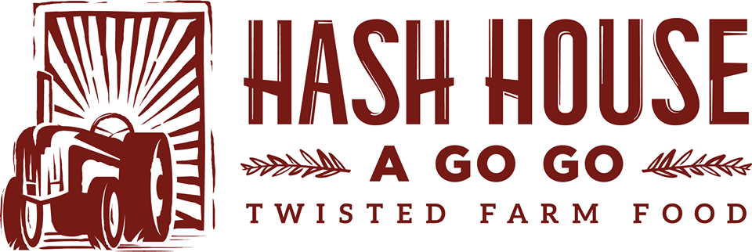
With

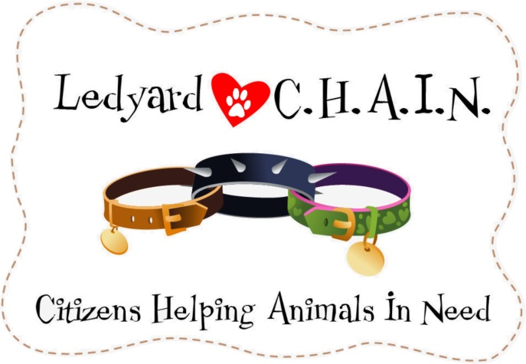

Come out on March 7th from 6pm-10pm to Hash House inside Mohegan Sun to benefit Ledyard C.H.A.I.N. and help raise money to replace the roof at the Ledyard Animal Control

Here’s how it works: bring this letter to Hash House a Go Go @ Mohegan Sun, and we will donate 20% of your sales receipt to “Ledyard C.H.A.I.N” to help benefit the Ledyard Animal Conrol

The more you spend, the more funds we can raise for this great cause. Come out in support of your community, enjoy the best food under the sun and lets raise the roof, together!

