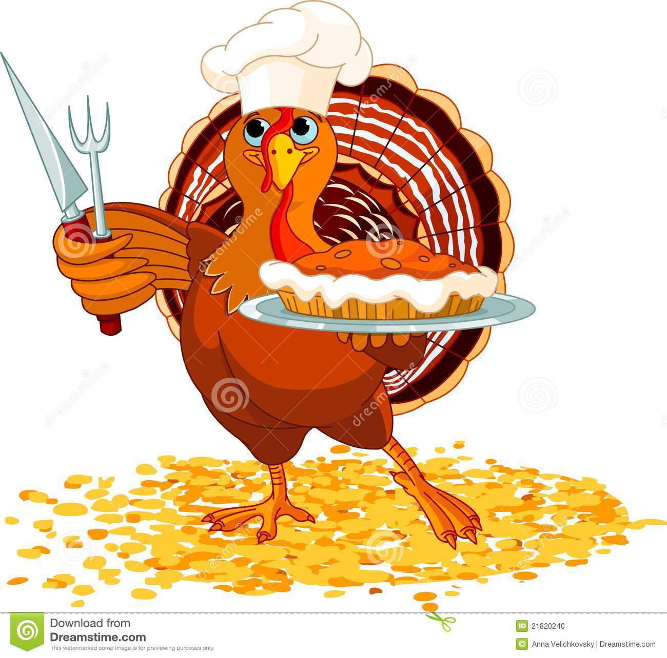
Apple pie $8
Pumpkin Pie $8

Pumpkin Roll $8

Homemade holiday desserts made by Southeast Tech culinary students!

*Will be sold with freezing and thawing instructions.*

Pick up Nov. 16th +17th

Name ____________________ Please turn in order form and money by Nov. 9th

Category | Description/Price | Qty | Total
Apple Pie | Whole Pie $8
Pumpkin Pie | Whole Pie $8
Pumpkin Roll | Whole Roll $8

