
Fundación Social Fénix
2018 Report

There have been unforeseen and interesting developments this year -- as well as graduations, university acceptances and academic and professional growth and progress: a greater commitment to language learning and, in career choices, a trend away from health towards education.
Several members determined that their major priority, academically and professionally, is gaining fluency in English, and went through all the daunting procedures to apply for passports and US visas, saved to buy tickets and, once in the United States, found rooms and jobs,
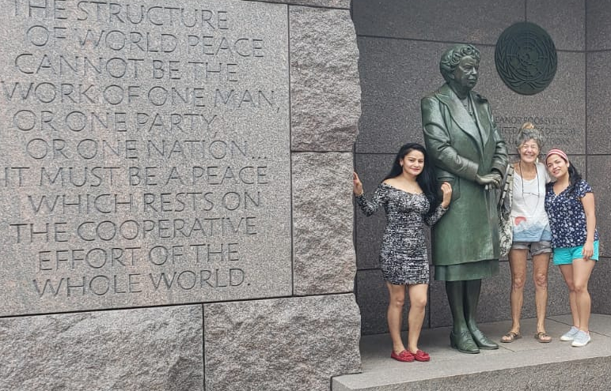
Lizeth and Eunise have been in New Jersey, working and taking English evening classes. A Fénix godmother, Tova Sola, gave them a memorable weekend tour of New York and Washington.
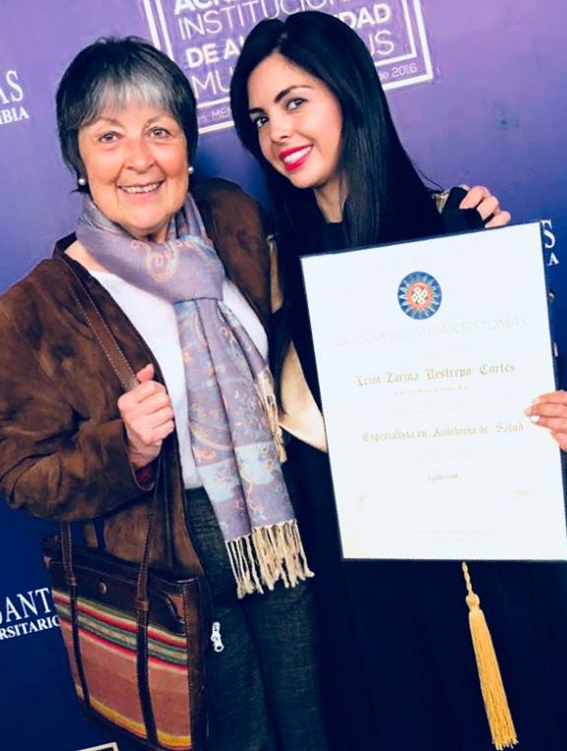
Zarina, who graduated at the beginning of the year from a postgraduate specialization in health care auditing, has gone to New York, where with her salary as an assistant dentist she can pay for an eight month English course in a community college to gain the language proficiency required for her next postgraduate qualification, and save towards setting up her own dental clinic on return to Bogotá.
Paola, a Social Worker with the Bogotá YMCA-ACJ programme for sexually exploited youth and at-risk children, went to a YMCA international women’s conference in Florida and then on to Los Angeles to stay with long-time Fénix participant Amy Ritterbusch, now a UCLA professor, and to explore UCLA possibilities for taking her master’s degree there.
All this has taken determination, autonomous decision-making, mature self-confidence and the courage to venture into the unknown.
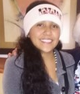
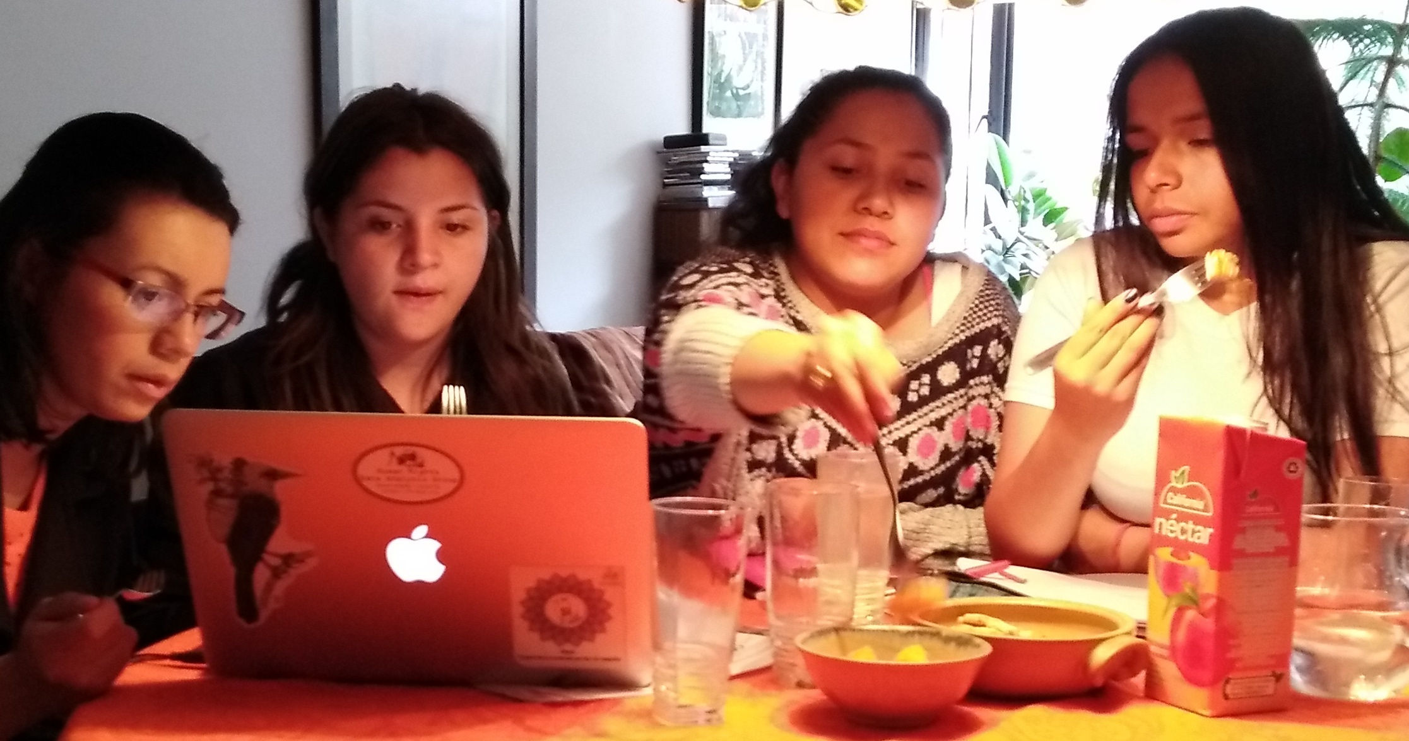
Others are making good progress in English with teacher Ezana at the Fénix Saturday classes, regularly attended by Angie (about to enter 11th grade, near the top of her class and planning on a career in teaching), and Indira (who has passed to 10th grade): “My vocabulary and pronunciation are steadily improving”. Iveth, Angélica and others sometimes have Saturday shifts in their jobs that make their participation less consistent, but they are advancing. English is a significant component of Colombian university entrance exams, while to graduate it is now obligatory to pass an international English exam such as IELTS or TOEFL, with a higher grade required for acceptance to postgraduate degrees.
Andres has provided invaluable tutoring in maths, a weak area for many girls, and Beatriz gives classes in text comprehension and essay writing, also areas where almost all need reinforcement.

On Saturdays psychotherapist Deyanire Sosa has worked with members on the stresses of growing up, their earlier traumas and current problems, and with other girls brought in by members for crisis support. We also had well-attended Saturday workshops on women’s rights, and on aptitudes and career choices.
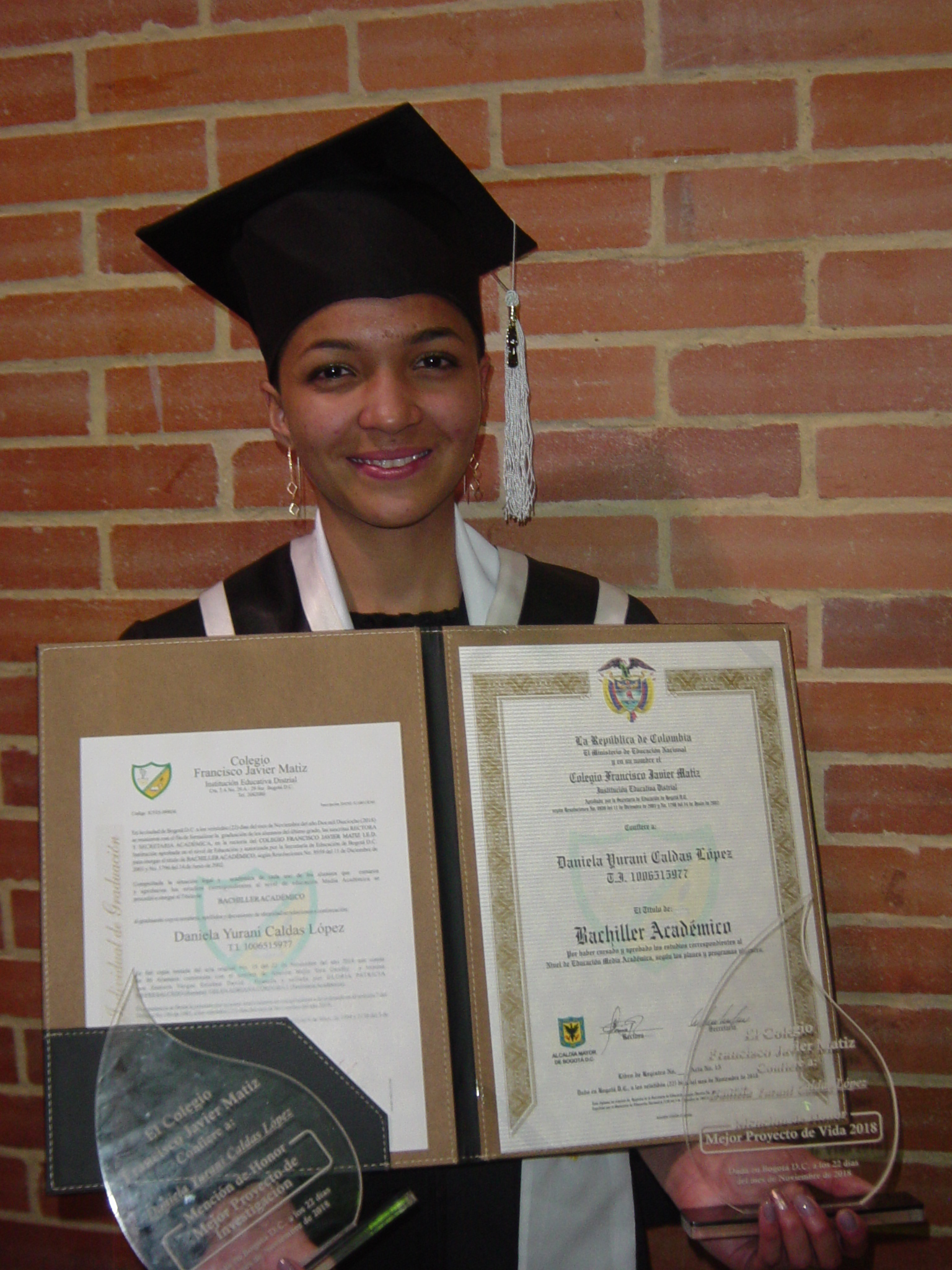
Daniela graduated from high school at the end of November, her grade point average boosted by a very high mark for English – in which she is now fluent after completing three semesters of intensive English classes on a scholarship at the Colombo-American Centre. Daniela has started to work evenings as a bilingual receptionist in an international restaurant, and has just been accepted for a day job in the bilingual call-centre of a multi-national company. She plans to keep both jobs through to mid-2019 so that she can afford to leave the protection of her foster-mother for the independence of her own room, and save towards the costs of a teaching degree. Fénix has some funds set aside to help her but may need to ask friends of Fénix for support in 2020.
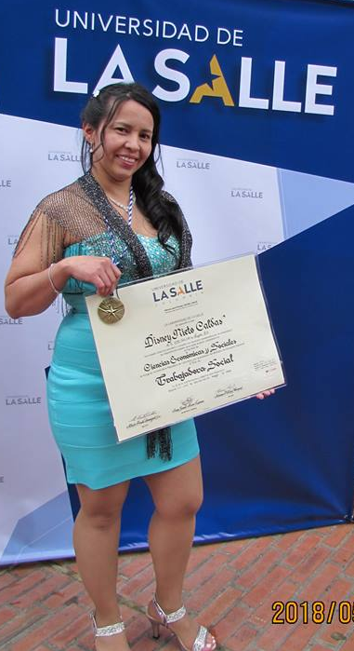
Her older sister Disney, who graduated as a Social Worker early in 2018, is working in the Fundación Procrear programme for high risk street people in problem areas of the city. She plans to start intensive English classes next year as a prerequisite for admission to a postgraduate specialization.
Many members who participated in Fénix’ pioneering programmes of street outreach and HIV/STI prevention, testing, treatment access and sexual and reproductive health rights gained the knowledge, experience and skills needed for full-time jobs in the programmes of other organizations, Paola with the YMCA-ACJ, Lady Johana with LigaSida, Disney with Procrear and Iveth with Idipron.
Angélica finished her contract with SOS Children´s Villages and has also joined Procrear’s project for HIV prevention with high risk populations, working in street brigades providing HIV testing and counseling, harm reduction with injection drug users and health care and risk reduction with people living with HIV. This experience has helped her decide on starting a social work degree in 2019.
She has been elected to the council of directors of Fénix, to replace Kilyam, whose demanding work as a staff nurse leading health programmes for indigenous communities in remote areas of the Amazon leaves her far out of contact for long periods of time.
Doctor Viviana received her Masters in Public Health at the beginning the year and continues managing a team responsible for organising patient procedures, tests and medications, and advising surgeons on patient qualifications for certain interventions.
Yenifer is a Nurse-Auditor with a major Bogotá hospital responsible for care quality; a highly competent professional who has to supervise and coordinate teams of specialists to ensure adequate and urgent treatment of dangerously ill patients. She plans next year to start language classes and a Masters in Medical Education, with a view to teaching (while also bringing up two lively daughters).
Fénix supported Oriana for a university entrance exam course and she has gained a place in the Universidad Pedagógica to start a degree in community education and human rights. Natalia has gained a place at the Universidad Libre to start a law degree.
Lady Johana also has been taking an intensive English course, will complete her higher education certificate in Human Resources in 2019 and return to a psychology degree course.
Sandra has applied the credits from her higher education certificate to a more advanced qualification in administration, and which could lead to a degree course.
Five years ago a volunteer with Fénix, Ashley Garcia returned from the US in June to present a paper from her PhD research at a conference in Bogotá and came to Fénix meet up with old friends.

Samantha Joeck, another former volunteer, whose experience of street work with Fénix led her into her masters’ research on harassment of women, was in Colombia for much of the second half of the year for her doctoral field-work – and members were very happy to renew contact with her – she will be back to complete her research in 2019.
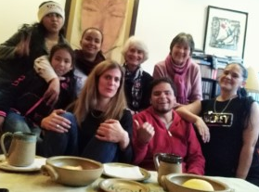
A very loyal and generous Fénix supporter, Heidi Riesen, came from Switzerland in September and with her daughter Sonia spent an afternoon with Fénix students.

Our great gratitude goes to the people and organizations, especially Heidi, Kate Seal, Regina Yando, Malcolm Deas, Carmenza Patiño, Martha Martinez, Lucia Moncada, Alex Raikes, Alan Riding, Brian Moser, Alison Wood and everyone at Children of Colombia. “Our thanks to every donor who helps us out of their own pockets to continue with our education and on the path to changing our lives positively, and so being able to do the same for other girls” (Angélica)

Warm regards,
Beatriz, Timothy and everyone in Fénix

