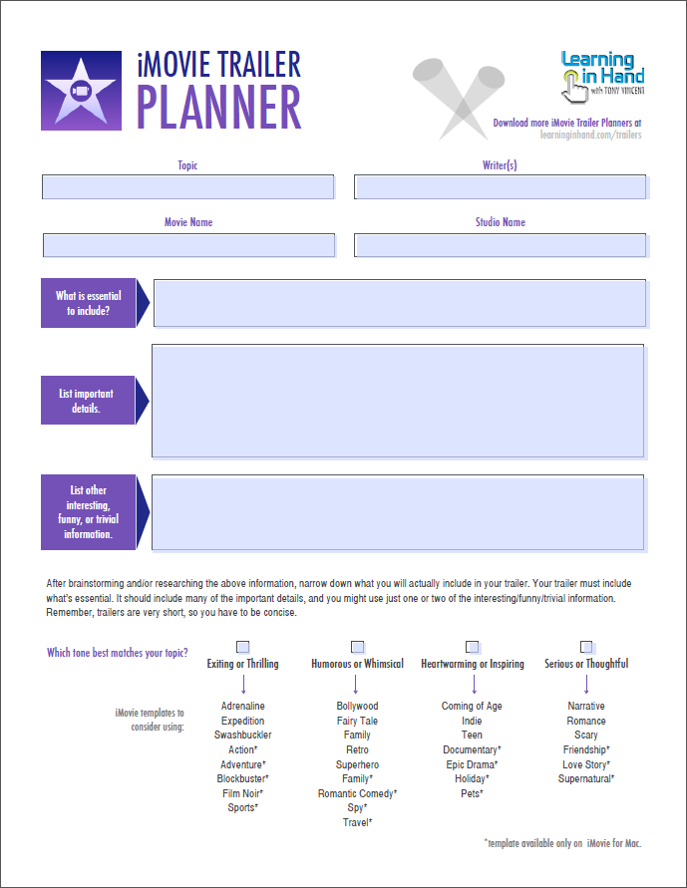
Group Members’ Names & Class Period

For some inspiration, check out the hundreds of collected film stills at http://film-grab.com/

For this assignment, you will design and pose a film still shot that reflects a Modernist, Harlem Renaissance, or women’s rights theme AND the struggles or lifestyle of a side or supporting character in The Great Gatsby. We see so much about the lives of Gatsby, Nick, Daisy, and Tom, but what about Pammy? Wolfsheim? Wilson? Others from the Valley of Ashes? What about that crazy Klipspringer?
Create a film still shot that uses camera angles and symbolism to show one of these characters’ lives.
Title of Film Still Shot

Side Character

Decide on a color scheme. Explain what and why here.

List & explain three symbolic items to include
Briefly describe the plot of your scene

List and explain the theme of your scene
Illustrate a draft of your scene here. Be descriptive and label everything, especially the symbols. Don’t forget: the camera shot angle is symbolic as well!

You will pose and take this picture during the next class period, so indicate who will bring what props and wear what clothing below:
Prop/Costume | Responsible Group Member
Explain the symbolism of each element you included:
Camera Shot Angle | Explanation of Symbolism
Setting Element | Explanation of Symbolism
Finally, put all of this information together in a polished presentation, and post it to each of your blogs.

