Revised Lesson Plan
Community-Word Project-Lesson Plan 2017-18

School/ Grade/CT: PS 316 Elijah Stroud. 1st Grade
Date: February 27th, 2018
Classroom Teachers: Ms. McKie & Ms. Zajmi,
Teaching Artist: Cayenne Douglass and Xiaolin Li

Theme of Lesson: Creating a Community Mural

Restating of Guiding Questions:

- How can students identify virtues and qualities for global citizenship and how can they bring them into their classroom and the community at large?

- How can students use creative writing, movement, sound, and visual art to explore the idea of narrative expression?

Opening Ritual (10:10 am- 10:15 am)
Objective: To focus and bring class energy to a space of open receptiveness and in doing so establish a type of “muscle-memory” that can be engaged each time we work together.
Activity: Song and Deep Breathing
Brief Description: Students will strengthen their “focusing muscles” and learn the difference between deep and shallow breathing. Also students will learn to be mindful and respectful to each other.
Breathing (3-part breath and mini guided meditation)
Song: “When I breathe in, I breathe in love, when I breathe out, I breathe out peace.”
Questions: Reflection: How did that make you feel?

Review and Introduction to Main (10:15-10:25)
Objective: To explain the activity of the main lesson to the class.
Activity: Review and Intro to the Main Activity.
Brief Description: We will introduce the activity, which is that we will be looking at how each child can use the qualities and characteristics of their animal friend to help create a community mural. We will review what community means as well as introduce and define “mural” We will have them read the definition out loud in unison and hand out color Xeroxes of murals in community spaces so that they can have a visual and linguistic understanding. We will then reintroduce Ananda Wood Houser: The animal friend the class helped to create together in lessons prior. This is a picture of it that Shawn drew in the moment. Every aspect was dictated by the children in the class in a popcorn style fashion.
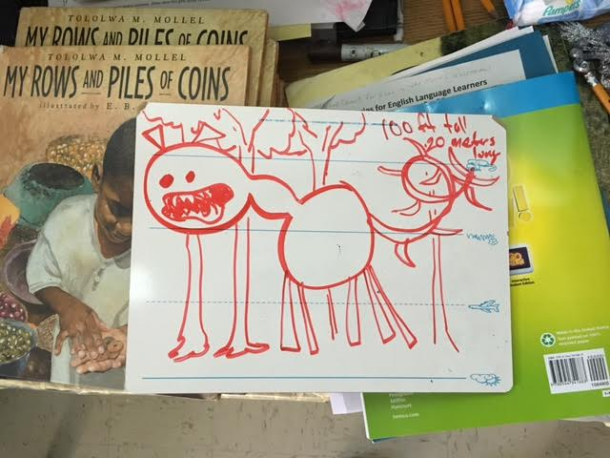

We would then ask each child how they can use the qualities and characteristics of their own animal friend, the one that they have created in their individual poems, to help Ananda Wood Houser serve the community. At this point we will reveal a larger version of Anada that Xiaolin will have pre-drawn on three big sheets of paper.

Main (10:25 am - 10:45 am)
Objective: To Create a Community Mural
Activity: The children will use the qualities and characteristics of their own animal friend to create a community mural both linguistically and artistically.
Brief Description: We will have the children create dialogue bubbles from the point of view of Ananda that state how each of their own animal friends help her serve the community. We will model what we want them to do. For example, if my animal is a blue unicorn named Nico-Pizza-Head. My bubble, from the POV of Ananda might say:

“Cayenne’s blue unicorn, Nico-Pizza-Head, helps me by collecting hay to help make beds for homeless people to lay in.”

At their desk they will have pre cut dialogue bubbles with fill in the blank sentences.
Once each child has completed their dialogue bubble they would be assigned a portion of the body to color in. Some kids will get the head and arms, some will get the belly, and others will get the butt, legs, and tail. We have broken up the art so that we can have three different tables going at once in hopes that we might better contain the class activity rather than having 15 children working on one drawing at once. We would be assisting then in filling out the bubbles as well as helping to glue them around Ananda. While the reflection is being conducted one of us will tape together the three panels so that that they can see the completed mural.
Reflection (10: 50am - 10: 58am)
Objective: To have them internalize the experience and ground their learning in a way that is personalized.
Activity Name: Reflection
Brief Description: How did it make you feel to create a community mural? Did you learn anything new about your character by doing this? What did you learn about your classmate’s animal friends? Why is it important to engage in community?

Closing Ritual: (10:58 am-11:00 am)
Objective: To acknowledge our work as a class and return to the rest of the day
Activity Name: “I Have a Voice”
Brief Description: “I have a voice. My voice is powerful. My voice can change the world” - The class will chant in unison using their normal voice, loud voice, and their animal’s voice. We will do one collective breath in, collective breath out to re-center the children and get them prepared for their next class.

Multiple Intelligences Addressed:
Logical-mathematical; Spatial; Linguistic; Bodily-kinesthetic; Interpersonal;
Intrapersonal; Naturalistic; Existential

Classroom Teacher Role: Principal role is to manage student behavior and model
existing classroom management. Participate in closing ritual, and if possible, opening
ritual as well.

Creative Elements (skill and theme; i.e. ensemble and love) mindfulness, qualities,
virtues
Skill(s): Dialogue Writing, Character Rendering, Storytelling, Empathy Building.
Theme(s): Global Citizenship, Community Building, Being of Service, Having an Impact, Learning that qualities of character can translate into meaningful action.
Artists/ Authors/ Works of Art (to be presented as models for skills/themes identified
above): The artists being featured in this lesson are Shawn, Xiaolin, and their own art. We will make sure that the artists whose murals we present as example are cited at well.
Outcomes
Highlight each outcome that applies to this lesson. Provide one indication of how you
are addressing each outcome.

Literacy, Critical Thinking, Creative Thinking, Emotional Intelligence, Citizenship

Indications:
Students will exhibit an ability to make purposeful word choices in their dialogue bubble.
Students will exhibit an ability to perceive themselves as creative beings.
Students will exhibit an ability to apply what they learn to their lives.
Students will translate how qualities and characteristics can be used in different circumstances.
Students will have a better understanding of global citizenship.
Students will appreciate and respect the artistic work of others and artistic collaboration.
Students will have a more invested interest in their surrounding world.
Students will think deeper about the person that they want to become and what their potential impact can be.
Students will make powerful statements about themselves and their surroundings
and experiences and take lessons beyond the classroom.
Students will demonstrate an expanded ability to articulate emotions in their work.

Here’s a picture of what the final product actually looked like. As you can see it went very much according to plan!

