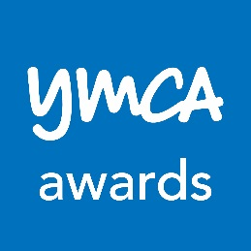

YMCA Level 2 Mandatory Units Assessment Workbook

Assessment workbook
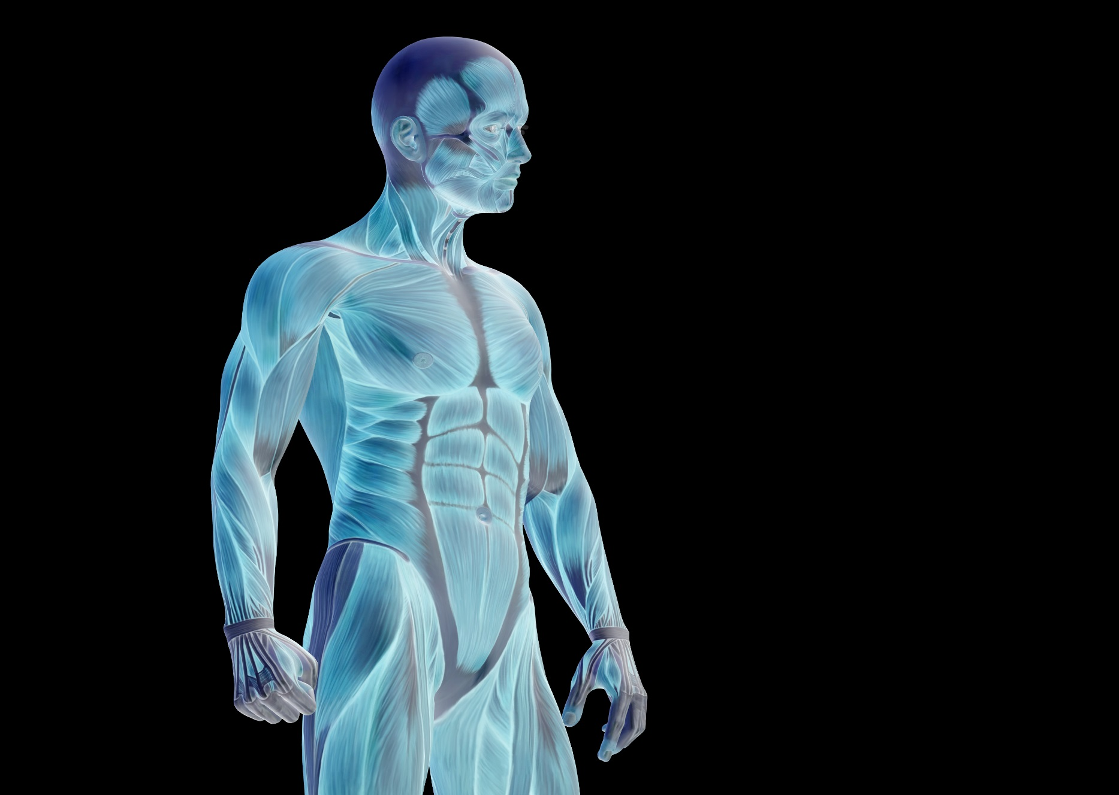

YMCA Awards

112 Great Russell Street
London
WC1B 3NQ

020 7343 1800

www.ymcaawards.co.uk

Level 2 Mandatory Units Assessment Workbook

Assessment workbook
Copyright © YMCA Awards 2017
The content of this document remains the intellectual property of, and is copyright to London Central YMCA (Trading as YMCA Awards). No part of these materials may be reproduced, stored, copied, edited or distributed in any form or by any means including photocopying, publishing, recording or by any other electronic or mechanical methods, without the explicit written permission of YMCA Awards. YMCA Awards reserves the right to seek legal remedies for any such infringement.

Contents

Introduction 6
Workbook 1: Health, Safety and Welfare in a Fitness Environment 7
Workbook 2: Know How to Support Clients who take part in Exercise and Physical Activity 13

Introduction

You will need to complete this Assessment Workbook as part of your Level 2/Level 3 YMCA qualification.

There are two sections to this assessment workbook:
- Workbook 1 - Health, Safety and Welfare in a Fitness Environment
- Workbook 2 - Know How to Support Clients Who Take Part in Exercise and Physical Activity

All questions must be answered correctly. The work must be your own and group completion is not allowed. This is an open book assessment and the questions refer to the content covered during your course. Information to aid completion will be delivered on course or via elearning.

The assessment workbook is available in the following formats:
- Paper-based document (download and print)
- eAssessment workbook (auto-marking) via Moodle.

Workbook 1: Health, Safety and Welfare in a Fitness Environment

You need to answer every question in this section correctly to pass.

Assessor’s key: √ = correct X = incorrect

Q1. Identify which of the following statements relating to emergencies and correct procedures in a fitness environment are ‘true’ or false’. | True/False
In the event of a bone fracture, the most appropriate emergency procedure would be to call 999 Ambulance service. | Choose an item.
In the event of a chemical leak, the most appropriate emergency procedure would be to carry out CPR procedures. | Choose an item.
In the event of a fire in the plant room, the most appropriate emergency procedure would be to call 999 Fire and Rescue and evacuate the building. | Choose an item.
In the event of a terrorist threat, the most appropriate emergency procedure would be to call 999 Police and evacuate the building. | Choose an item.
In the event of a cardiac arrest, the most appropriate emergency procedure would be to call 999 Police. | Choose an item.
Assessor only: | Choose an item.

Q2. Select the individual responsible for: (Choose one)
Responding to injuries and illness of staff and participants
Communicating with ambulance crews
Maintaining first aid and accident records
Instructor ☐
First Aider☐
Fire Marshall☐
Lifeguard☐
General Manager☐
Assessor only: | Choose an item.

Q3. Select the individual responsible for: (Choose one)
Marshalling staff and participants out of the premises safely
Checking everyone has arrived at the emergency evacuation point
Instructor☐
First Aider☐
Fire Marshall☐
Lifeguard☐
General Manager☐
Assessor only: | Choose an item.

Q4. Select the individual responsible for: (Choose one)

Observing participant safety within a pool environment
Taking action to rescue those in difficulty and administer CPR
Carrying out and recording pool water testing
Instructor☐
First Aider☐
Fire Marshall☐
Lifeguard☐
General Manager☐
Assessor only: | Choose an item.

Q5. Select the individual with overall responsibility for the health, safety and welfare of staff and participants by: (Choose one)

providing training
complying with requirements under the Health and Safety at Work Act
carrying out and recording risk assessment activities
Instructor☐
First Aider☐
Fire Marshall☐
Lifeguard☐
General Manager☐
Assessor only: | Choose an item.

Q6. Select three statements which best describe how to maintain the safety and provide duty of care to children, older people and disabled people. | Tick three
Carry out disclosure checks on fitness professionals and support staff | ☐
Provide a crèche for babies and young children | ☐
Reject participants with individual needs | ☐
Provide ground floor facilities or lifts to upper floors | ☐
Provide exercise sessions specifically targeted at different groups of people | ☐
Provide the same products and services despite individual needs | ☐
Assessor only: | Choose an item.

Q7. Identify one statement which best describes the importance of health and safety in a fitness environment. | Tick one
To stop participants making personal injury claims | ☐
To keep participants safe by minimising risk | ☐
Make sure participants arrive safely | ☐
Providing café facilities | ☐
Assessor only: | Choose an item.

Q8. Match the statement to the correct legislation. |  | Tick one
Ensure a safe environment is provided for staff, participants and visitors, which is free from anything which could cause harm, or cause risk to health or life.
Health and Safety at Work Act |  | ☐
RIDDOR (Report of Injuries, Diseases and Dangerous Occurrences) |  | ☐
COSHH (Control of Substances Hazardous to Health) |  | ☐
DDA (Disability Discrimination Act) |  | ☐
Assessor only: |  | Choose an item.
Q9. Match the statement to the correct legislation. | Tick one
The control of substances hazardous to health and prevent or reduce staff, participants’ and visitors’ exposure to hazardous substances.
Health and Safety at Work Act | ☐
RIDDOR (Report of Injuries, Diseases and Dangerous Occurrences) | ☐
COSHH (Control of Substances Hazardous to Health) | ☐
DDA (Disability Discrimination Act) | ☐
Assessor only: | Choose an item.

Q10. Match the statement to the correct legislation. | Tick one
Requires employers and other people in control of work premises to report and keep records of work-related incidents which cause death, serious injuries, industrial diseases and dangerous occurrences with the potential to cause harm.
Health and Safety at Work Act | ☐
RIDDOR (Report of Injuries, Diseases and Dangerous Occurrences) | ☐
COSHH (Control of Substances Hazardous to Health) | ☐
DDA (Disability Discrimination Act) | ☐
Assessor only: | Choose an item.

Q11. Match the statement to the correct legislation. | Tick one
Take action to make sure the organisation does not discriminate against staff or participants with physical disabilities in connection with employment, the provision of goods, facilities and services.
Health and Safety at Work Act | ☐
RIDDOR (Report of Injuries, Diseases and Dangerous Occurrences) | ☐
COSHH (Control of Substances Hazardous to Health) | ☐
DDA (Disability Discrimination Act) | ☐
Assessor only: | Choose an item.

Q12. Identify which of the following statements are ‘true’ or ‘false’. | True/False
All fitness organisations must have CCTV installed. | Choose an item.
All fitness organisations must make sure staff, participants, visitors, premises and equipment are secure. | Choose an item.
It is a legal requirement for staff working directly with vulnerable groups such as children, older people and disabled people to have full disclosure checks. | Choose an item.
There is no legal requirement to protect the security of personal information held about staff and participants. | Choose an item.
It is highly recommended that fitness organisations monitor who is entering and leaving the premises. | Choose an item.
Assessor only: | Choose an item.

Q13. Match the following possible hazards to the most relevant control area. | Choose one answer for each possible hazard.
Heating system failure | Facilities ☐  Client behaviour ☐ Equipment ☐  Lifting and handling ☐ Hygiene ☐  Security ☐
Application of an incorrect fitness technique | Facilities ☐  Client behaviour ☐ Equipment ☐  Lifting and handling ☐ Hygiene ☐  Security ☐
Faulty fitness equipment | Facilities ☐  Client behaviour ☐ Equipment ☐  Lifting and handling☐ Hygiene ☐  Security ☐
Water spillage on the studio floor | Facilities ☐  Client behaviour ☐ Equipment ☐  Lifting and handling ☐ Hygiene ☐  Security ☐
Assessor only: | Choose an item.

Q14. Match the following possible hazards to the most relevant control area. | Choose one answer for each possible hazard.
Using an office chair to reach items on a high shelf | Facilities ☐  Client behaviour ☐ Equipment ☐  Lifting and handling ☐Hygiene ☐  Security ☐
Changing the layout of the fitness suite on your own | Facilities ☐  Client behaviour ☐  Equipment ☐  Lifting and handling ☐Hygiene ☐  Security ☐
Not wiping down cardio equipment after a sweaty session | Facilities ☐  Client behaviour ☐ Equipment ☐  Lifting and handling ☐ Hygiene ☐  Security ☐
Staff that have been vetted and concerns around historical convictions are identified. | Facilities ☐  Client behaviour ☐ Equipment ☐  Lifting and handling ☐ Hygiene ☐  Security ☐
Assessor only: | Choose an item.

Q15. Identify four ways to control risks associated with hazards in a fitness environment. | Tick four
Carry out equipment checks before participant arrival | ☐
Identify potential hazards and take no action | ☐
Check that emergency exits are unlocked and free from obstruction | ☐
Carry out participant induction into the safe use of equipment and associated techniques | ☐
Routine and systematic cleaning schedule for all operational and staff areas | ☐
Have the belief that health and safety risk assessment and removing risk is not your responsibility | ☐
Assessor only: | Choose an item.

Q16. For each of these statements, identify whether they relate to a ‘child’ or ‘vulnerable adult’. | Choose one answer for each statement
Under the age of 18 | Child ☐  Vulnerable adult ☐
Over the age of 18 and is or may be in the need of community care such as mental or other disabilities. | Child ☐  Vulnerable adult ☐
Assessor only: | Choose an item.

Q17. Select two statements which accurately describes the key responsibility of a fitness instructor in regard to ‘safeguarding’ | Tick two
Guarding money in a safe | ☐
Meeting the needs of all children and adults who may be vulnerable or at risk of abuse | ☐
Keeping children and vulnerable adults inside the building | ☐
Ensuring you are aware of and follow the organisation’s safeguarding policies and procedures | ☐
Assessor only: | Choose an item.

Q18. Identify which of the following statements are ‘true’ or false’. | True/False
A sign of physical abuse could be unexplained bruising. | Choose an item.
A sign of emotional abuse could be depression. | Choose an item.
A sign of neglect could be sexually explicit behaviour or language. | Choose an item.
A sign of sexual abuse could be an individual being undernourished or obese. | Choose an item.
A sign of bullying could be insecurity. | Choose an item.
Assessor only: | Choose an item.

Q19. Identify which of the following statements are ‘true’ or false’. | True/False
If the abused asks you not to tell others about the abuse, you must keep this information to yourself and not take any action. | Choose an item.
You must directly confront the alleged abuser, parent or carer. | Choose an item.
Behaviour and conduct of fitness instructors towards children and vulnerable adults must be professional and safe. Instructors should not put themselves in a position where accusations of abuse may be made against them. | Choose an item.
It is important to work in an open environment so you are not alone with vulnerable individuals. | Choose an item.
You can take photographs or videos of children without the consent of their parent or carer. | Choose an item.
It is not up to the instructor to judge whether a person is being abused but it is their responsibility to report to the appropriate statutory authority. | Choose an item.
Assessor only: | Choose an item.

Workbook 1 result: | Pass / Refer / Re-submit (please circle)
Assessor feedback:
Click here to enter text.

Learner’s signature: | Click here to enter text. | Date: | Click here to enter a date.
Assessor’s signature: | Click here to enter text. | Date: | Click here to enter a date.
IQA’s signature: | Click here to enter text. | Date: | Click here to enter a date.

Workbook 2: Know How to Support Clients who take part in Exercise and Physical Activity

You need to answer every question in this section correctly to pass.

Assessor’s key: √ = correct X = incorrect

Q1. Identify three ways of forming effective working relationships with clients. | Tick three
Plan training which meets the individual needs of the client. | ☐
Show professional conduct at all times. | ☐
Engage in inappropriate conversations with clients. | ☐
Communicate clearly and effectively using verbal and non-verbal communication skills. | ☐
Avoid eye contact when talking to them. | ☐
Assessor only: | Choose an item.

Q2. Identify whether these statements about communication skills are ‘true’ or ‘false’. | True/False
Using open questions is an example of non-verbal communication skills. | Choose an item.
Maintaining eye contact is an example of a non-verbal communication skills. | Choose an item.
Active listening is an example of a verbal communication skill. | Choose an item.
Using correct pitch, tone of voice and language is an example of verbal communication. | Choose an item.
Assessor only: | Choose an item.

Q3. Identify two examples of the importance of valuing equality and diversity when working with clients: | Tick two
To discriminate against an individual. | ☐
To segregate individuals based on gender. | ☐
To recognise and appreciate difference. | ☐
To identify and overcome barriers which might prevent some groups of people from participating in physical activities. | ☐
Assessor only: | Choose an item.

Q4. Barriers to exercise and fitness can be broken down into five key areas. Match each of the examples below with one of these areas. |  | Type one answer for each barrier
Barrier | Key areas
Health | Physical Emotional Availability Time Motivational | Click here to enter text.
Being self-conscious | Physical Emotional Availability Time Motivational | Click here to enter text.
Fitness facilities | Physical Emotional Availability Time Motivational | Click here to enter text.
Family commitments | Physical Emotional Availability Time Motivational | Click here to enter text.
Boredom | Physical Emotional Availability Time Motivational | Click here to enter text.
Work commitments | Physical Emotional Availability Time Motivational | Click here to enter text.
Assessor only: |  | Choose an item.

Q5. Identify two examples of how incorporating client preferences in exercise/physical activity programmes can strengthen motivation and adherence. | Tick two
Exercise/physical activity will be more engaging and enjoyable. | ☐
Clients will look elsewhere for exercise/physical activity programmes. | ☐
Client is more likely to book additional sessions. | ☐
Clients will be less motivated to continue working towards their goals. | ☐
Assessor only: | Choose an item.

Q6. For each of these examples of incentives and rewards, identify which ones are an ‘incentive’ and which ones are a ‘reward’.
Praise | Choose an item.
Health benefits | Choose an item.
Prizes for achieving goals | Choose an item.
Holiday | Choose an item.
Review of progress | Choose an item.
Free session/fitness class | Choose an item.
Assessor only: | Choose an item.

Q7. Identify three strategies which can help clients overcome barriers to exercise. | Tick three
Incorporating physical activity into daily routines | ☐
Go it alone | ☐
Setting short term SMART goals | ☐
Establish unrealistic expectations | ☐
Rely on others to overcome barriers | ☐
Varying teaching approach | ☐
Assessor only: | Choose an item.

Q8. From the statements below, identify strategies that can positively influence behaviour change. Answer true or false. | True/False
Improving physical activity habits | Choose an item.
Be accountable for actions | Choose an item.
Self-management strategies | Choose an item.
Setting goals that motivate | Choose an item.
Be forceful and aggressive | Choose an item.
Increase intensity of physical activity | Choose an item.
Learn from relapses | Choose an item.
Assessor only: | Choose an item.

Q9. From the statements below, identify two examples that explain the importance of setting specific and measurable goals with clients. | Tick two
For the client to forget about where they started. | ☐
For the trainer to compare the client against others. | ☐
For the client to compare their start point to where they are now so that they can see progress. | ☐
To encourage the client to overcome barriers to exercise. | ☐
Assessor only: | Choose an item.

Q10. Identify which of the following objectives for client care are important to the ‘client’ and which are important to the ‘organisation’. (circle the correct answer for each statement)
Satisfaction leads to loyalty and increased spending | Choose an item.
Encourages referrals to a facility by word of mouth | Choose an item.
It is cheaper and easier to retain customers than acquire new ones | Choose an item.
The need to feel valued and respected | Choose an item.
Service meets or exceeds needs and expectations | Choose an item.
Duty of care | Choose an item.
Assessor only: | Choose an item.

Q11. Identify which of the following statements relating to information sources are true and which are false. | True/False
‘The internet is a reliable source of information to meet client needs regarding health and wellbeing.’ | Choose an item.
‘Client profile/lifestyle records are helpful for developing a fitness programme that meets client needs.’ | Choose an item.
Assessor only: | Choose an item.

Q12. Fill in the blank in the sentence below.  To exceed a client’s expectation, it is the little things that go a long way. Offer advice, support and assistance above and beyond what the client is expecting but remember, it is always best to under promise and over ____________. | Tick one
deliver | ☐
compensate | ☐
promise | ☐
do it | ☐
Assessor only: | Choose an item.

Q13. Identify true or false for the following scenarios regarding organisational procedures. | True/False
You are delayed in meeting a client. The appropriate organisational procedure would be to not attend the meeting and wait for the client to call you to book another appointment. | Choose an item.
Gym equipment is out of order. The correct organisational procedure would be to report the fault, and advise the client about other equipment which will work the same muscles. | Choose an item.
There is no water in the water fountain. The correct organisational procedure would be to direct the client to other sources of drinking water or provide bottled water. | Choose an item.
Assessor only: | Choose an item.

Workbook 2 result: | Pass ☐/ Refer ☐ / Re-submit ☐ (please select one)
Assessor feedback:
Click here to enter text.

Learner’s signature: | Click here to enter text. | Date: | Click here to enter a date.
Assessor’s signature: | Click here to enter text. | Date: | Click here to enter a date.
IQA’s signature: | Click here to enter text. | Date: | Click here to enter a date.

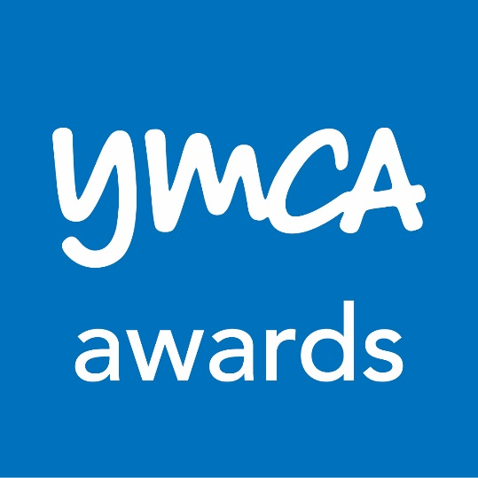

YMCA Awards is one of the UK’s leading health, fitness and wellbeing specific awarding organisations. It offers training centres and learners across the world a diverse suite of qualifications, from introductory (Level 1) to advanced levels (Level 4).
YMCA Awards issues over 30,500 qualification certificates a year, helping learners in the UK and overseas to launch and progress their careers in the active leisure sector.
To view YMCA Awards’ full range of qualifications please visit www.ymcaawards.co.uk.

www.ymcaawards.co.uk
awarding excellence
112 Great Russell Street, London, WC1B 3NQ | T +44 (0)20 7343 1800 | F +44 (0)84 3221 1549 |
E awards.info@ymca.co.uk | W ymcaawards.co.uk
Registered charity no. 213121 | Registered in England & Wales no. 119249

