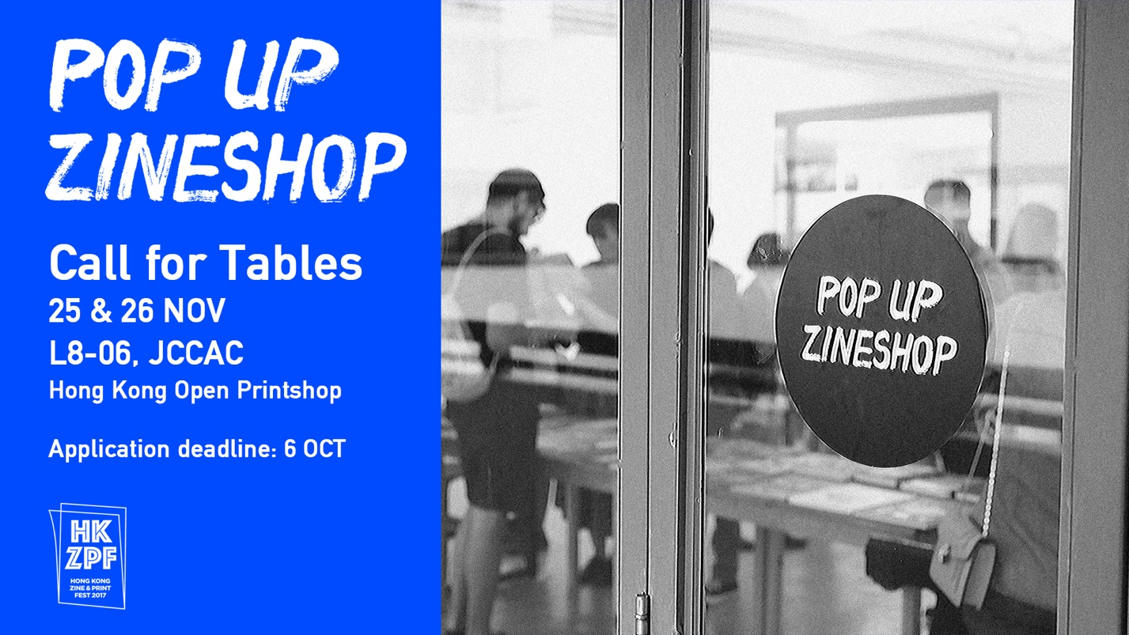

喂！擺檔喇！

喺香港Zine & Print Fest 2017期間，我哋會將香港版畫工作室嘅The Print Lab及 L8-06 Gallery 變身成Pop Up Zineshop！誠邀各地Zinester 嚟擺檔一邊交流一邊賣zine & print！費用全免！
日期：2017年11月25及26日（星期六及日）
時間：下午1－7時
地點：香港版畫工作室 The Print Lab 及 L806 Gallery
費用：全免，亦不會收取任何佣金。歡迎捐款支持是次活動
空間尺寸：約1米×1米，位置隨機分配

攤檔及作品類型
－ 攤檔所有作品必須為原創之獨立出版或印刷品（Zine & Print）
－ 香港版畫工作室會以攤檔作品之獨特性、內容、數量等作為選擇準則

申請程序
填妥報名表格，並於香港時間2017年10月6日或以前電郵至：hkzpf2017@open-printshop.org.hk
註明：[HKZPF攤位申請]

申請確認
主辨單位將於10月13日或之前以電郵通知成功申請單位 。

條款及細則
－ 參加者必須閱讀、明白並同意遵守香港Zine & Print Fest 2017的所有條款。
－ 參加者一旦遞交申請，則視為同意有關條款，而香港版畫工作室保留最後修改權利。
－ 參加者必須 2天全數出席並不得轉讓。
－ 香港版畫工作室將隨機分配1個位置予每位成功申請者或機構。
－ 參加者擁有攤檔之作品的知識產權及所有版權。
－ 參加者須同意授權予香港版畫工作室使用其作品作展覽、宣傳、推廣、教育研究及出版之用。
－ 所有保險及寄出作品之費用均由參加者支付。香港版畫工作室將不會對任何意外損壞或遺失，包括盜竊及火損等負責。
－ 主辦單位有權即時取消違規者及缺席者之攤位資格。

查詢及聯絡
電話：23191660
電郵：hkzpf2017@open-printshop.org.hk

Hong Kong Zine & Print Fest 2017 – Pop Up Zineshop

Call for tables / Zinesters Wanted!

We are turning The Print Lab & L8-06 Gallery of Hong Kong Open Printshop into a Pop Up Zineshop during Hong Kong Zine & Print Fest 2017! Come and set your own stall at the amazing printmaking studio for FREE! Worldwide Zinesters are all welcomed.

Date: 25 & 26th November, 2017 (SAT & SUN)
Time: 1 – 7 PM
Venue: The Print Lab & L8-06 Gallery, Hong Kong Open Printshop
Fee: No rental or commission charge!
Donation to support the exciting event is more than welcome.
Size of table: Around 1M×1M, will be randomly assigned

TABLES & ARTWORK
- All artworks must be original printed zine or print
- Hong Kong Open Printshop will select the tables under the consideration of its uniqueness, content and quantity etc.

APPLICATION PROCEDURE
Please complete the application form and email to hkzpf2017@open-printshop.org.hk on or before 6th Oct 2017,
Subject: [HKZPF call for table]

CONFIRMATION
A confirmation email will be sent to successful applicants by 13 Oct 2017.

TERMS AND CONDITIONS
- Applicants should read and understand and agree to be bound by the HKZFP2017 rules. Submission of application implies the acceptance of all current and future conditions and provisions made by Hong Kong Open Printshop.
- Applicants must attend 2 days’ event and must not transfer the table to others.
- Only 1 table will be offered to each successful applicant.
- Applicants hold the intellectual property rights for all imagery contained in the submitted work.
- Submission of application also authorizes Hong Kong Open Printshop to use/display works submitted in forthcoming exhibitions or to illustrate promotional, educational and research publications.
- All insurance costs and shipping expenses incurred during delivery shall be borne by the applicant. HKOP will not be responsible for any loss or damage.
- HKZPF2017 reserves the right to disqualify no show applicants and applicants violated the above terms and conditions.

For further information about HKZPF2017, please visit www.hkzpf2017.com
Facebook & Instagram: HKZPF2017
Tel: 2319 1660
Email: hkzpf2017@open-printshop.org.hk

香港Zine & Print Fest 2017 – Pop Up Zineshop攤檔申請表

Hong Kong Zine & Print Fest 2017 – Pop Up Zineshop Application Form

☐ Overseas Participant | 海外參加者
☐ Local Participant | 本地參加者

Have you ever been a stall owner at any zine fest or art & craft market?
曾否於市集擺檔？
☐ 有
☐ 沒有

I am a participant of Hong Kong Zine & Print Fest Exhibition:
我已參加香港 Zine & Print Fest 2017展覽:
☐ Yes | 是
☐ No | 否

Contact Person | 聯絡人姓名

Name of organization (if applicable) | 團體單位（如適用）

Email | 電郵

Phone | 電話

Nationality | 國籍

City | 城市

Website | 網頁
Facebook
Instagram

Biography (Not more than 100 words) | 自我簡介（不多於100字）

About the selection of artworks (100 words) | 攤檔作品簡介（不多於100字）

Age | 年齡
18 or under | 18歲或以下  ☐ | 19 - 25  ☐ |  | 26 - 35  ☐ | 36 - 45  ☐ | 46 or above | 46歲或以上  ☐

Artwork Sample (Please provide 3 to 6 photos) | 請為每件將出售約的作品提供3－6張樣本圖片
(Artwork Sample 1 | 樣本圖片1) | (Artwork Sample 2 | 樣本圖片2) | (Artwork Sample 3 | 樣本圖片3)
(Artwork Sample 4 | 樣本圖片4) | (Artwork Sample 5 | 樣本圖片5) | (Artwork Sample 6 | 樣本圖片6)

No. | Item | 作品 | Quantity | 數量 | Price (HK$) | 價格(港幣)
1
2
3
4
5
6
7
8
9
10

How did you know about HKZPF 2017? | 從何處得知香港Zine & Print Fest 2017?
☐Facebook
☐Instagram
☐Media Coverage | 媒體報導
☐Word-of-mouth | 朋友介紹
☐Event Website | 活動網頁
☐Other (please specify) | 其他（請註明）：______________________________

-The End | 完-

