Collegiate Vintage Bomber Jacket Development Research for Alternative Apparel
Presented by:
Group 08
Dayzia Gray, Caitlyn Henderson, Zoya Jones, Jamila McCalla, Abbie Padgett, Lindsey Thomas

Introduction
When one thinks of formal wear, it is associated with professional or elite attire. While casual wear is perceived as laid back or subordinate. At the University of Oxford, students are required to wear a subfusc, an academic dress that dates back to the seventeenth century when sitting for exams. It consists of black trousers or skirt paired with a white blouse or shirt. Does what you wear influence how you learn or perform on test in a classroom environment? A study published by “Social Psychology and Personality Science”, found that people who wore formal clothing had enhanced, abstract, cognitive processing or thought more superordinate, holistic, or productive (Slepian, Ferber, Gold, & Rutchick, 2015). On the other end, wearing casual clothing enhances concrete cognitive processing or narrow thought process and more on things that are facts or literal definitions. Does what you wear matter? According to author and history professor Deirdre Clemente, casual fashion was born out of college students in her book “Dress Casual: How College Students Redefined American Style” (Clemente 2016). It is not uncommon to see students going to their 9am lectures in a hoodie, sweatpants and sneakers. In previous studies, it is found that consumers are more likely to buy clothing of cheaper quality, more frequently and less likely to keep them. On the other hand, clothing of higher quality, consumers will purchase less of and keep longer. One of the issues facing fashion designers is how to find a balance with clothing that is quality but affordable for the college students.
Alternative Apparel, a fashion clothing and accessories store, reached out to our firm to conduct research based upon college-aged students’ fashion style and opinions on clothing for school. Our firm wanted to gain more insight into the mind of students, thus we conducted exploratory and descriptive research. The exploratory research was conducted via a focus group for college students. Followed by descriptive research in the form of a questionnaire. After the research, our firm came up with the idea to produce bomber jackets with vintage details, in order to help Alternative Apparel create a trendy yet affordable piece of clothing.
Exploratory Research
The firm began the research process by conducting an exploratory research using the focus group method. A focus group usually consists of six to ten individuals and is used to gather a wide depth of information about a group’s feelings and opinions on a topic or situation. The firm decided that by conducting a focus group, we would be able to gain a greater understanding of the buying decisions and fashion choices of current college students.
For our focus group, we decided that our target population would be diverse and would consist of 10 college students, with ages ranging from 18-23 years old. Our focus group was held at The University of West Georgia where we had all the participants meet in one room on the same date. There we had our moderator lead the focus group, asking the participants a series of questions that referred back to how their fashion style used to be in high school to now and how their fashion changed while being in college. The participants were also asked questions that revealed where their fashion inspiration comes from, their fashion dislikes, and what they look for in clothes while shopping. By asking numerous questions, we were able to get an understanding of what is important to each individual when it comes to their style and fashion. As the moderator was asking questions and the participants were discussing amongst the group, we collected the information by having a notetaker write down each participants answers.
By conducting the focus group, we discovered many product opportunities for the college market. The results showed that college students are looking for versatile clothing options that are trendy and decently priced, yet are of good quality. College students fashion styles and choices are very much influenced by today’s trendiest celebrities which means, the students want to be wearing the clothes that are in style and that make them feel confident and comfortable.
Descriptive Research
After conducting our exploratory research, we then began to survey students in order to start our descriptive research. We conducted a survey to get the ideas and opinions of the target audience, which was college students. This gave us insight on how these students dress, how they describe their style, and much more. There are rigid requirements that must be followed whenever one chooses to conduct a survey in order to obtain the most detailed and definite results as possible. Rest assured, we made it our mission to follow these exact requirements throughout our process.
We chose to survey 50 college students, attending the University of West Georgia. Our fifteen question survey was designed to understand the overall style of the college student, in regards to wearing a bomber jacket. Overall, the questionnaire helped us measure price possibilities, potential materials, and the possible style of the probable bomber jacket. Our target audience was college students between the ages of 18 and 25 years old. We ultimately believe that our results are a definite portrayal of the University of West Georgia students, based upon our comparison to the UWG Fact Book.
Results
The purpose of our questionnaire was to evaluate the specific buying choices of college students. We specifically narrowed this down to a bomber jacket. Many of the questions were centered around popular clothing materials and colors for this specific jacket. The first two questions related to the price an individual would typically spend on a bomber jacket. The first question gives price ranges while the second question relates to items that are on sale. Based on the pie charts below, it can be concluded that although a large majority of the jackets purchased by individuals are not on sale, most individuals will not buy jackets that are priced higher than $50.
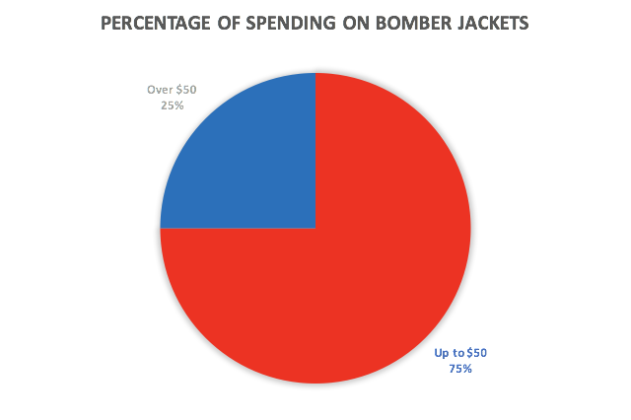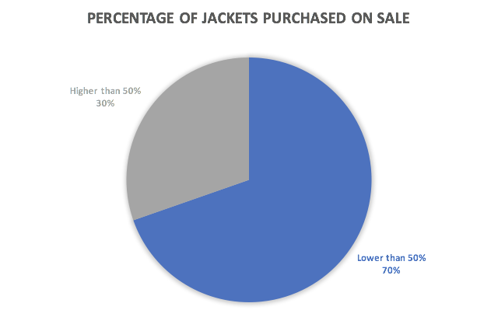
Another good question that came up related to how often individuals purchase jackets. The data showed that jackets are not an item regularly purchased by individuals. For the most part, they seem to be purchased annually or seasonally. Seventy-seven percent of individuals purchase jackets seasonally while another 18% purchase them annually. Based on experience, I can conclude that this ties directly in with the questions above. If you are looking for affordable clothing, you buy your clothing out of season. You would buy summer clothes for cheaper in the winter and vice versa. These are times where you would have big “End of Season” sales.
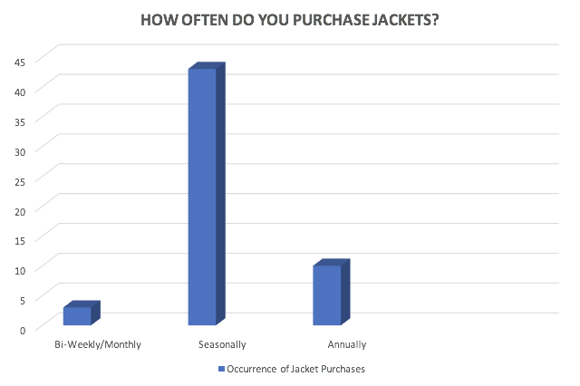
We wanted to gather an understanding for the different types of materials and styles that individuals favor in a bomber jacket, so the next few questions simply discussed that. Out of 55 respondents, 45 favored darker colors such as black, dark blue, and dark purple. In terms of jacket material, the data appeared to be scattered. Twenty-eight percent of respondents preferred Polyester Cotton, 23.21% of respondents liked Leather and Nylon, while the rest of the respondents favored Suede, Jacquard, or Silk. In reference to style, our data showed that Plain is favored and Patterned is not. About 94% of respondents favored Plain or Plain with Patches while the remaining opted for Patterned or Patterned with Patches. Comparison of the three charts show that Darker Colors, Polyester Cotton, and Plain or Plain jackets with patches are commonly preferred.

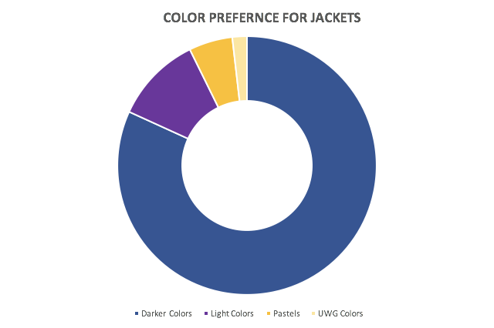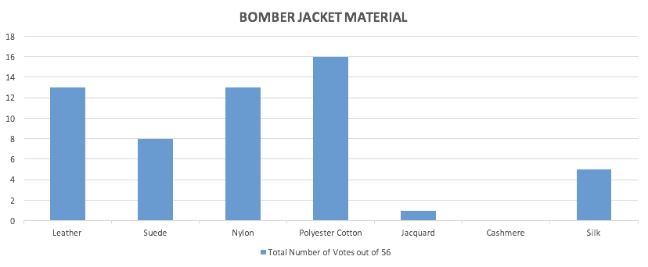
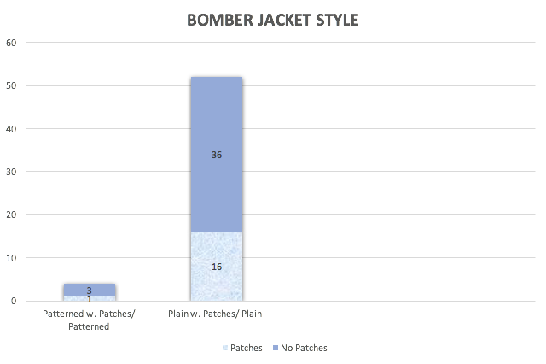

The next two questions refer to length and fit of a jacket. We asked these questions because the length and fit are very important in relation to comfortability. If more buyers prefer a fitted jacket we could do that and vice versa. In relation to length, longline bombers are in style at the moment, so we asked this question to see if college students preferred this particular length or opted for the usual midline length jacket. Jackets that were super loose and typical length were the preferred choices. This is found surprising because as stated, longline bomber jackets are trendy right now. Only 16 of the 56 voters opted for very long jackets.

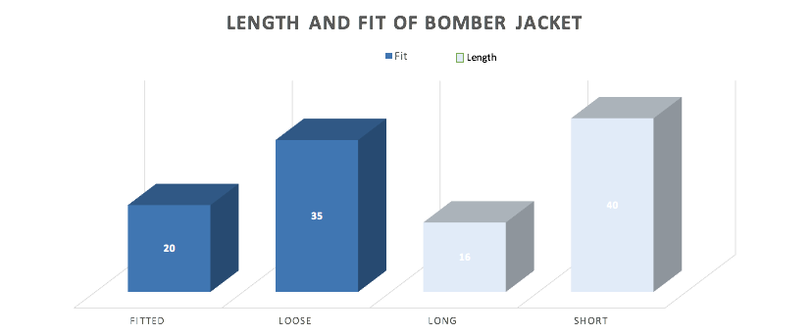

The next two questions related to what users typically look for when they go shopping and how important these features are to them. What the data showed was that comfort is the most important thing our users look for. This can add onto the results from the data earlier that talked about length and fit. The data above showed that loose and short were preferred; this relates to comfortability. Another question we asked users related to if they looked for quality, quantity, or both. Quality took the top vote with 53% and both had 44.64%. When comparing this to the display of bar charts below we see that Quality and Durability were ranked second and third respectively. In relation to those that were seen as unimportant brand, atmosphere, and advertisement ranked the lowest. This is surprising because most users shop at brand name stores (Nike, Adidas, Gucci, etc). Advertisement and buying decisions typically play in hand but according to the votes, these don’t which is alarming.
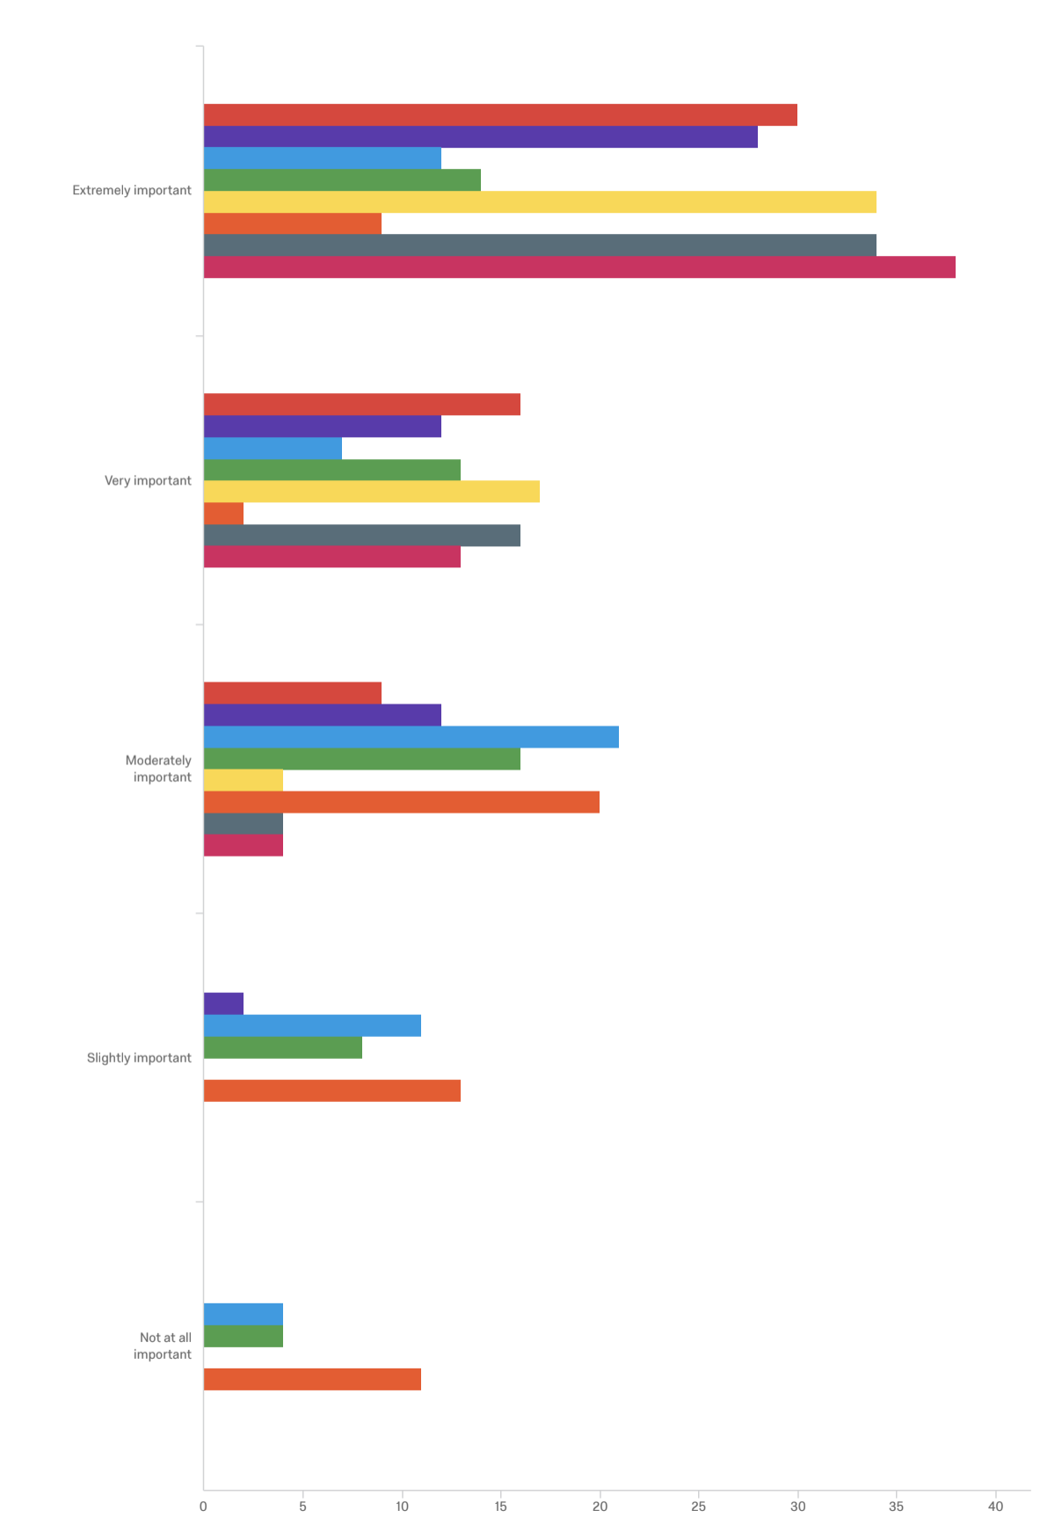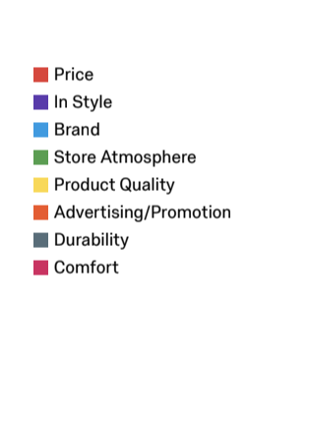
The below table summarizes the data singling out most important and unimportant.

 | Most Important | Somewhat Important | Not Important At All
Comfort | 69.09% | 7.27% | 0%
Price | 54.55% | 16.36% | 0%
Durability | 62.96% | 29.63% | 0%
Brand | 21.82% | 38.18% | 7.27%
Quality | 61.82% | 7.27% | 0%
Atmosphere | 25.45% | 29.09% | 7.27%
Advertising | 16.36% | 36.36% | 20%
“In Style” | 51.85% | 22.22% | 0%

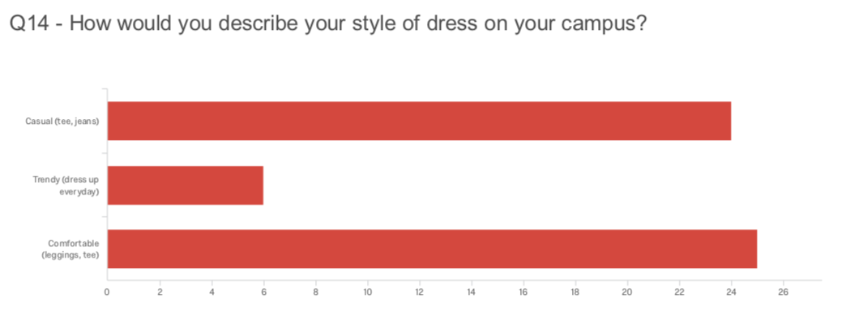

The last two questions were asked as demographic questions. It fits very well with the data. Most of the individuals who took the questionnaire were females. Studies have shown that females typically tend to favor comfortability and quality when making purchasing decisions. Males tend to pay more attention to brand and things that are in style. Females tend to care more about the fit of a jacket and the colors. Darker colors are often seen as universal colors (colors that go with anything); this could possibly be why the darker colors and loose fit were preferred. With 75% of the votes coming from females we are confident we can create a stylish bomber jacket that will attract many buyers.
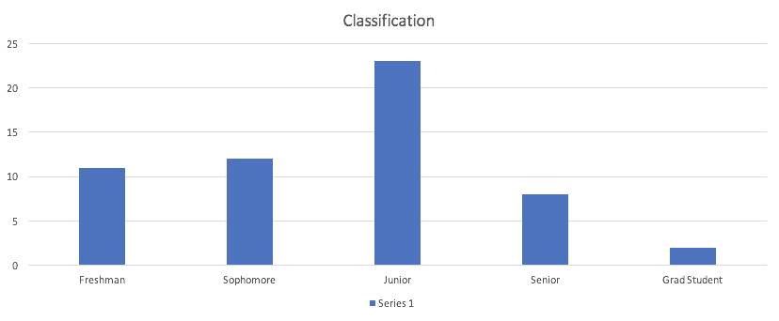
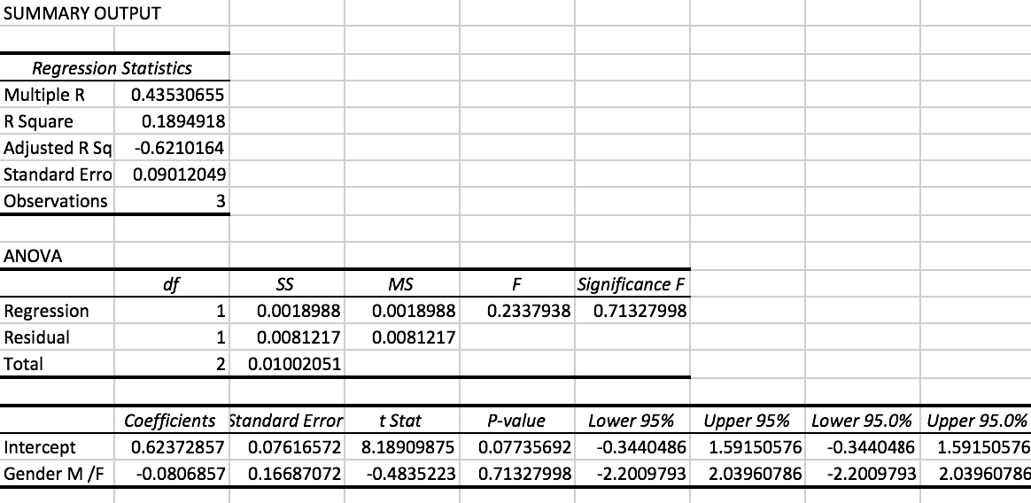
A hypothesis test was conducted to determine whether or not females are more likely than males to favor durability and comfort when shopping over males. The null hypothesis says that there is no gender preference when it comes to favoring durability and comfortability. This says that pFemales=pMales. The alternative hypothesis says that there is a gender preference when favoring durability and comfort. Alpha is .05 and our p-value is .7. Because our p-value was not less than our significance level we can fail to reject the null. More females took this questionnaire than males so it could prove to an explanation for why the null failed to be rejected.
Limitations
Despite the success of our Alternative Apparel research, we did encounter a few limitations. One of the first limitations we noticed was during our focus group. When conducting the focus group individuals seemed hesitant to give responses to the questions that were asked by the moderator. When answering questions, there were few who gave their true personal opinion; many of the answers were similar because the previous person most likely agreed with the person who answered before them. A lot of times, it is good to see a varied level of responses because it helps to produce a product that best suits everyone.
Another limitation we noticed related to the selection of the focus group. We selected the focus group using convenience sampling. A more effective selection method for the focus group would have been random sampling. With random sampling, you can see a varied level of responses between the respondents.
Lastly, we noticed limitations in relation to the questionnaire. Although there were questions that targeted our group’s specific product, there could have been a better question format for questions that related to shopping preferences. Question 12 discussed important shopping features, and they were rated from not important to extremely important. With five different levels of importance, it was hard to see which shopping feature users valued the most.
Specific Recommendations
After analyzing all of the information, we believe that we can offer the best possible recommendations for Alternative Apparel. Based upon our research, we have ultimately come to the conclusion that targeting the American college student is dependent upon three key elements: price, comfort, and simplicity. Conclusively, these students wouldn’t spend over $50 on the jacket, they prefer to be stylish yet comfortable, and they are interested in the typical bomber jacket without vintage patches or additional designs. Focusing on these three elements will not only take your company to the next level, but it’ll also equip you with the essential tools needed to take over the college student segment of the market.
26.79% of the students surveyed typically wouldn’t purchase a jacket on sale, and they make those purchases online, as well as in stores. Due to the fact that 75% also wouldn’t spend over $50 for a bomber jacket, they are basically purchasing jackets of average quality. A low-quality bomber jacket will cost around $20, and an average jacket is worth between $40 and $50. If a consumer decides to spend over $50 on a jacket, it’ll typically be of finer quality. Therefore, we recommend producing a bomber jacket that will cost around $40 to target college students. This audience doesn’t have the monetary flexibility to spend a plethora of money on a bomber jacket. Since 53.57% prefers quality over quantity, Alternative Apparel could also offer a higher priced jacket, with better quality. This would satisfy the students that want a nicer, and much more reliable jacket, as well as the students that only wear bomber jackets for a particular outfit. The higher priced jacket would range from $60 to $70.
Also based upon our survey, a college student’s level of comfort is vital in regards to their clothing. 28.57% of the students preferred to wear a polyester cotton bomber jacket, which is evidently one of the most comfortable materials for a bomber jacket. So clearly comfortability is a must-have. Plus, 38% of those surveyed also believed that comfort is an extremely import aspect when shopping for that perfect look. The most common style of dress on campus also happened to be a “comfortable style”, according to 44.64%. Therefore, the bomber jacket must loose, cozy, and nevertheless comfortable for the consumers. This must be the go to jacket that can be worn for long periods of time, without any issues whatsoever. Although beauty is pain, comfort is much more profitable from this particular consumer.
Simplicity is the ultimate definition of everyday college style. The typical college student doesn’t spend hours trying to search for the most unique outfit to wear to class. An outstanding 64.29% of the students surveyed favored the simple, solid colored bomber jacket. Only 28.57% of the population preferred the bomber jackets with vintage patches on them. This shows our firm that this audience doesn’t want the jacket to be the “showstopping” element of their outfit. They would rather have a straightforward bomber jacket to simply complete their original look. For that reason, the bomber jackets should be plain-colored, yet the students should be given a wide assortment of colors to choose from. This will eliminate multiple students having the exact same bomber jacket, and it will also give them the option to create many different outfit looks. Ultimately, create a reasonably priced, comfortable, and solid colored bomber jacket and your company will profit exceedingly.

Appendices
Appendix A - Discussion/Interview Guide
Appendix B - Questionnaire
Appendix C - Qualtrics Report
Appendix D - Exploratory Research Video:
Appendix E - Citation Page

Appendix A

FOCUS GROUP: DISCUSSION GUIDE
Welcome: We would like to thank you all for joining us today. We value your time and appreciate your cooperation during this process.
Introduction: The purpose of this focus group is to get your opinions and ideas for our client, in regard to American Apparel’s collaboration with college students. The maximum time for this focus group will be two hours, although there is a chance that it will end earlier. If everyone is content, we will proceed by turning the recorder on. Is everyone okay with that?
Anonymity: Although this discussion is taped, anything said in this room will be confidential. Recordings will not be published, and responses will remain anonymous. We ask that everyone refrain from any discussion outside of this room. We would like for you to answer all questions as honestly as possible. If you feel uncomfortable answering any question, you do not have to do so. We appreciate your cooperation and hope for your active participation throughout this process.
Ground rules
- We first ask that everyone allows only one person to speak at a time.
- This is a discussion, so there are no right or wrong answers. Therefore, we would like to hear from all sides.
- What is said in this room stays in this room. Confidentiality is key. No individuals will be said by name.
- Participation is voluntary.
- You do not have to answer topics in which you feel uncomfortable discussing.
- Respect the opinions of others, even if you do not agree.
- Are there any questions? If there are not, we will begin.
Warm up
Now, we would like to do an icebreaker to get each of you acquainted with each other. Could everyone state their names and their favorite color?
Introductory question
We would like to give everyone a few minutes to gather their thoughts on how fashion has changed over the past 10 years. Can anybody share with us, their experience with fashion from 2008 to now (2018)?
Guiding questions
- How would you describe your fashion in high school?
- Do you think your sense of fashion change when you enter college?
- Do you have an inspiration? Where do you look for inspiration?
- What item of clothing can you wear with anything?
- In the future what do you see trending?
- What do you think influences fashion and their trends?
- Which fashion trend is your least favorite?
- Many people say fashion is recycles itself and there is now innovation, what is your view?
- What are your favorites pieces of clothing?
- If the occasion in informal what do you prefer to wear? What about formal?
- As a consumer, which is a factor when shopping; price or quality?
- Do you follow any brand’s social media and what do you get from following them?
- Does brands making clothes eco-friendly important?
- Do you shop more on sales or whenever you feel the need?

Concluding question
After everything we have discussed today, in your opinion, what are the most important issues of this checklist that you would like to express?
Conclusion
- Thank you all for coming, your participation is greatly appreciated.
- Your thoughts and opinions will be a great asset to our study.
- We hope that each of you have found today's discussion interesting.
- If you are unhappy with anything, please feel free to contact the local PI or speak with me later.
- We would like to remind you that any of your comments featured in this report will be anonymous.
- Before you leave, we ask that you please complete and hand in your personal details questionnaire.
Appendix B
Invitation Survey



Dear Alternative Apparel Customer,

As an avid customer of Alternative Apparel, you have been selected to participate in our survey. Also, as a college student, you happen to be a part of our specific target audience, and your opinion is crucial to our company. Rest assured your response will remain anonymous. Our goal for this survey is to help us improve your customer experience. We actively use feedback to enhance the quality of our products, as well as revamp our service quality. Based on past experiences, this survey will take five minutes. Please take a little time out of your schedule to offer your feedback.

Please click here for survey
Or copy the link
https://westga.co1.qualtrics.com/jfe/form/SV_25FBwXVDozkv94x

Thank you for taking the time to offer your input.

Sincerely,
Alternative Apparel Marketing Team

Alternative Apparel Questionnaire
The goal of this survey is to understand the typical UWG student's jacket preference. The results will help us come to a conclusion on possibly creating a UWG bomber jacket with vintage patchwork.
Thanks for participating!

If you were to purchase bomber jackets every 6 months, how much would you spend on them?
o Up to $50
o Up to $100
o Up to $400
o More than $400

About how many of your jackets were purchased on sale?
o 0%-10%
o 11%-30%
o 31%-50%
o 51%-70%
o 71%-100%

How often do you purchase jackets?
o Bi-Weekly
o Monthly
o Seasonally (Spring, Summer, Fall, Winter)
o Once a year

Do you prefer to purchase your jackets online or in store?
o Online
o In store
o Equal amount from both

What color jackets do you like to wear?
o Darker colors (black, grey, dark purple, dark blue, etc)
o Light colors (yellow, orange, pink)
o Softer colors (pastels)
o White
o School colors (red & blue)
o Dislike a moderate amount
o Dislike a great deal

What type of bomber jacket material do you look for when purchasing clothing?

o Leather
o Suede
o Nylon
o Polyester Cotton
o Jacquard
o Cashmere
o Silk

What type of bomber jacket style do you typically prefer?

o Patterned
o Plain (solid color)
o Plain color with vintage patches
o Patterned with vintage patches

How do you prefer your jackets to fit?

o Very fitted
o Super loose
What length do you like your bomber jackets to be?

o Very long
o Short (typical length)

When shopping for jackets what do you tend to look for?

o Quality
o Quantity
o Both

When shopping how important are the following features to you?

 | Extremely important (1) | Very important (2) | Moderately important (3) | Slightly important (4) | Not at all important (5)
Price | o | o | o | o | o
In Style | o | o | o | o | o
Brand | o | o | o | o | o
Store Atmosphere | o | o | o | o | o
Product Quality | o | o | o | o | o
Advertising/Promotion | o | o | o | o | o
Durability | o | o | o | o | o
Comfort | o | o | o | o | o

What encourages your fashion style?
o Family
o Friends
o Celebrities
o Seasonal Changes in Fashion
o Your Significant Other

How would you describe your style of dress on your campus?
o Casual (tee, jeans)
o Trendy (dress up every day)
o Comfortable (leggings, tee)

What is your gender?

o Male
o Female
o Prefer Not To Answer

What is your classification?
o Freshman
o Sophomore
o Junior
o Senior
o Graduate Student

Appendix C

Qualtrics Report

PDF Version click here or copy link below.

https://drive.google.com/open?id=1gRzufSU-Xv2nAhuLoeYJNCW9Uc3FSr3L

Appendix D

Exploratory Research Video Links

Part 1

https://youtu.be/mg1Egcs7aA8

Part 2

https://youtu.be/4pm9qBRjkZ0

Appendix E

References

Clemente, D. (2016). Dress Casual: How College Students Redefined American Style (Gender and American Culture). Chapel Hill: The University of North Carolina Press.

Goodwin , P. (2017). Forecasting After a Fashion. Foresight: The International Journal of Applied Forecasting, 15-18.

Slepian, M. L., Ferber, S. N., Gold, J. M., & Rutchick, A. M. (2015, August 1). The Cognitive
Consequences of Formal Clothing. Social Psychological and Personality Science, 6(6), 661-668. doi:10.1177/1948550615579462

University of Oxford. (n.d.). Academic dress. Retrieved from University of Oxford: https://www.ox.ac.uk/students/academic/dress?wssl=1

