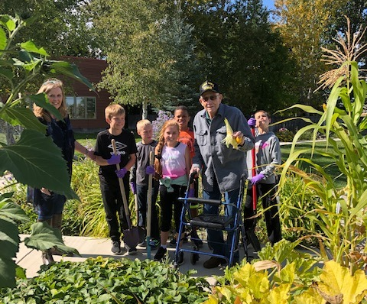  Course Pre-Requisites  Students must provide proof of the following health requirements prior to enrollment in the program.  - Tuberculosis testing-two step PPD or chest x-ray (Positive results requires a physician’s letter before a student can work in the clinical setting).  - Diphtheria-Tetanus /Pertussis-Tdap vaccination (up-to-date).  - Influenza Virus Vaccine-in season.  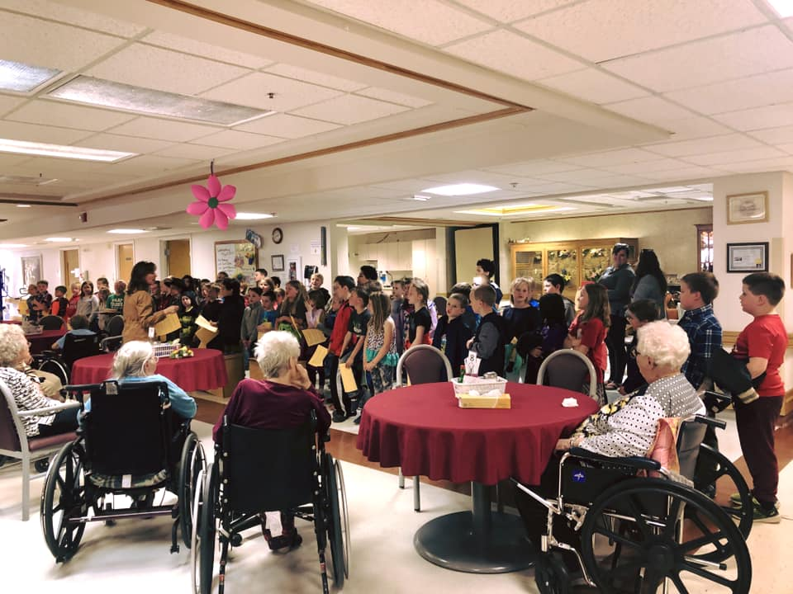  - BLS card-current (Montana Health Network does offer this course if needed). | Online CNA Program  Enroll Today  Sign up for this four-week online course and begin your rewarding journey in the healthcare field from the convenience of your hometown!  To Apply:  Phone: 406-234-1424  bbrunk@montanahealthnetwork.com www.montanahealthnetwork.com  - Select “Education”  - Fill out request form  Call Jenny Broesder for more information on the course or Clinical Training at PMC  Montana health network/ NorthEast MT AHEC  519 Pleasant  Miles City, MT 59301 | Start your new rewarding career online today!  In partnership with Pondera Medical Center  Montana health network/NorthEast MT AHEC  - ONLINE CNA PROGRAM
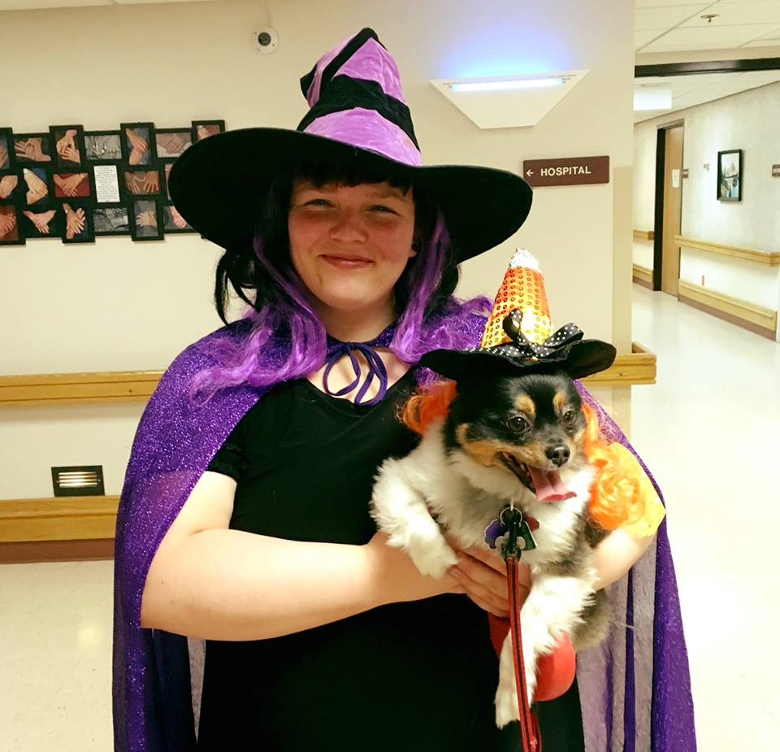  Course Description  The Nursing Aid curriculum will prepare students for careers in healthcare under the supervision of the Licensed RN or LPN. Students learn the basic entry-level nursing skills to work in the healthcare setting as a Certified Nursing Aid. Curriculum includes providing or assisting in client care, bathing, dressing, grooming, toileting, ambulation, transferring, feeding, and use of equipment, documenting, and reporting the general well-being of the resident.  Theory and clinical study will provide necessary information and skills needed in long-term, home care, and acute care settings to take the Montana Department of Health, State Competency Evaluation Examination, which is required for the Nursing Assistant State Registry. | Headmaster Exam  The State exam includes written (computer) as well as a clinical (skills) portion. Clinical Testing will be conducted at Pondera Medical Center. Testing is through and examples are available online at: www.hdmaster.com.  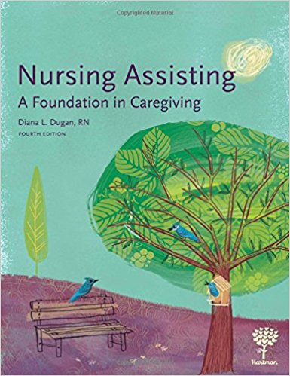  Required Text  Dugan, Diana, Hartman’s Nursing Assisting: A Foundation in Caregiving 4th Edition. Albuquerque, NM: Hartman Publishing, INC., 2010 ISBN: 978-1-60425-061-9 | 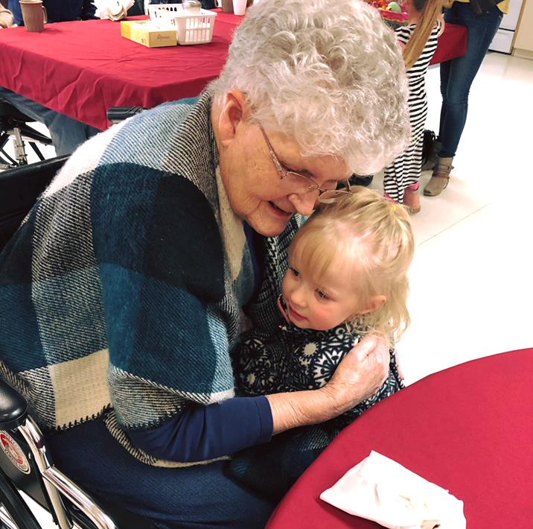  Required  - Access to a computer with internet (Desktop computers available in the PMC IT Dept.)  - Coordinated colored scrubs that fit properly  - Work shoes with closed toe  If you are ready to start your career in the gratifying role as a Certified Nursing Assistant, please contact Jenny Broesder at Pondera Medical Center to learn more and schedule clinical at PMC.  Jenny Broesder, Clinical Instructor  Pondera Medical Center  805 Sunset Blvd  Conrad, MT 59425  jennylb@ponderamedical.org  (406) 271-2201 (Phone)

