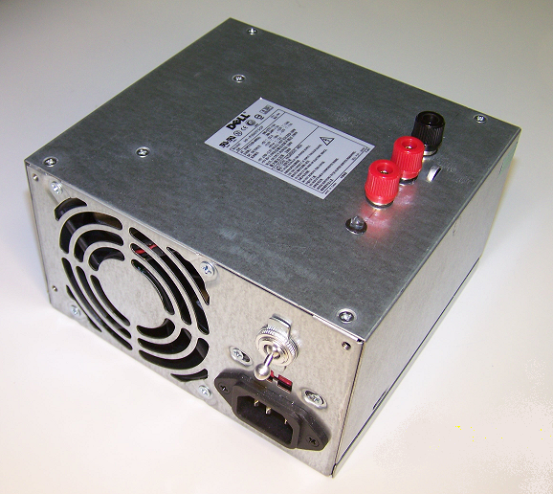

12 volt DC Regulated Power Supply

This is a converted computer power supply that has been modified to provide two separate, highly regulated DC outputs. The first is a 12 volt DC output that can supply, depending on the unit you purchased, from 8 to as much as 30 amps of regulated DC current, suitable for powering battery chargers that are designed to operate from a car battery or other 12 volt source. The second is capable of providing from 10 to 30 amps of 5 volts DC, which can be used to power receivers and servos, even high-torque digital servos, directly from the power supply. (Note: Some units now feature dual 12 volt DC outputs for additional charging capacity. These units can be identified by the extra set of banana jacks mounted on the top panel.) The 12 volt output(s) will allow you to charge several batteries at once, and/or to power more than one charger at the same time. The 5 volt output can connected directly to your receiver, eliminating the need for a battery pack, and will drive as many servos as you wish, great for testing and/or setting up a new plane.

This power supply is fan cooled, and has internal short-circuit and thermal overload protection. If the outputs are shorted or overloaded, it will shut down before damage can occur. If your power supply is overloaded or if the outputs are shorted out, the unit will immediately shut itself off. Turn the power switch off, remove the overload or short condition, wait 15-30 seconds, and turn the unit back on.

Note: If your power supply shuts off as soon as you connect your charger to it, try connecting the charger and turning it “on” before you turn the power supply on. Some chargers contain large internal capacitors that must charge as soon as the charger is connected, and occasionally a power supply will view this as a problem condition. Connecting and turning the charger “on” the charger before you turn the power supply on will usually prevent the unit from shutting itself down.

If you have any questions or problems, don’t hesitate to contact me. ENJOY!
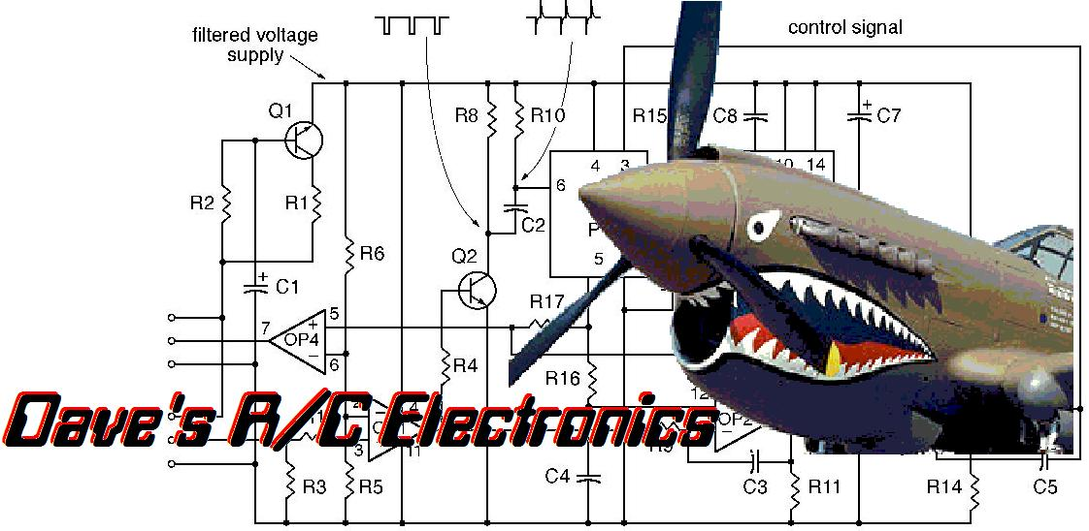
www.davesrce.com
sales@davesrce.com
(423) 544-1657
SCAN HERE

