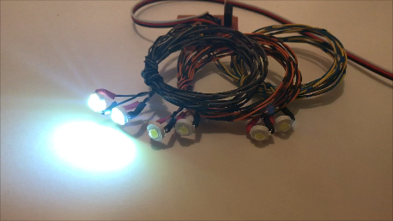
High-Power (1 Watt) LED Cannons

This circuit is designed to simulate the guns commonly found in the wings, in the nose, or on the fuselage of many WWII fighters. The LEDs used on this circuit are high-power 1-watt emitters, so they are much brighter than “standard” 5mm or 8mm LEDs. But because they are flashing for only a fraction of a second each time they “fire”, they do not draw excessive current, so they do not require a separate battery to power them, nor do they get hot enough to require any special mounting considerations. The flashing effect is enhanced by a completely random firing pattern, which also includes a random delay between “bursts“, that will simulate a pilot’s tendency to fire his cannon in short bursts of fire, rather than in a continuous stream. There are 6 LEDs per wing, which are connected to 3 separate circuits, so they can be grouped together in the leading edge of a wing and will appear to fire randomly. The 3 circuits are controlled by a micro-processor, and each circuit is wired to 2 LEDs that use wires of the same color combinations, so you can arrange the firing order of the cannon on each wing as you see fit for maximum realism. I recommend that you use a different order on each wing, for instance, 1-2-3 on one wing and 3-1-2 on the other. The best way to install the LEDs is left for the modeler to decide, since they don’t have any particular way in which they have to be mounted they can be installed in whatever way is best suited to your model and your building skills. They can be glued behind whatever tubes or molded cannon that are provided with your model, or used in conjunction with cannons designed and/or made by the modeler. Or they can be used in conjunction with some of the 3D-Printed cannon sets available from other suppliers.
Connect the servo wire from the board to a spare channel on your receiver, and program that channel to the switch (or knob) of your choice. Now you can simulate cannon fire by simply toggling the correct switch.
The most difficult part of installing your cannon will be routing the wires from the LEDs through the wing’s leading edge and into the fuselage. Because the LEDs can’t be inserted from the back of the leading edge (unless you’re building a kit), it may be necessary to cut the wires to the LEDs, route them through the wing as required, and reconnect them once they’re installed. A 6-pin multiplex connector is provided to allow you to disconnect the LEDs on models with a removable wing. Install the connectors in the location that is most convenient for your model, and simply match the wire colors from one side of the connector to the other to maintain polarity of the LEDs. If you prefer, the circuit board can be located completely within the model’s wing area, and the receiver/servo wire can be used to connect/disconnect the circuit.

If you have any questions or problems, don’t hesitate to contact me. ENJOY!

www.davesrce.com
sales@davesrce.com
(423) 544-1657
SCAN HERE

