Night Prowler ARF

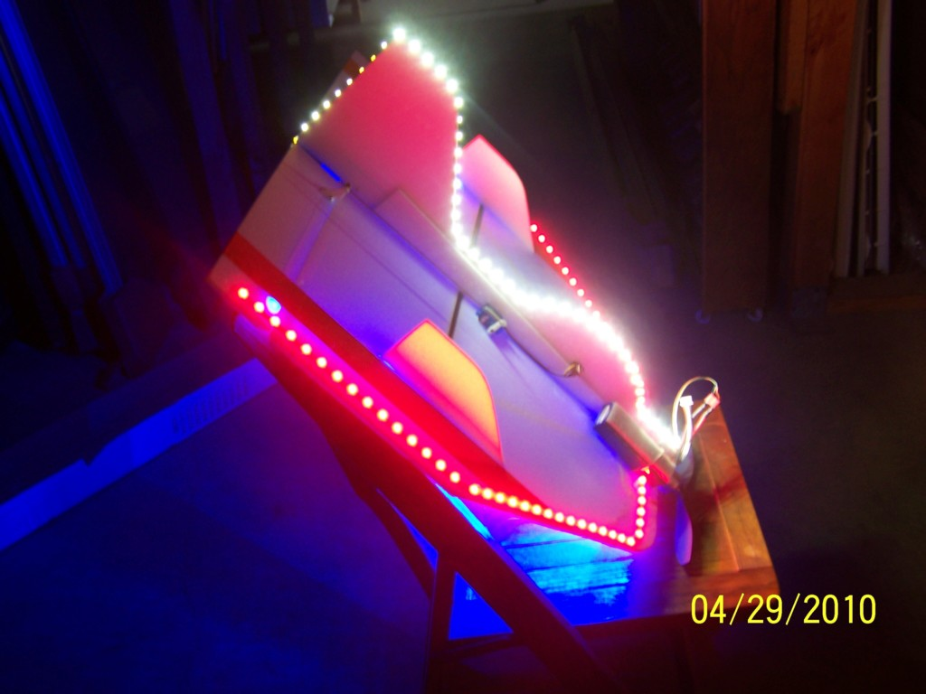

Congratulations, and thanks for your purchase of a Night Prowler ARF! This manual will include information that you can use to get the most from your new plane.

This version is not completely assembled so it can be shipped more easily, only a few steps remain to get it ready to fly. Please follow the instructions below. If you have any questions, feel free to call or email me anytime, the link to my website is listed below.
Step #1: Glue the upper fuselage/fin assembly in place. Position the fuse assembly on the top of the wing as indicated, slide it forward against the firewall and press it down into the slots on the top of the wing. There are two screws that protrude from the top of the firewall, simply press them into the foam, and make sure that the fuse assembly is snug against the firewall. I recommend foam-safe CA for the long joint between the wing and fuse, and hot glue for the back of the firewall. Once it’s glued firmly into place, you may also want to add some extra hot glue to the back of the firewall where it contacts the fuse assembly. Use a small square to hold the fin in place as the glue dries.
Step #2: Glue the vertical stabs into place. Both stabs are identical (no right or left), they are inserted down into the slots in the wing from the top, refer to the picture above if you are unsure of the correct orientation. Run a small bead of glue just below the notches sit on top of the wing, se lines, and on the bottom of the notches in the front and back, these tabs will rest on the top of the wing itself. You may also want to use a small square to hold the stabs in place as the glue dries.
Step #3: Connect the wires from the upper fuse assembly to the wires on the wing top. There are 2 small wires connected to the LEDs on the fuse, and 2 connected to the LEDs on the wing top. They are color coded for easy identification. These need to be connected together to provide power to the LEDs on the fin/fuse assembly. Twist them together, matching the colors, of course, and add a small piece of tape or heat shrink to the joints. If you’d rather, you may choose to remove one set and connect the remaining wires to the solder points to which the wires you removed were connected. If you do, just slide a small #11 knife blade under the solder points before you heat them to prevent the foam from distorting.

(Continued on back)

Step #4: Connect the motor and ESC wires together. The wires from the motor and ESC are color coded, match the colors together and you motor should turn the proper direction. If it does not, simply swap any 2 wires and the motor’s rotation will be reversed.
There are several prop sizes suitable for the Night Flyer, any 8 or 9” prop works well, I recommend for your first few flights a 9” x 3.8 or 9” x 4.75, either prop will slow the plane down just a bit and give you a chance to get used to flying in the dark. After you get more comfortable with it, you can step up to a 9” x 6 for more speed and more excitement. Both sizes will allow you to hover and hang it in the wind, but still slow down nicely for landing.
You can use any 11.1 volt 3-cell Li-Po of 1000 to 2200mAh, I prefer to use a 1300-1500mAh pack for good performance and longer flights using the lights. Position the battery all the way forward on the right side (opposite the ESC), and use a piece of Velcro or other fastener to secure it to the top of the wing. The small JST connectors are used to power the LEDs, just plug them together once the battery is connected and you’re ready for night flying. Position your receiver on the same side as the ESC, slightly behind it. The Center of Gravity should be between 5 and 6 inches from the back of the wooden firewall. The plane will usually fly slightly nose up with a 3-cell pack of 1500mAh or larger. The ESC is rated at 30 amps and is fully programmable, the instruction sheet is attached to the plane, or it can be downloaded from my website.
Repairs can be made with either foam-safe CA or hot glue. Just be sure to keep the tip of the glue gun away from the foam itself, or it will melt it. Drip or drizzle the glue where you need it and press the pieces together. White glue also works well, but is slower to cure and not quite as strong. If the ends of the LED strips begin to lift or come loose, just a drop of either type of glue will hold them down firmly.
If you need replacement parts, just let me know. I keep the parts for this plane in stock (motor, ESC, servos, etc.), and you can check our website (link is below) for prices. Fly safe, and have fun!

If you have any questions or problems, don’t hesitate to contact me. ENJOY!
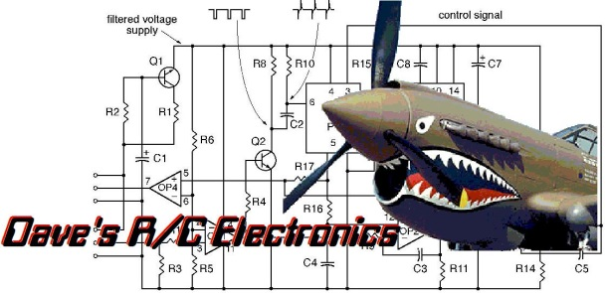
www.davesrce.com
sales@davesrce.com
(423) 544-1657
SCAN HERE

