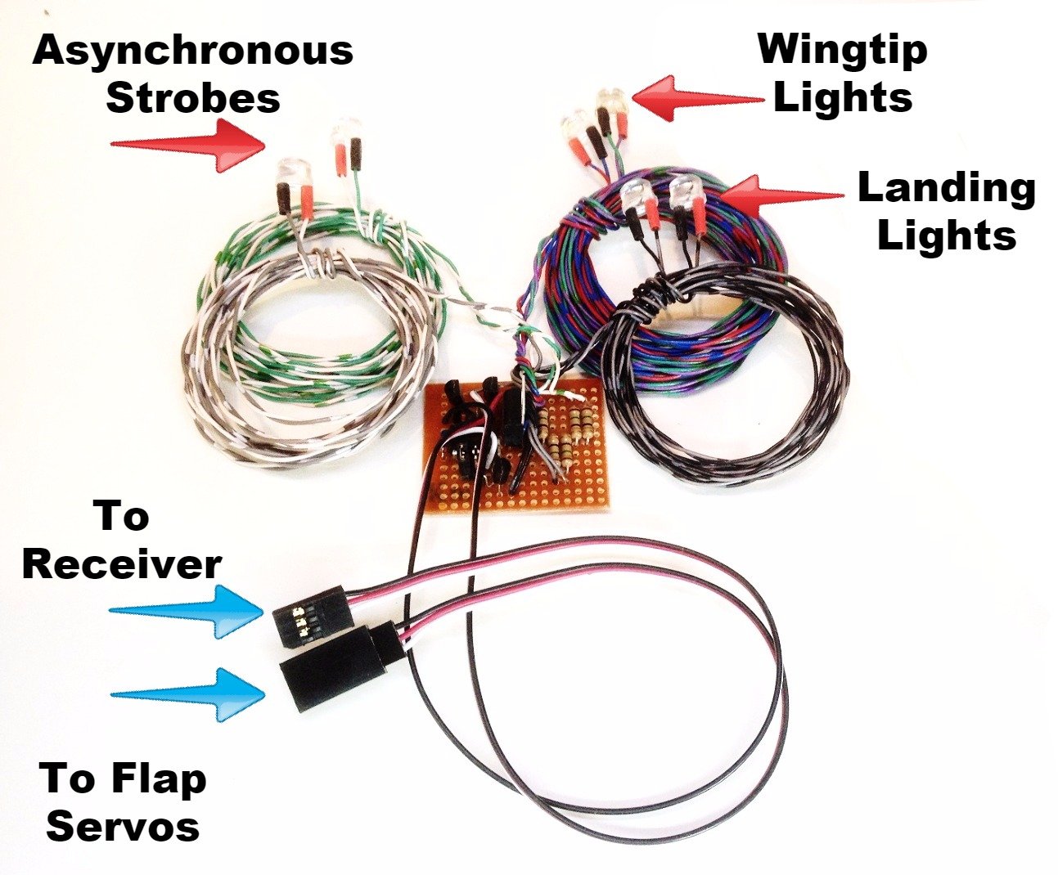
Ultimate Navigation Lights & Servo Slow-8mm

The Ultimate Navigation Lights set includes 2 wingtip lights (1-red, 1-green), 2 landing lights (white), and 2 asynchronous strobe lights (either white or red), which are pre-set in a double-blink pattern. The wingtip lights and strobes will come on as soon as the receiver is turned on, and the landing lights can be switched on/off from the transmitter. In addition, it includes a servo speed reducing function that will slow the movement of a regular, proportional servo to make the movement of flaps or retracts more scale-like and realistic. The circuit can be plugged into any channel on your receiver, either by itself, with a servo Y connected to flap or retract servos. The landing lights will come on as soon as the flaps or gear are lowered, and will go off as soon as the flaps or gear are raised. If you find that they come on at the wrong time, i.e. when the flaps or gear are up, or when the throttle stick is a full throttle, their action may be reversed using the reversing jumper. On the left side of the circuit board are 2 pairs of brass pins, one pair of which is exposed, and one pair of which is covered with a black jumper. Refer to the picture above for their exact location. To reverse the action of the landing lights, simply move the jumper to the other (exposed) pair of pins.
Servo speed reduction is pre-set and automatic. Any servo plugged into the male servo connector will move much more slowly than normal, even if it is connected to a non-proportional channel like the gear channel. Use it to slow the action of flaps, to make them look more realistic and to prevent “ballooning” of the model when flaps are deployed. It may also be used with a regular servo to slow the action of retracts for scale-like operation. Note that servo speed can only be reduced on a regular, proportional servo, not on a standard “retract” type servo. True retract servos recognize only 2 positions from the receiver, either fully clockwise (CW) or fully counter-clockwise (CCW), and when pulsed from the receiver rotate from one position all the way to the other, and cannot be paused or stopped anywhere in between. A regular, high-torque servo can be easily modified to work as a retract servo. Search the internet and you’ll find several excellent sites with instructions on exactly how to do it.

(continued on back)

` The LEDs are powered from the receiver’s battery pack, and since this circuit is regulated, it can be used on any receiver and any size or voltage receiver battery, including HV (high voltage) receivers. Total current draw is still very low, so there is no need for a separate power source.

If you have any questions or problems, don’t hesitate to contact me. ENJOY!
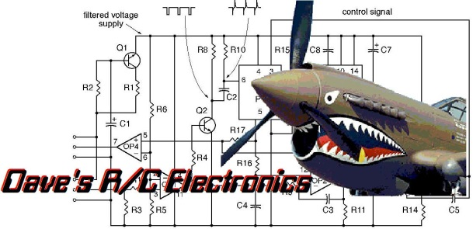
www.davesrce.com
sales@davesrce.com
(423) 544-1657
SCAN HERE

