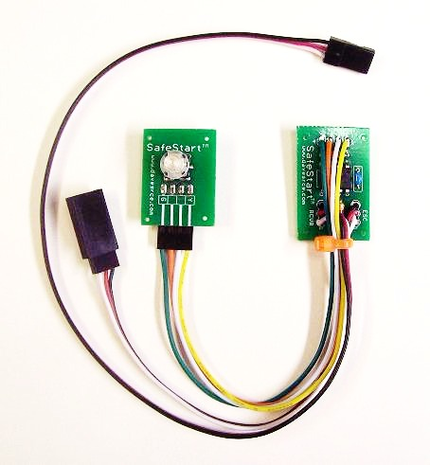
SafeStart

SafeStart is an easy-to-use, and easy-to-install circuit designed to provide an extra layer of protection for models that use electric motors and ESCs. It will prevent unwanted and unexpected motor starts that can be caused by bumps to the transmitter’s throttle stick, or by unexpected losses in signal due to a transmitter that has been turned off before the flight battery has been disconnected. It allows the modeler to do maintenance and make adjustments to the model in absolute safety, even with the flight battery connected, and eliminates painful prop strikes that can occur in an unguarded moment. A super addition to any electric-powered model!

SafeStart installs between the ESC and your receiver’s throttle channel. Simply plug the female lead into the throttle channel of your receiver, and the male lead to the wire coming from your ESC. The illuminated push-button switch should be mounted inside the fuselage with the cap of the switch protruding out enough that it is visible and can be accessed easily to arm the ESC. The 4-wire plug from the switch to the main circuit board can be disconnected from the 4-pin angled header if necessary to make installation easier. The plug comes with a small spot of hot glue to secure it in place, if you need to remove it for any reason, make note of the direction of the color coded plug and secure it back into place with a little glue or cement.

SafeStart works with any brand or type of ESC, regardless of the size or capacity, and any size or type of motor, brushed or brushless. It will work on 72MHz and 2.4GHz radios, any brand, PPM or PCM. Since it affects only the signal, it has no effect on the power going to the motor.

Note: The “End Point” or “ATV” setting of your transmitter’s throttle channel should be set to -100% and +100% for proper operation of SafeStart. Increasing these settings to more than 100% in either direction will not increase the output of your ESC, as most ESC’s detect the low and high throttle settings when the throttle stick is advanced to each extreme for the first time after power up, and they adjust their output accordingly. But to insure that your SafeStart can correctly detect the low throttle stick position, your radio’s throttle channel end points must be set to 100% in both directions.

Operation of SafeStart is easy and automatic. Plug the flight battery into the ESC as normal, and SafeStart will begin by sending a signal to the ESC to arm it and place it in the “Off” state, and will then check the current position of the transmitter’s throttle stick. If the transmitter is not “On”, SafeStart will remain in the “Safe” mode until it detects a valid transmitter signal. If the transmitter is “On”, but the throttle stick in not in the full “Off” position, the LEDs in the push-

Page 1

button switch will blink Orange rapidly.

Move the throttle stick to the “Off” position, and the LED will turn solid Red, indicating you are in the “Safe” mode. In “Safe” mode the transmitter’s throttle stick is not active, and movement of the stick will have no effect on the motor. All the other receiver’s channels will be working normally, however, so you’ll be able to make adjustments to the sub-trim, make control rod adjustments, or check for proper movement of the plane’s control surfaces safely. When you are ready to fly, make sure the throttle stick is all the way down, and press and hold the push-button switch for about 3 seconds. The LED will begin to blink red, indicating that SafeStart is about to enter the “Run” mode. Once the switch has been held for 3 seconds, the LED will begin to blink green. Release the switch, and the LED will turn solid green, indicating that SafeStart is now in the “Run” mode, and that the throttle stick is now active. If, while holding the switch down for 3 seconds, the throttle stick is not in the “Off” position (or is bumped), the LED will continue to blink red and will not allow the unit to enter the “Run” mode. Also, if the switch is released before 3 seconds, the circuit will revert to the “Safe” mode (Solid red LED). Once the unit has entered the “Run” mode, pressing the switch again will stop the motor immediately, and place SafeStart back into the “Safe” mode (Solid Red LED). The throttle will now be held in the “Off” position, even if the transmitter is turned off, until the battery has been disconnected from the ESC. This feature is great for placing the model in a completely safe mode immediately after flight, as it renders the throttle stick on the transmitter completely inoperable, and prevents the motor from twitching or jerking even if no signal is present!

Once SafeStart has entered the “Run” mode, the transmitter’s throttle stick position is transferred to the ESC without change, and the delay is on the order of about 10 microseconds, so it will not produce any detectable delay in throttle response. And in the “Safe” mode, an “Off” signal is always being sent to the ESC to prevent any accidental bumps or movement of the motor and prop, even if there is no valid transmitter signal present.

LED Color and State | Mode
No LED On | Transmitter not “On”, no signal detected
LED Blinking Orange rapidly | Throttle Stick Position (TSP) is not at “Low” (Startup Only)
LED Solid Red | Safe Mode. Throttle stick is NOT active.
LED Blinking Red | Pre-Run Mode. If TSP is “Low”, and switch is held for 3 seconds, unit will enter Ready Mode
LED Blinking Green | Ready Mode. When switch is released, unit will enter Run Mode.
LED Solid Green | Run Mode. Throttle Stick is now active.

Please remember to try your best to keep hands, fingers, and body parts clear of your model’s prop in all circumstances, even after installing SafeStart. The best way to prevent an injury caused by a prop strike is to never allow your hands or fingers to be in a position to be hurt. Also, after every flight, and before you carry your model to the pit area, please form the habit of placing your SafeStart into the “Safe” Mode by pressing the Mode button one last time. The time immediately following a successful flight is the period when many, if not most, accidents seem to occur, as you work to remove a hatch, cowling, or battery cover, and disconnect the flight battery. Placing your SafeStart into the “Safe” Mode after every flight will ensure that no accidental bump to the throttle stick, or loss of signal, can cause the motor to jerk and cause a possible injury to you or someone nearby. I hope your new SafeStart provides you with many hours of safer, more enjoyable flying!

If you have any questions or problems, don’t hesitate to contact me. ENJOY!
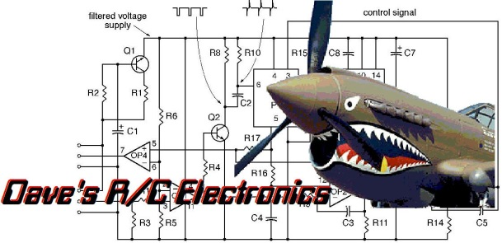
www.davesrce.com
sales@davesrce.com
(423) 544-1657
SCAN HERE

