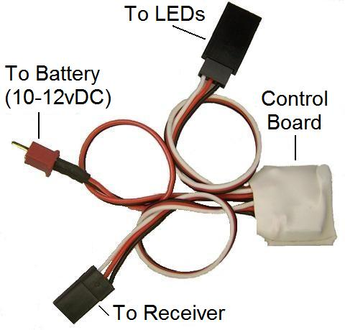
Afterburner Ring

The 7 ¾” strip of orange 3528 LEDs can be installed on either the inside or outside of your model’s afterburner cone, and when connected to the receiver will come on when the throttle stick is advanced to the full throttle (WOT) position. The LEDs are powered by voltage from a 3-cell 11.1volt Li-Po battery, which can be provided by a separate battery installed in the model, or in the case of electric models, can be supplied by the regular Li-Po flight pack. Because they only “flicker“ when on, the LEDs draw very little current. They are mounted on a flexible strip backed with 3M self-adhesive tape, and can be cut to length between every 3rd LED to fit models of almost any size. Additional LEDs can easily be added for models with extremely large afterburner cones.

Install the LEDs in whatever manner is suitable for your model. The best effect is achieved when they are mounted inside the afterburner cone or ring, back from the edge about ½” or so. You may want to paint the inside of the cone black to make the LEDs more visible. If necessary, they can be secured more firmly by adding a few drops of CA to the back of the strip. Route the LEDs’ power wires up through the model and connect them to the female servo connector on the control unit marked “To LEDs“. If the LEDs’ wires have to be run through the side of the fuselage or through a bulkhead, you can un-solder the wires where they are connected to the LED strip, route them as needed and then re-solder them. The polarity of the solder pads is marked on the strip with small (+) and (-) symbols. (On ducted fan models, make sure the LEDs’ wires don’t interfere with the operation of the fan unit. It may be best to route the power wires on the outside of the model to get around the fan blades.) If you choose to use the model‘s 3-cell flight pack to power the LEDs, you can simply add a matching Mini-Deans connector to the wires coming from your ESC. On electric models that use a 4-cell or bigger flight pack, power for the LEDs can be taken directly from the balance tap, using a connector that fits your particular battery‘s balance connector. On glow models, you’ll need to install a separate 3-cell 11.1 volt Li-Po battery in your model to power the LEDs. An 800MAh battery or bigger should provide enough power for a full weekend of flying. Connect the battery lead to the 2-wire lead from the control unit marked “To Battery”.

Connect the control board to your receiver’s throttle channel using a common servo Y, or you may choose to plug it into a spare channel that is then mixed with the throttle channel. Note: For the circuit to work correctly you must make certain that the “ATV” or “End Point” of your throttle channel is set at 100% (throttle stick forward or high). Operation of your Afterburner Ring is simple, simply advance the throttle stick to near the WOT position, and the LEDs will flicker to simulate a full-scale afterburner.

If you have any questions or problems, don’t hesitate to contact me. ENJOY!
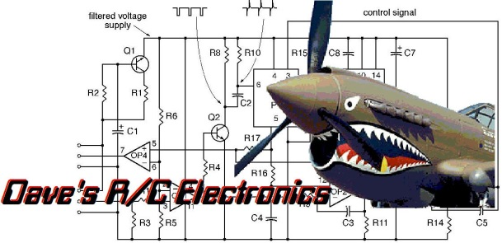
www.davesrce.com
sales@davesrce.com
(423) 544-1657
SCAN HERE

