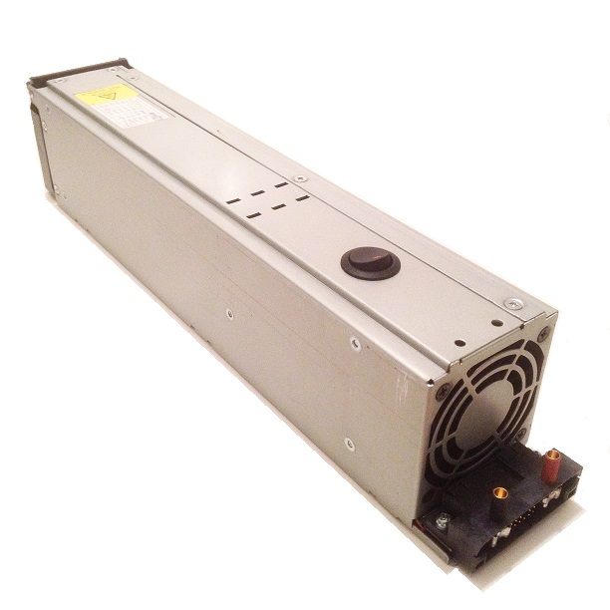
41 amp 12 volt Power Supply

This power supply consists of a computer server power supply that has been converted for use as a bench top power supply. It provides a highly regulated 12 volt output that’s perfect for use with battery chargers that require a lot of amps when charging at high current levels, or for use when charging several batteries at once. As with most computer-based power supplies, the circuit itself is overload protected, temperature protected, and short-circuit protected, making it almost impossible to damage in normal use, and is cooled by high-speed fans that protect the internal components even when operating at high current levels. If the outputs are shorted or overloaded, or if the unit overheats, it will shut down before damage can occur, and can be re-set by simply turning it off for a few seconds before turning it back on again.

The blade-type connectors on the front of the unit are normally used to connect it to the server tower, but we have installed standard-size 4.0mm banana jacks to make it easy for you to connect your charger to the power supply’s output. The switch on the top of the unit makes it easy to turn the power supply on/off without having to unplug the unit from the wall outlet.

Observe the correct polarity when connecting your charger, red = (+) and black = (-). Keep the unit’s fan clear, especially when charging at high current levels.

If you have any questions or problems, don’t hesitate to contact me. ENJOY!

www.davesrce.com
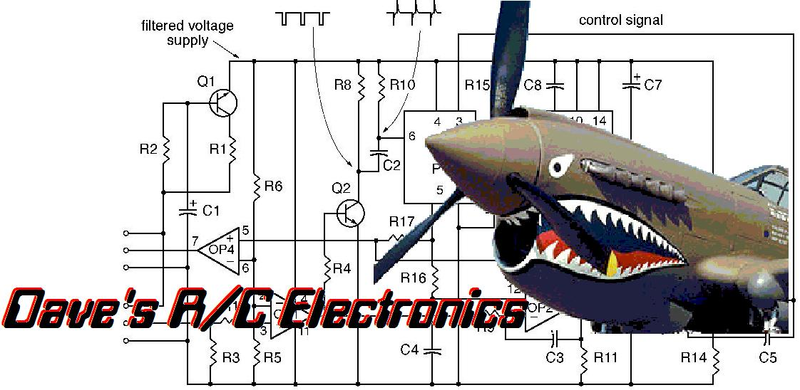
sales@davesrce.com
(423) 544-1657
SCAN HERE

