DeHavilland Beaver NavLights - 8mm Giant Scale

The DeHavilland Beaver NavLight Light Set includes 2 Wingtip Lights (1-red, 1-green), 2 Landing Lights (white), 2 Wingtip Strobes (white), 1 Fuse Strobe (red), and 1 Tailcone Beacon (white). The Fuse and Wingtip Strobes are pre-set in a double-blink pattern, and they blink asynchronously with each other. The Tailcone Beacon is solid, as are the Wingtip Lights. The Landing Lights blink back and forth in what is usually referred to as a “Wig-Wag” pattern, standard for many float planes like the Beaver and the Cessna Bushmaster.
The circuit is controlled by the transmitter, and features three distinct modes. Mode 1 is All Lights Off. Mode 2 turns the Wingtip Lights (2), Strobes (3), and Tailcone Light ON. In Mode 3, all Lights are ON, including the Landing Lights (2). The modes are toggled by advancing the channel into which the circuit is connected, and the unit must be plugged into a proportional channel like the flap channel or higher, rather than the gear channel. Consult the manual for your specific transmitter for instructions on programming a mix that will allow you to use a 3-position switch to control the various modes. The chart below shows the approximate channel settings used to achieve the three Modes of operation.

Mode | Function | Channel Setting
Mode 1 | All Lights OFF | less than ~ 40%
Mode 2 | Wingtips, Strobes, Tailcone ON | ~40% to ~ 60%
Mode 3 | All Lights ON (including Landing) | ~60% or greater

The LEDs are powered from the receiver’s battery pack, and since this circuit is regulated, it can be used on any receiver and any size or voltage receiver battery, including HV (high voltage) receivers. Total current draw is still very low, so there is no need for a separate power source.

If you have any questions or problems, don’t hesitate to contact me. ENJOY!
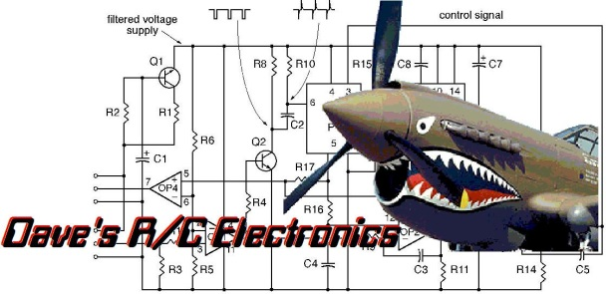
www.davesrce.com
sales@davesrce.com
(423) 544-1657
SCAN HERE

