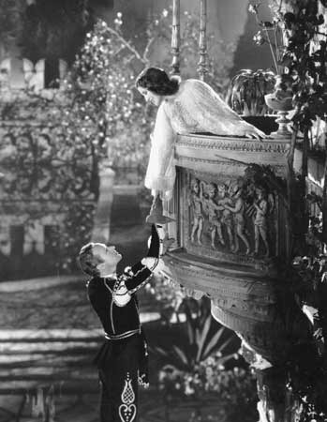

English Language Arts is used in our daily lives to communicate ideas and feelings, in understanding our environment and personal relationships with others, and in the enjoyment and understanding of literature, music and drama. This class will provide students with the opportunity to develop and apply their knowledge and skills of the English Language within the six strands of language arts: listening, speaking, reading, writing, viewing and representing.
Competencies – Skills
- Conduct effective inquiry and research based learning.
- Exchange ideas and viewpoints in a respectful manner.
- Respond to text in personal, creative and thoughtful ways.
- Ask questions about the text, the author, the period of time in which it was written, etc.
- Exploring different ways of presenting stories: visual, written, oral, etc.
- Being able to identify and understand the various elements of a text, including plot, theme, and audience.

Themes

Creativity: Students write stories, poetry, plays, etc.

Stories: How they relate to our lives.

Interpreting: Understanding intended meaning and application.

Writing: exploring different styles

Reading: exploration of texts.
Migra.on: changing cultural

Migra.on: changing cultural

Big Ideas

Language and Text can be a source of creativity and joy.

Exploring stories helps us understand ourselves and the world around us.

We interpret what we see and read based on our worldview.

Texts are socially, historically, and culturally constructed.

Questioning what we read and hear helps us become educated and engaged citizens.
The Big Ideas provide some focus areas and themes for our course, and will help explain why English Language Arts is important. At the heart of this course is the exploration of stories and their importance in our daily lives. To do this, we will practice skills and processes known as Competencies by exploring, interpreting, and analyzing different texts. We will discuss in class and present our findings. Students will take the ideas and themes found in the stories and illustrate how they are relevant in our modern world today.
Course Expectations
- Mutual Respect – treat the students, teacher, and learning space with dignity, safety, calmness and joy.

- Self-reliance – take responsibility for your actions, attendance, work habits, expected workload, deadlines and progress.

- Balance – there is a season for everything (even in our class): group, individual, talk, listen, laugh, reflect.

- Curiosity – ask thoughtful questions of the content, your self, teacher, classmates, and ask for help when you need it.

- Technology – cell phones, tablets, iPods, etc. are to be put away, unless instructed for use by the teacher.
Hatzic Middle School
Fall/Winter Semester 2016-17

English Language Arts 8
Mr. M. Koe
http://mykekoe.wixsite.com/koeville
E-mail: Mykael.Koe@mpsd.ca

William Shakespeare’s
Romeo and Juliet

Late Policy
For you…
- If you’re late, come talk to me about it.
- If it becomes a routine I will contact your parents.
For homework…
- If you forget to do it, please try to get it in that day (by the end of the day.)
- If you need an extension, come talk to me.
- If you don’t talk to me, and you don’t hand it in, then it’s going to be -10% for each day it’s overdue.

Grading
Task | Percentage
Silent Reading + Assignment | 10%
Classwork + Homework | 40%
Projects + Essays | 30%
Tests | 20%

Grades
Grade | Meaning | Percentage
A | Excellent | 86-100
B | Very Good | 73-85
C | Satisfactory | 67-72
C | Satisfactory | 60-66
C- | Satisfactory | 50-59
I | Incomplete | 0-49
F | Failing | 0-49

English Language Arts 8 Course Outline

Term One

Unit 1 – Short Stories
Unit 2 – Creative Writing

Term Two

Unit 3 – Poetry
Unit 4 – Poetry Remix
Unit 5 – Novel Study

Term Three

Unit 6 – Essay Writing
Unit 7 – Literature Circles
Unit 8 – Media Literacy

Term Four

Unit 9 – Shakespeare

Required Materials:
- Binder with dividers
- Loose-leaf paper
- Two different colored highlighters.
- Pencil pouch with Pencil Crayons. Eraser and Sharpener
- Pencil or Pen
- Recommend bringing independent reading book
It is essential that students come prepared to class every day. If acquiring these materials is a problem, please let me know and I will help you get what you need.
8th Grade English Language Arts Syllabus 2017-18
Mr. M. Koe

Student Name (Print) _________________________________________________

I have read, reviewed with my parents/guardians, and understand the guidelines and expectations for this course.

______________________________________________ _____________________
Parent/Guardian Signature Date

______________________________________________ _____________________
Student Signature Date

Parent/Guardian Contact Information:

Home Cell Work | Phone Number: ______________________
Best time to call: _____________

Home Cell Work | Phone Number: ______________________
Best time to call: _____________

Address: ___________________________________________________________________________

E-Mail Address: _____________________________________________________________________

What is the best way to contact you? (Check all that apply)
Home Phone Cell Phone Work Phone E-Mail Home Visit School Conference
Comments:

Please answer the following questions:

Tell me something special about your child. Do they have a special talent or interest?

Does your child struggle in writing, class presentations, or reading comprehension?

Is there anything else you would like me to know about your child?

