B.C. First Peoples 12
Chapter 4-6 Test

Section 1 - Definitions
Choose any 4 of the following 9 words and give a definition (1 mark) and an example to illustrate your own understanding of the word (1 mark) Total = 8 Marks

- Colonialism
- Imperialism
- The Gold Rush
- The Fur Trade
- Nookta
- Chilcotin Wars
- Gold Rush
- Gunboat Justice
- James Douglas

1. ______________________________ Definition: ___________________________________________________________________
_________________________________________________________________________________________________________________
_________________________________________________________________________________________________________________
Example: _________________________________________________________________________________________________________________
_________________________________________________________________________________________________________________

2. ______________________________ Definition: ___________________________________________________________________
_________________________________________________________________________________________________________________
_________________________________________________________________________________________________________________
Example: _________________________________________________________________________________________________________________
_________________________________________________________________________________________________________________

3. ______________________________ Definition: ___________________________________________________________________
_________________________________________________________________________________________________________________
_________________________________________________________________________________________________________________
Example: _________________________________________________________________________________________________________________
_________________________________________________________________________________________________________________

4. ______________________________ Definition: ___________________________________________________________________
_________________________________________________________________________________________________________________
_________________________________________________________________________________________________________________
Example: _________________________________________________________________________________________________________________
_________________________________________________________________________________________________________________

Section 2- Mapping Section
On the Map Below, identify (by drawing) the location of the following places in British Columbia.

      - Yuquot Cariboo Wagon Road
      - Hope Vancouver Island
      - Yale Douglas Trail via Harrison Lake
      - Lytton Harrison Lake
      - Quesnel
      - Williams Lake
      - Prince George
      - Barkerville

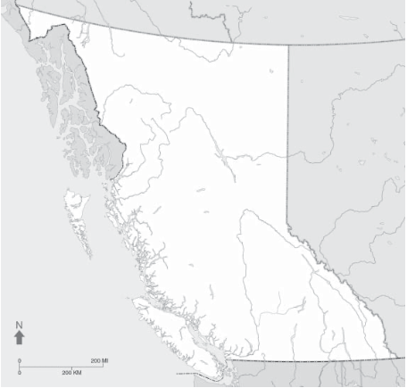
Section 3 - Short Answer – Choose 6 of the following 20 questions to answer. Always offer examples to supplement your responses. Remember your reader knows NOTHING about these subjects; they will be grading you based off of your ability to explain each of these

- Explain how early explorers came to B.C.’s waters with reference to Sir Francis Drake, Juan Perez and James Cooke expeditions. (Who did they encounter, and where did each of them land – create a small map to illustrate their arrivals)
- Explain how the Maritime Fur Trade worked? (What items did Europeans trade with the FN, what items did FN trade with Europeans, what did Europeans use their new items for back in the “Old World’?)
- Explain how the Land Based Fur trade worked? (What companies were involved? Who were some of the early explorers to B.C.? How did they ship their products out prior to 1821? How did the ship them out after? What did FN trade with the Europeans? What did Europeans trade with the FN?)
- Explain how certain FN tribes were mediators – offer an example of one such tribe and how it aided the Europeans in that area, offer an example also of one such fort that did not receive FN assistance and the consequences of that.
- Explain the role of women during the Fur Trade with reference to the Connoly vs. Woolrich case and why this is significant to FN women/children? (Remember:
- Explain the impacts that the fur trade had on FN communities (Focus on Social, Political, and Economic impacts)
- Explain how diseases like smallpox and measles came to B.C. during the Colonial Period and what impact they had on FN communities; specifically reference how they transferred from South B.C. to North B.C.
- Explain the impacts the Gold Rush had on B.C., with reference to what changes it brought to FN communities as well as the Map of B.C.
- Explain what the Douglas Treaties were, how they affected FN communities and what impact they had on FN communities in B.C.?
- Explain what Gunboat Justice was and how the colony of B.C. utilized it to control FN communities?
- Explain the events of the Chilcotin War/Massacre and their significance for FN communities?
- Explain how the “Indian Act” came about, some of the laws it created and the impact this might have on FN communities.

Section 4 - Essay – 30 Marks

