Demographic Test

Answer all of the following questions on the scantron provided. Please make sure you use a Pencil.
- In the 1804 the World Population was at ___________?
  - 1 Billion
  - 2 Billion
  - 3 Billion
  - 500 Million
- Today the World’s Population is at _________ ?
  - 7.1 Billion
  - 6.3 Billion
  - 7.7 Billion
  - 10 Billion
- Many of the world issues that confront us today cannot be understood without studying our relationship to __________________.
  - The Ozone Layer
  - Other People
  - The Planet we live on.
  - McDonalds.
- In Ancient Times which of the following was not a benefit of having large population?
  - It allowed for a strong military
  - It allowed for a lesser tax collection.
  - It allowed for better security.
- Which of the following is not a reason for population growth in the 20th century.
  - Clean Water
  - Medicinal Improvements
  - Agricultural Improvements
  - Increased Death Rates

Using this Chart – Answer Questions 6-9
Country | Birth Rate per 1000 | Death Rate per 1000 | Natural Increase per 1000 | Percentage of Increase
Germany | 8.42 | 11.29 | -2.9
Greece | 8.80 | 11.00 | -2.2
Portugal | 9.42 | 10.97 | -1.55
Spain | 10.91 | 8.72 | 2.19
Norway | 10.90 | 9.26 | 1.64
DR = 70/N.i % N.I. % = N.I / 10
- What is the percentage of increase for Greece?
  - -.22
  - -.0022
  - -.022
  - -2.2
- What is the Percentage of Increase for Spain?
  - .0219
  - .219
  - .00219
  - .000219
- How long will it take Spain’s Population to Double?
  - 400 years
  - 319 years
  - 364 years
  - 754 years
- How long will it take Norway’s Population to Double?
  - 426 years
  - 300 years
  - 310 years
  - 2199 years

- The majority of the world’s population lives close to the ______________.
  - Mountains
  - Oceans
  - Desserts
  - None of the Above
- Over half the world’s population lives on what percentage of the land?
  - 5%
  - 25%
  - 50%
  - 35%

Use the following Chart to answer Questions 12-14
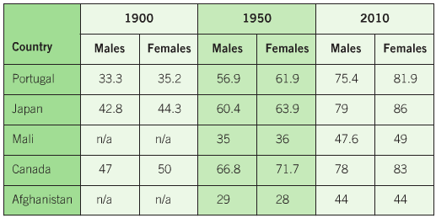
- Which Two Countries are most similar from 1900 - 2010
  - Portugal and Japan
  - Japan and Mali
  - Canada and Mali
  - Afghanistan and Portugal
- If Canada and Japan were considered ‘developing’ countries in the 1900, which country in 2010 could be considered ‘developing’
  - Portugal
  - Mali
  - Japan
  - Canada
- In which country do woman life the longest in 2010?
  - Japan
  - Canada
  - Portugal
  - Afghanistan
- Population Density is calculated by
  - Dividing the number of people in a population by the total land area
  - Dividing the number of people living in towns and cities by the total land area
  - Dividing the total land area by the number of people
  - Multiplying the number of people by the total land area
- The Natural Increase is calculated by …
  - Adding the birth rate to the death rate
  - Subtracting the birth rate from the death rate
  - Subtracting the death rate from the birth rate
  - Subtracting the death rate from the birth rate and adding the number of immigrants.
- Birth and Death Rates are always given as a rate per….
  - 10,000 people
  - 1,000,000 people
  - 100 people
  - 1,000 people
- A Graph that displays age and gender is known as a _________________________.
  - Population Pyramid
  - Doubling Population
  - Gender-Age Pyramid
  - Population Triangle

Use the following Diagram to Answer Questions 19-23
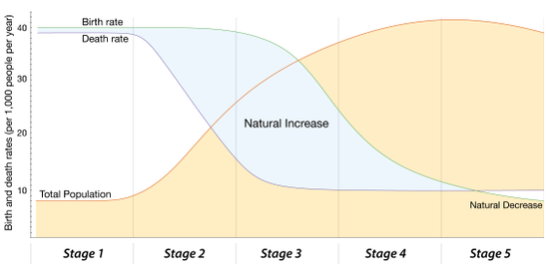
- At which stage does the Death Rate begin to decrease?
  - Stage 1
  - Stage 2
  - Stage 3
  - Stage 4
- At which stage does the Birth Rate begin to decrease?
  - Stage 1
  - Stage 2
  - Stage 3
  - Stage 4
- At which stage does the Population Rate begin to Increase?
  - Stage 1
  - Stage 2
  - Stage 3
  - Stage 4
- At which stage does the Birth Rate and Death Rate reach the lowest point?
  - Stage 1
  - Stage 2
  - Stage 5
  - Stage 4
- At which stage does the Population Reach its Pinnacle?
  - Stage 1
  - Stage 5
  - Stage 3
  - Stage 4

Use this chart to answer questions 24-25
Date | Immigrants | Emigrants | Net Migration
2011 | 248,700 | 56,677
2012 | 257,905 | 61,904
2013 | 259,024 | 60,370
2014 | 260,411 | 63,629
2015 | 240,844 | 64,079
2016 | 320,932 | 67,144
- What was the net migration in 2011?
  - 199,000
  - 305,377
  - 248,700
  - 192,023
- What was the net migration in 2016?
  - 253,788
  - 388,076
  - 465, 700
  - 320,932
- Demographic Transition theory states that, as a country becomes industrialized,
  - the birth rate declines and then the death rate declines
  - the death rate declines and then the birth rate declines
  - neither birth nor death rates decline
  - the death rate declines, but not the birth rate
  - the birth rate and death rate decline together.
- The most important fertility-reducing practice in our society is ______________.
  - religious values
  - contraception
  - vasectomies
  - breast-feeding
  - abortion.

- In our society, the most significant expectation of life different is between/among _________________.
  - sexes
  - classes
  - liberals and conservatives
  - ethnic groups
  - religious groups.
- If you move from Mission to Vancouver, you are referred to as what?
q. Immigrant
b. Migrant
c. Emigrant
d. All of the above.
- If you move from Mission, where you were born and raised, to Portland, Oregon, you are referred to as what?
a. Immigrant
b. Migrant
c. Emigrant
d. All of the above.
- If you move from Mexico to Canada you are referred to as what?
  - Immigrant
  - Migrant
  - Emigrant
  - All of the above.
- Thomas Malthus predicted a global crisis involving
  - poverty
  - starvation
  - war
  - economic deprivation
  - nuclear disaster
- The dependency ratio is the ratio of ____________________________.
  - Young to middle-ages people
  - Young to old people
  - Young and old to working-aged people
  - Old to middle-aged people
  - Young to working-ages people

- The increasing concentration of human populations in cities is called urbanization.
  - True
  - False
- What event in the mid-1700s significantly changed human population growth?
- Industrial Revolution
- development of agriculture
- bubonic plague
- human settlement began
36. Which combination of factors will produce the highest rate of population growth?
- high life expectancy and high infant mortality
- low life expectancy and low infant mortality
- low life expectancy and high infant mortality
- high life expectancy and low infant mortality
- In the time it took you to read this sentence, people were born and people died, but it is likely that fewer people were born than died.
  - True
  - False
- If 300 bears live within a 20-km² area, then 15 bears per km² is the bears ______ for that area.
- Carrying Capacity
- Population Density
- Limiting factor
- Survivorship curve

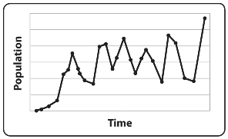
39. In the graph above, the population size is
- increasing.
- decreasing.
- remaining stable.
- None of the Above.

40. A population’s growth rate is determined by births, deaths,
- immigration, and emigration.
- immigration, and migration.
- migration, and biotic potential.
- immigration, and biotic potential.

41. Which of the following has the highest population density?
- 100 deer in 100 sq kilometers
- 20 deer in 10 square kilometers
- 10 deer in 10 square kilometers
- 50 deer in 20 square kilometers

42. Every summer, Siberian cranes fly from India to Siberia, where they breed and raise their young. When winter comes, the cranes fly back to India. This is an example of
- immigration.
- emigration.
- migration.
- population control.
43. The equation for determining population growth is
- (births + deaths) – (immigration + emigration).
- (births + emigration) + (deaths – immigration).
- (births + immigration) + (deaths – emigration).
- (births + immigration) – (deaths + emigration).

