B.C. First Peoples 12
Chapter 1-3 Test

Section 1 - Definitions
Choose any 4 of the following 9 words and give a definition (1 mark) and an example to illustrate your own understanding of the word (1 mark) Total = 8 Marks

- Elder
- Oolichan
- Intertidal Zone
- Seasonal Rounds
- Muskeg
- Stewardship
- Obsidian
- Medium of Exchange
- Lahal

1. ______________________________ Definition: ___________________________________________________________________
_________________________________________________________________________________________________________________
_________________________________________________________________________________________________________________
Example: _________________________________________________________________________________________________________________
_________________________________________________________________________________________________________________

2. ______________________________ Definition: ___________________________________________________________________
_________________________________________________________________________________________________________________
_________________________________________________________________________________________________________________
Example: _________________________________________________________________________________________________________________
_________________________________________________________________________________________________________________

3. ______________________________ Definition: ___________________________________________________________________
_________________________________________________________________________________________________________________
_________________________________________________________________________________________________________________
Example: _________________________________________________________________________________________________________________
_________________________________________________________________________________________________________________

4. ______________________________ Definition: ___________________________________________________________________
_________________________________________________________________________________________________________________
_________________________________________________________________________________________________________________
Example: _________________________________________________________________________________________________________________
_________________________________________________________________________________________________________________

Section 2- Mapping Section

On the Map Below, identify (by drawing) the location of the following places in British Columbia.
      - (2) Mountain Ranges: Cascade, Coast, Rockies, Columbia
      - (3) Rivers: Fraser, Thompson, Kootenay, Columbia, Skeena
      - (3) FN Territories: Kwakwaka’wakw , Haida, Sto:lo, Squamish, Nisga’a
      - (2) Lakes: Kootenay, Harrison, Okanagan, Atlin, Quesnel

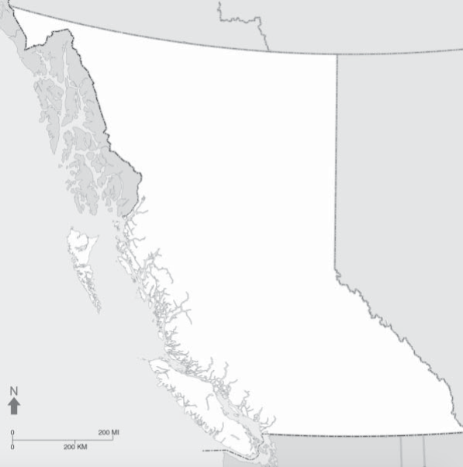

Section 3 - Short Answer – Choose 6 of the following 20 questions to answer. Always offer examples to supplement your responses.

- Explain the difference between the Metis, Inuit and First Nations in Canada.
- Explain the Story of the “Raven and the First Men” and the significance to FN people.
- Explain the Story of “Turtle Island” and the significance to FN people.
- Explain the Theories around how “First Peoples” arrived in North America (make reference to the Beringia Theory, Sea Routes, (be sure to reference dates) and why it’s important to First Peoples today.
- Explain what a worldview is, how it is constructed, and how it differs between First Peoples and Western Europeans?
- Explain what a Traditional Territory is, with reference to the traditional territories of the 4 tribes M.S.S is found on.
- Pick one of the Four Regions in B.C. (The Coast, Southern Interior, Northern Interior, and North-East Region) and explain what the climate is like, what resources can be found there, and what the culture of the people was like (buildings, arts, spiritual practices, etc)
- Explain what Traditional Ecological Knowledge is and how FN people are utilizing it today with the scientific community?
- Explain what controlled burning is and how it was used in FN communities in B.C. in the past?
- Explain how FN communities have used different trapping methods to catch fish, be sure to reference at least 3 types – use illustrations to explain how they function.
- Explain the process of tanning a hide, from beginning to end, with reference of how hides are used in FN cultures today.
- Explain the difference of buildings, between the Sto:lo and Haida, and that of the interior FN. Be sure to draw illustrations where appropriate to explain to your reader what you’re writing about.
- Explain how the trade economy worked in FN communities in B.C. and how Obsidian has helped the scientific community understand this trade network?
- Explain the FN education system, how is different from that of our western society? What are the benefits/limitations of this system?
- Explain why FN communities fought with each other, the reasoning behind it, and how FN warriors would cleanse themselves after and why?

Section 4 - Essay – 30 Marks

Write a 750-1500 word essay (Introduction, 3 Body Paragraph, Conclusion) - Challenging the following statement. To do this, use the information you gathered during class discussions on “Myth Busting”

“B.C. First Nations have it made. The Canadian Government gives them everything and then some. Free education, free homes on reserves, free use of all resources. They can hunt whenever they want, and can fish whatever they want without any limits, they’re given so much. They don’t pay taxes for anything, they have it made in the shade.”

Bonus Section: Choose 1 of the following 4 topics from a film we watched in class and answer it. (5 marks)
- Explain the process of collecting Herring Roe.
- Explain how a hide is tanned.
- Explain how a seafood garden is created
- Explain how Oolichan Grease is made

