Unit 1
Human Geography:
Demography, Population Growth and Standards of Living
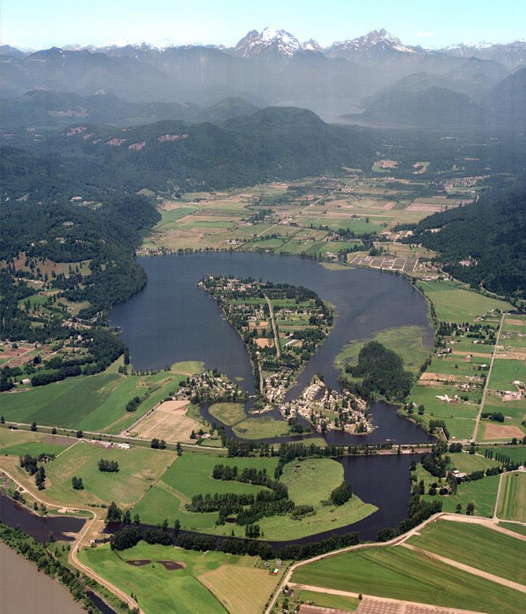
Hatzic Island, Mission

Vocabulary
Using the textbook or ‘Google’ write out the definitions for each of these words. You will need to be familiar with them during this unit.

- Demography:
- Census:
- Developed Country
- Developing Country
- Birth Rate
- Death Rate
- Immigration Rate
- Emigration Rate
- Natural Increase
- Exponential Rate
- Rule of 70
- Doubling Time
- Net Migration
- Population Growth Rate
- Life Expectancy
- Demographic Transition Model
- Mortality
- Population Pyramid
- Age Cohort
- One-Child Policy
- Dependency Ratio
- Carrying Capacity
- Population Distribution
- Population Density
- Nutritional Density

Introduction
- Many of the world issues that confront us today cannot be understood without studying our relationship to the planet on which we live.
- We must understand geography in order to make sense of the complex issues that surround our world.
- We will be studying examining the issues and problems related to the physical world around us.
- The significant growth in population, reasons for this growth, and the ability to meet the demand for resources are examples of topics to be investigated.

Geography
- A broad subject that is concerned with describing and analyzing relationships between people and their home.
- Links the physical sciences with humanities.
- Geography seeks to answer the WHERE, HOW, and WHY questions and to understand their importance.

- Global issues:

- Human geography:

- Inter-connectedness:

- Global Village:

Demography
- The study and analysis of trends relating to human populations.
- Many demographers believe that the world’s rate of population growth needs to slow down.
- Q: Why might the population growth need to slow down?

- Q: What are ways in which a Population can slow down?

- Q: What changes (new technologies, innovations, etc) have come about in the 21st Century to slow these processes down?

- In ancient times, demographers believed that population growth was beneficial:
  - A large population allowed for a strong military and therefore better security.
  - Allowed some cultures to expand their empires (ex. Romans).
- Q: “All levels of government need accurate figures of population change…” Why though? List 5 reasons below

- Businesses are interested in demographic information as they plan marketing strategies.
- Helps us to understand the causes and consequences of population change
Activity #1

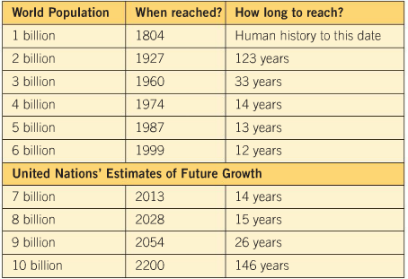
Below…
1) Create a line graph of the actual growth in population from 1804 to 1999 and the four estimates for 2013 – 2200.
  - Make sure to Label your X and Y Axis

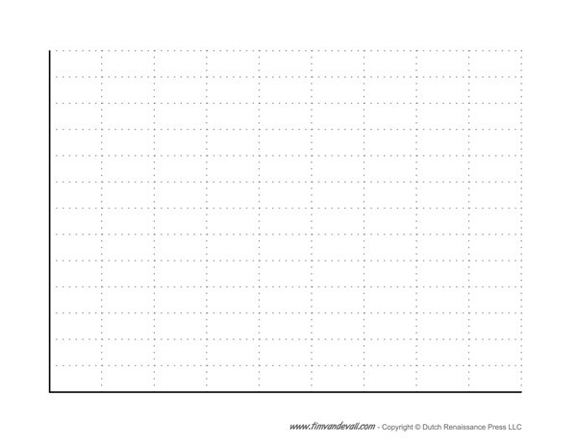

Activity #1 Cont’d

- Brainstorm reasons for
  - The rapid growth in the 20th century.
  - Reasons for the different UN estimates
  - Possible consequences of rapid growth.

Questions | Reasons
Rapid Growth in the 20th C
Reasons for Different UN estimates
Possible Consequences of Rapid Growth

Census
- A Census is a Survey
- In order to help governments maintain accurate records of its people, most countries complete a census every five to ten years.
- A census is a national count of the population.
- It is the process of collecting, compiling, and publishing demographic, economic, and social data pertaining to a particular time.
- Limits of a census:
  - Rarely completely accurate.
  - Difficult to track individuals without a permanent address.
  - Many births/deaths go unrecorded and skews census data.
  - Illiteracy and poor communication make it difficult to complete therefore it’s difficult to combat the problem and the trends becomes circular.

Q: For this exercise I want you to put yourself into the shoes of someone else (not literally). Brainstorm 3 questions that you might want to ask on a census based on the perspective of each person below.

i) A Teacher
1)
2)
3)
ii) A Developer
1)
2)
3)
iii) A Police Officer
1)
2)
3)

Activity #3
Your job is to make a map that shows both sets of data from this table below. You may work with a partner, but you each must submit a map.
1. Decide how you want to represent the data sets. Remember, you are putting the data on a map to create a visual message. If you just write the corresponding numbers from the table in each province, are you making good use of the map? Will the reader be able to see the patterns in the map?
2. How can you use colors, patterns, or symbols to represent the data sets? You will need to divide the data into ranges. To do this, arrange each set from least to greatest, and divide it according to the number of ranges you would like to use. Make sure each range or category contains data. Then, color the map.
3. Once you have represented the data on your map, fill in the map key. Include the ranges for the colors, patterns and/or symbols you have used.
Province | Average House Price | Median Income (2015)
BC | $730,000 | $33,012
Alberta | $387,000 | $42,717
Saskatchewan | $288,000 | $38,299
Manitoba | $296,000 | $34,188
Ontario | $578,000 | $33,539
Quebec | $297,000 | $32,975
N.S | $249,000 | $31,813
N.B | $178,000 | $30,961
P.E.I | $230,000 | $31,744
Yukon | $420,000 | $45,804
N.W.T. | $396,000 | $50,618
N.L | $246,000 | $46,088
Nunavut | $475,000 | $29,743
*Median Income: This is the middle income, meaning 50% of the population makes more than this, and 50% makes less.
http://www.eco.gov.yk.ca/pdf/Income.pdf
https://www.livingin-canada.com/house-prices-canada.html

Calculating Population Change
- Demographers are most interested in statistics that help them predict trends or changes in a population.
- There are four basic components to population change
1)
2)
3)
4)

Year | World Population
6, 000 BCE | 5 million
1 CE | 250 million
~1800 | 1 billion
1960 | 3 billion
Today | 7.6 billion
2100? | 10 billion?
Exponential Population Growth
- The table above highlights the __________________________ _______________________ ___________________________ the world has experienced since 1800.
- Exponential population growth is characterised by ultra-rapid growth occurring over a short period of time.
- Does not occur equally across the globe, some regions are faster/slower than others.
- Population clock: http://www.worldometers.info/world-population/

Activity #4: What are some concerns about such growth? List 3 Problems with this type of rapid population Growth, and 3 Benefits.
Problems
1)

2)

3)
Benefits
1)

2)

3)

Natural Increase Equation
Birthrate is the number of children born in a region for every 1000 inhabitants.
Canada = 10.6 = Birthrate per 1000
Death rate is the number of people who die in a region for every 1000 inhabitants.
Canada = 7.4 = Death rate per 1000.

Equation =

Doubling Time
The amount of time it takes a population to ______________.
__________________________ – Doubling time is equal to seventy divided by the growth rate (per year).
Canada’s natural growth rate = 0.6
Canada’s growth rate (including immigration) = 0.9
How long will it take for our population to double?
Activity #5

Fill in this chart below and calculate the Natural Increase and Percentage of Increase.

Country | Birth Rate per 1000 | Death Rate per 1000 | Natural Increase per 1000 | Percentage of Increase
Germany | 8.42 | 11.29 | -2.9 | -.0029
Greece | 8.80 | 11.00
Portugal | 9.42 | 10.97
Spain | 10.91 | 8.72
Norway | 10.90 | 9.26
Finland | 10.35 | 10.51
Poland | 9.77 | 10.37
Hungary | 9.16 | 12.73
Ukraine | 10.50 | 14.40
Latvia | 9.90 | 14.40
Namibia | 21.82 | 12.97
Yemen | 34.37 | 7.24
Somalia | 43.44 | 15.24
Uganda | 47.55 | 11.90
Madagascar | 37.89 | 7.97
Country | Birth Rate per 1000 | Death Rate per 1000 | Natural Increase per 1000 | Natural Increase percentage
Jordan | 27.06 | 2.66
Iraq | 29.41 | 4.92
Kenya | 35.14 | 9.26
Rwanda | 37.26 | 10.19
United States | 13.83 | 8.38
Hong Kong | 7.45 | 6.91
Taiwan | 8.97 | 6.87
South Korea | 8.72 | 6.15
China | 12.17 | 6.89
Australia | 12.39 | 6.81
Cuba | 11.02 | 7.29
Barbados | 12.42 | 8.39
Argentina | 17.75 | 7.39

2. Earlier you learned how you could take Census data and plot it on a map using different colors/symbols. I would like you to plot the data unto a world map. The World Map will be provided to you!
- Arrange your data from lowest to highest in regards to the Natural Increase rate. (You may do this on the side of your Chart, or on a separate piece of paper)

- Now: Create a Range Scale of 5.0 intervals and assign each interval a color. ( -5 – 0, 0-5, 5-10, 10-15, etc)

- Plot the Data unto your Map (You will need to locate the country, assign it a color based on your range)

- Make sure you create a Legend, add a directional chart (compass) and give your map a title.

- When you’re done, answer the questions below

- Q: Which country has the lowest Natural Increase rate?

- Q: Which country has the highest Natural Increase rate?

- Q: Which Continent is seeing the largest increase in Population?

- Q: Which Continent is seeing the slowest increase in Population?

- Using the ‘Doubling Equation’, calculate how many years it will take each of the following countries to double their population.
  - United States
  - Jordan
  - Kenya
  - Norway
  - Uganda

Doubling Equation = 70 x % of growth rate = years for a country to double.
Activity #6
Net Migration
Net Migration Equation = _____________________________________

- Congratulations! You’re well on your way to becoming a fully certified Geographer! Let’s utilize some of the skills you’ve been learning to complete this activity.
- Complete the Chart below.
Net Migration Equation = Immigrants (minus) Emigrants = Net Migration
Date | Immigrants | Emigrants | Net Migration
2010 | 280,700 | 52,335
2011 | 248.700 | 56,677
2012 | 257.905 | 61,904
2013 | 259,024 | 60,370
2014 | 260,411 | 63,629
2015 | 240,844 | 64,079
2016 | 320,932 | 67,144
2. Create a point graph on the Net Migration on the Chart Below.

Bonus: Why in 2016 was there a sudden jump in Immigrants to Canada? What happened this year in the Government and around the world?
Population Growth Rate:_______________________________________
_________________________________________________________
Activity 7
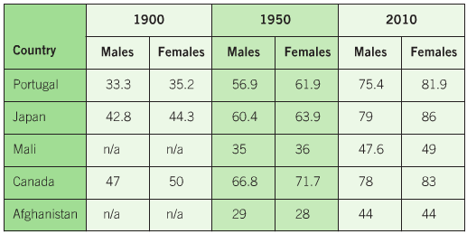

- List 3 factors that have contributed to population growth in these countries?
1)
2)
3)
- Suggest 2 reasons for the higher life expectancies.
1)
2)
- How might a demographer use the information to argue that Japan and Canada in the 1900’s were a developing country?
____________________________________________________________________________________________________________________________________________________________________________________________________________________________________________________________________________________________________________________________________________________________________________
Demographic Transition Model

Demographic Transition Model: _________________________________
_________________________________________________________
_________________________________________________________
_________________________________________________________
Stage 1:
Stage 2
Stage 3:
Stage 4
Stage 5

Activity 8
Examine the Chart Below then answer the following questions:
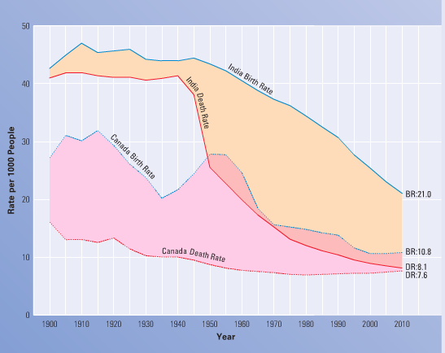

- In which years was the natural increase greatest of each country?
  - Canada:__________________________________
  - India: ___________________________________
- Based on the demographic transition model, in what stage is:
  - Canada at Present: __________________________
  - India at Present: ___________________________
- Make a prediction of what will likely happen to India and Canada in the next five decades. Explain your answer.
______________________________________________________________________________________________________________________________________________________________________________________________________________________________________________________________________________________________________________________________________________________
Population Pyramids

A) Analyze the following Population Pyramids and answer the questions below.
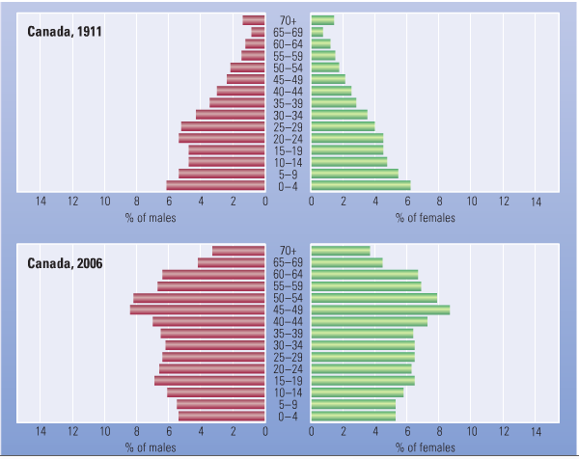
- At what stage of development (early, expanding, stable, or contracting) would you place each of these pyramids?
  - Canada 1911 Male: _______________________________
  - Canada 1911 Female: _____________________________
  - Canada 2006 – Male: _____________________________
  - Canada 2006 – Female: ___________________________

- What impact will the increasing number of older people in 2006 have on the population?
________________________________________________________________________________________________________________________________________________________________________________________________________________

- What other information can be learned by analyzing these pyramids? Give examples of how government and business might use these pyramids to deal with present and future trends.

____________________________________________________________________________________________________________________________________________________________________________________________________________________________________________________________________________________________________________________________________________________________________________________________________________________________________________________________________________________________________________________________________________________________________________________________________________________________________________________________________________________________________________________________________________________________________________________________________________

The Dependency Ratio: _______________________________________
___________________________________________________________________________________________________________________________________________________________________________
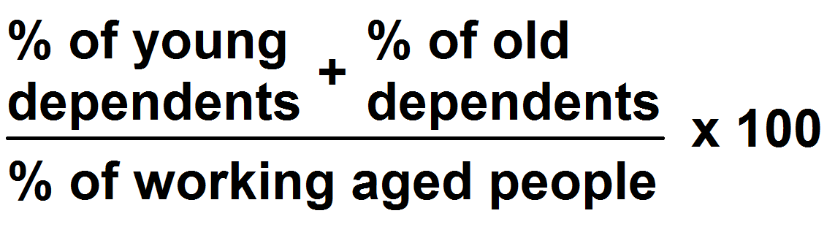

The Population Pyramids
A population pyramid is a _________ that shows the age, sex, and structure of a population.
A bar graph that divides a population by ______ and ____________.
Age: population is divided into 5-year age groups (_________).
Gender: usually males on the left, females on the right.
It makes it easier to analyse the distribution of ages within a particular population.
There are four different types of pyramids:
  - ______________________________
  - ______________________________
  - ______________________________
  - ______________________________

1. | 2.
3. | 4.

Population Pyramids Continued
B) Analyze the Pyramids below then answer the following questions.
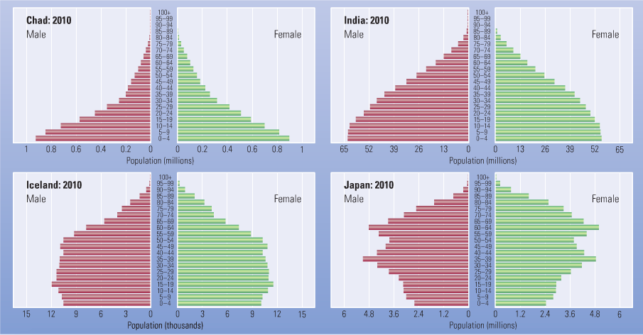
- What evidence is there that the pyramid for Chad has a very high birth rate? What percentage of the population would you estimate is under the age of 15?
________________________________________________________________________________________________________________________________________________________________________________________________________________________
______________________________________________________

- What does the shape of the pyramid for India tell you about trends in infant mortality in that country? How does India compare with Chad and Iceland in this regard?
________________________________________________________________________________________________________________________________________________________________________________________________________________________
- What does the pyramid for Iceland tell you about the future population numbers in that country?
________________________________________________________________________________________________________________________________________________________________________________________________________________________
______________________________________________________
- Suggest a number of problems Japan will face as a result of the age structure of its population?
________________________________________________________________________________________________________________________________________________________________________________________________________________________
______________________________________________________

- In what state of the demographic transition model is each of the pyramids? Explain.
________________________________________________________________________________________________________________________________________________________________________________________________________________________
______________________________________________________
________________________________________________________________________________________________________________________________________________________________________________________________________________________
______________________________________________________

Activity #9

The Dependency Ratio of a country indicates the number of people who need assistance in living from the working class. There are two categories of dependency: Children (ages 0-15) and Adults (ages 65 and older).

List 3 challenges that a young dependency ratio (0-15 years of age) would have on a country like Kenya?

1)__________________________________________________________________________________________________________________________________________________________________________

2)_________________________________________________________________________________________________________________________________________________________________________

3)_________________________________________________________________________________________________________________________________________________________________________

List 3 challenges that an old dependency ratio (65 years or older) would have on a country like the United States.

1)__________________________________________________________________________________________________________________________________________________________________________

2)_________________________________________________________________________________________________________________________________________________________________________

3)_________________________________________________________________________________________________________________________________________________________________________

Historical Significance
List the 3 most likely consequences that Canada’s aging population will have on you.

1)__________________________________________________________________________________________________________________________________________________________________________

2)_________________________________________________________________________________________________________________________________________________________________________

3)_________________________________________________________________________________________________________________________________________________________________________

Population Distribution

- Refers to the way people are spread out over the Earth’s surface.
- Permanently inhabited areas are known as ______________.
- ________ of the world’s land is not suitable for settlement.
- Over half of the world’s population lives on 5% of the land.
- ________ of the people live on _________ of the land.
- ________ of the people live north of the equator.
- 2/3 of people live within 500km of the ocean

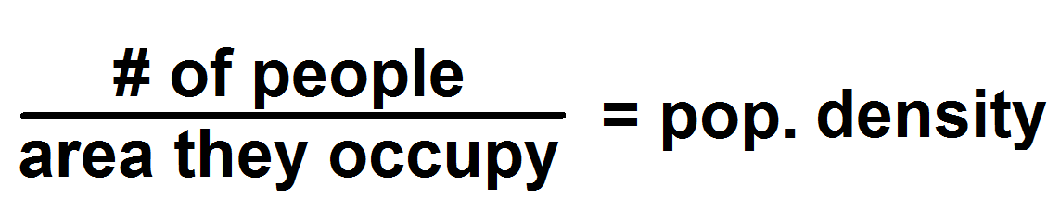
_______________ Factors | ____________  Factors
- __________: Very dry or very cold = low density.  - __________: lowlands = higher density.  - __________: Areas rich in a variety of resources = higher density.  - __________: Rich river valley’s results in higher densities.  - _____________: Areas of very dense vegation (amazon) = low density; grasslands = higher.  - ___________: reliable water source.  - ________________: Easy to reach by land or sea. | - Government Policies: May force people to move (Inuit, Siberia, Amazon)  - ______________: Higher incidence of diseases = less density  - ______________: Highly developed economy = higher density  - _____________: Nomadic or Agriculture.  - Communications: Easy to reach by land or sea.

Activity #10
Each of the dots on this map represents 100,000 people. Analyze the map then answer the questions below!

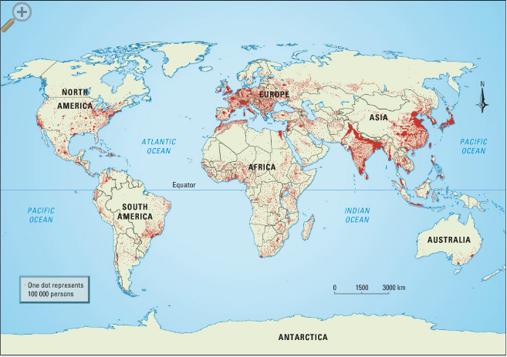

- Why do you think the dot method is used for distribution on the map rather than other methods, such as shading?
________________________________________________________________________________________________________________________________________________________________________________________________________________

- Are the most densely populated areas north or south of the equator?
________________________________________________________________________________________________________________________________________________________________________________________________________________

- Which two continents are most densely populated? Make a list of reasons that might account for the density in these two continents?

