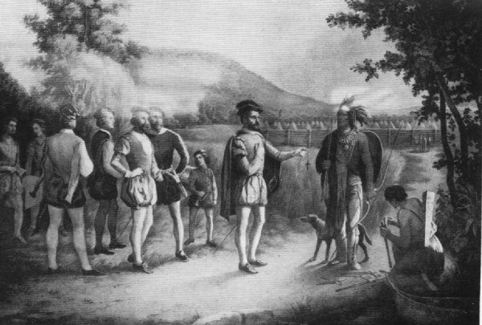

Social Studies is the exploration of people, societies and cultures – in essence it is the exploration of ourselves, the people around us and the world we inhabit. In this course, students will develop critical thinking skills by examining and interpreting historical evidence, assessing and defending various positions, and conducting inquiry research related to our course topics. Students completing Social Studies 9 will have a fuller, more inclusive understanding of Canada’s past, present and future, while understanding their own place within Canada’s story.
Course Expectations
- Mutual Respect – treat the students, teacher, and learning space with dignity, safety, calmness and joy.

- Self-reliance – take responsibility for your actions, attendance, work habits, expected workload, deadlines and progress.

- Balance – there is a season for everything (even in our class): group, individual, talk, listen, laugh, reflect.

- Curiosity – ask thoughtful questions of the content, your self, teacher, classmates, and ask for help when you need it.

- Technology – cell phones, tablets, ipods, etc are to be put away, unless instructed for use by the teacher.
Competencies – Skills
- Conduct effective inquiry and research based learning.
- When presented with evidence or differing views on historical events, students will be able to:
  - Identify what is significant
  - Identify what makes a source credible?
  - Understand bias in pictures, writing, and stories.
  - Identify the Social context of events.
  - Interpret information presented to them.

The Big Ideas provide some focus areas and themes for our course, and will help explain why Social Studies is important. At the heart of this course is the exploration of “What impact does colonization have on the environment and the people” by examining the colonization of North America. To do this, we will practice skills and processes known as Competencies by interpreting primary sources and using them to both generate and answer questions. We will also relate our historical understandings and findings to present day problems and issues within our society.
1541: Jacque Cartier at Hochelega

Themes
Innovation: the power of ideas, adaption and change
Resources: the human- environment dynamic
Conflict: wars, rebellions, control and colonization
Migration: changing cultural identities, emerging issues
Migra.on: changing cultural

Migra.on: changing cultural

Big Ideas

New ideas profoundly influence society and events.

The environment influences political, social, and economic change.

Differences in power can alter the relationships between individuals between societies.

Collective identity is constructed can change over time.

Hatzic Middle School
Fall/Winter Semester 2016-17

Social Studies 9
Mr. M. Koe
http://mykekoe.wixsite.com/koeville
E-mail: Mykael.Koe@mpsd.ca

Late Policy
For you…
- If you’re late, come talk to me about it.
- If it becomes a routine I will contact your parents.
For homework…
- If you forget to do it, please try to get it in that day (by the end of the day.)
- If you need an extension, come talk to me.
- If you don’t talk to me, and you don’t hand it in, then it’s going to be -10% for each day it’s overdue.

Social Studies 9 Course Outline

Term One

Unit 1 – Geography of Canada + Mapping
Unit 2 – The Founding, Rise and Fall of New France
Unit 3 – The Seven Years War

Term Two

Unit 4 – The Industrial Revolution
Unit 5 – The American Revolution
Unit 6 – The French Revolution

Term Three

Unit 7 – Slavery in North America
Unit 8 – Western Expansion: Canada and United States
Unit 9 – Residential Schools in Canada

Term Four

Unit 10 – World War I
Grading
Task | Percentage
Classwork + Homework | 50%
Projects + Essays | 30%
Tests | 20%

Required Materials:
- Binder with dividers
- Loose-leaf paper (100 sheets per term)
- (2) different coloured highlighters (preferably not yellow)
- Pencil pouch with Pencil Crayons. Eraser and Sharpener
- (1) Pencil or Pen
- (1) 6 or 12 Inch Ruler
It is essential that students come prepared to class every day. If acquiring these materials is a problem, please let me know and I will help you get what you need.
Grades
Grade | Meaning | Percentage
A | Excellent | 86-100
B | Very Good | 73-85
C | Satisfactory | 67-72
C | Satisfactory | 60-66
C- | Satisfactory | 50-59
I | Incomplete | 0-49
F | Failing | 0-49

9th Grade Social Studies Syllabus 2017-18
Mr. M. Koe

Student Name (Print) _________________________________________________

I have read, reviewed with my parents/guardians, and understand the guidelines and expectations for this course.

______________________________________________ _____________________
Parent/Guardian Signature Date

______________________________________________ _____________________
Student Signature Date

Parent/Guardian Contact Information:

Home Cell Work | Phone Number: ______________________
Best time to call: _____________

Home Cell Work | Phone Number: ______________________
Best time to call: _____________

Address: ___________________________________________________________________________

E-Mail Address: _____________________________________________________________________

What is the best way to contact you? (Check all that apply)
Home Phone Cell Phone Work Phone E-Mail Home Visit School Conference
Comments:

Please answer the following questions:

Tell me something special about your child. Do they have a special talent or interest?

Does your child struggle in writing, class presentations, or reading comprehension?

Is there anything else you would like me to know about your child?

