French President, Georges Clemenceau
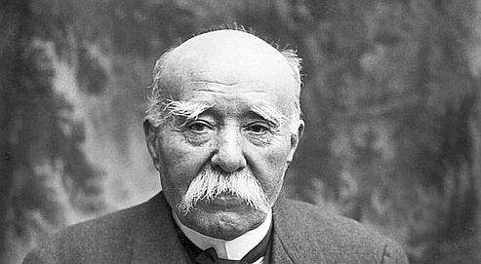
Germany invaded your country, thus starting WWI. Most of the fighting took place on French soil. You, the French, lost 750,000 homes and more than 1.4 million men. You want to punish Germany and make sure that Germany is too weak to fight another war. You feel that Germany should never join ‘The League of Nations’. That you should be given the Saarland which is rich in Coal to help pay your country back for your lost homes and lives. You worry that Germany will want to re-unite with Austria, which could make them strong, and you want them to remain weak. You also want to get the land back that Germany had taken from you 50 years earlier.
Germany took a place called ‘Alsace-Lorraine’ from you in 1871. Should it be returned to France, or should Germany keep it?
The Rhineland is an area from which Germany can easily attack France. You are worried that if Germany is allowed to keep it as before, France will be in danger in the future. Should you try and stop Germany keeping an army there?

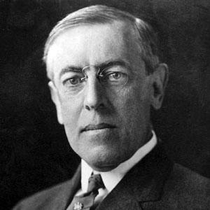
American President, Woodrow Wilson
The Americans did not suffer as much as Britain or France from the War. You lost 116,000 men and a few hundred civilians. The War actually made you a lot of money.
You have a plan to form a ‘League of Nations’, which will help countries to solve problems by encouraging them to talk together. Hopefully this will stop any future wars. Should all countries be allowed to join, or should those at fault for WWI be stopped from joining?

You are worried that a German army may be the biggest danger to future world peace. You don’t want the treaty to be too harsh to them in case they are very angry, and seek revenge. Should you allow Germany to keep a full army, or order Germany to cut down drastically on all her armed forces?

You guess that Germany and Austria may want to join to become one country. They share the same language and culture. Do you allow them to join as one country or not?

British Prime Minister, David Lloyd George
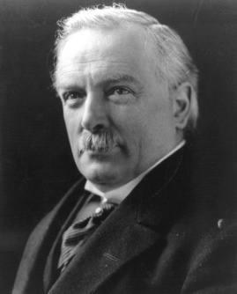
You want Germany to be punished but you also want Germany to remain quite strong. This is because you are worried that if Germany is too weak then communism (which you see as an enemy) might spread from Russia across the whole of Europe. This could lead to another terrible war. You also want to set up a group of countries who will work together to prevent any future wars, like a League of Nations.
Britain had a very large empire and navy. You think that Germany’s empire and navy should be broken up as they might be a threat to your own. You already hold many countries in Africa in your grasp, and now you have the opportunity to own a few more if you can seize them from Germany during the Treaty.
The war had brought massive destruction, especially to buildings and farmland in France. How could all this damage be repaired?

German observers
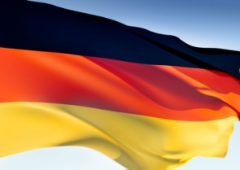
You are invited to observe the proceedings, and must sign the eventual Treaty on behalf of your country, but cannot take part in the decision-making. While you are observing, you are left to consider what the German people will think of the decisions being made.
You did not start the war, you merely came to the aid of your allied country Austria. You were told you would be attacked, so you took initiative and attacked Belgium and France first before they attacked you. During the war, Germany’s borders were never crossed, and you made many advances into France and Allied Territory. Because of this, many German people think you did not lose the war, but just agreed to stop fighting. They think that you should not agree to anything that punishes you when you fought so well.
However, by the end of the war, the German Army Chief decided that the German army could not fight any more. If the war had gone on, then the German army would have collapsed as they were unhappy and running out of supplies. This is why you signed the armistice agreement.

