Unit II:
The great depression
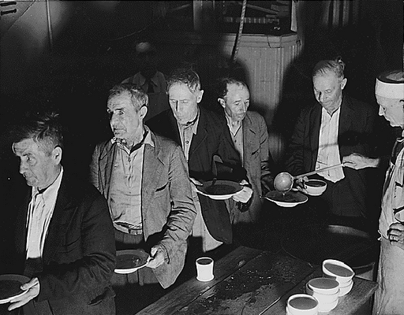

Name: ____________________ PERIOD________

1930’s VOCABULARY

1. Bull Market - continuing rise in stock prices

2. Buying on Margin - buying stocks on credit with a loan from a broker

3. Speculation - buying stocks in the hope of making a profit.

4. Stock Market Crash - October 29, 1929 the stock market completely collapsed; stocks became worthless

5. Bear Market - continuing drop in stock prices

6. Great Depression - a time of high unemployment and low productivity.

7. Hoovervilles - shacks where the homeless lived. Many people blamed President Hoover for not doing enough to help America get out of the Great Depression so the shacks were named after him.

8. Dust Bowl – severe drought hit the Great Plains destroying millions of acres of farm land.

9. Okies - migrant farm workers from Oklahoma who moved west during the Dust Bowl.

10. Fireside chats - FDR gave speeches over the radio sitting by his fireplace; families gathered around their radios because they felt that FDR understood their problems

11. New Deal - FDR’s plan for getting America out of the Great Depression; He started hundreds of programs - relief for the unemployed, plans to recover the economy from a depression, and reforms to prevent another depression

1930’s and the Great Depression
POWERPOINT PRESENTATION

For most of the 1920’s there was a _________________.

A _______________ is when the stock market was doing well and stock prices were ______________.

TWO Problems with the stock market:
- Buying stocks on ______________- buying stocks using _______________, not cash
- Speculation- buying stocks in the hope of making a ________________

From 1929-1932 there was a ___________________ A ____________ market is when the stock market was NOT doing well and stock prices _________________

Stock Market Crash

Everyone tried to _________________ their stocks and the stocks became _______________. Over $_______ Billion dollars was lost ($424 Billion today)
When the stock market crashed, people went to the banks to get their money, but it was _________!

What were the causes of the Great Depression?

Installment Buying and buying _________________ _______________

T
H
E

G
R
E
A
T

D
E
P
R
E
S
S
I
O
N

Banks _loaned_ money without any to back it up, so when people went to get their ______________out of the bank it was _________________.

The overproduction of goods and _______________ Factories and __________________ were producing too much causing prices to go down

Cycle of
______________- businesses can’t get loans from _________________ so businesses cut wages, hours, and laid off workers don’t have money to buy goods, so businesses went ____________________ ___

United States made large _________________, but had to stop giving loans, which caused Europe’s banks to _____________. The same cycle occurred overseas causing a ___________________________________________

The Dust Bowl

How were the black blizzards of the Dust Bowl formed?

Severe drought hit the ___________________ from 1931-1939. The black blizzards formed from the __________________ and 50 mph winds. They destroyed over ______________________ acres of land. It ended when __________________ finally fell consistently and temperatures remained steady. During the Dust Bowl, temperatures changed 70 degrees in a matter of hours. In addition there were record highs of 120 degrees and no rain for months. The Dust Bowl forced hundreds of __________________ and their families to move __________ to _______________ to start a new life

Who were Okies?

A family from Oklahoma packed up all their belongings and headed for ___________________ where they hoped to find better soil and start a new life. These __________________ families were nicknamed ____________________
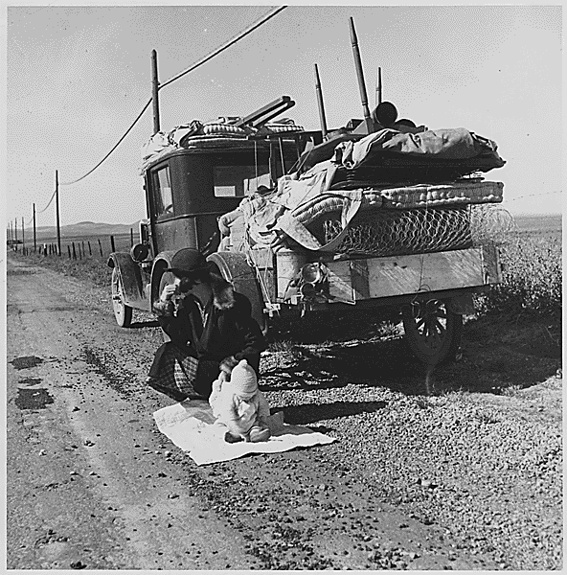
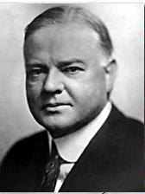
President Herbert Hoover
31st President
1928-1932

What did President Hoover believe about the economy?

- Herbert Hoover believed in laissez-fair government. He started some programs to help the United States get out of the _______________ but they did not apply to the masses of people who were ___________________.
- Most people did not believe Hoover was doing enough, so the shacks that the _______________ people lived in were called __________________ and the ______________________ that people covered up with were called Hoover blankets

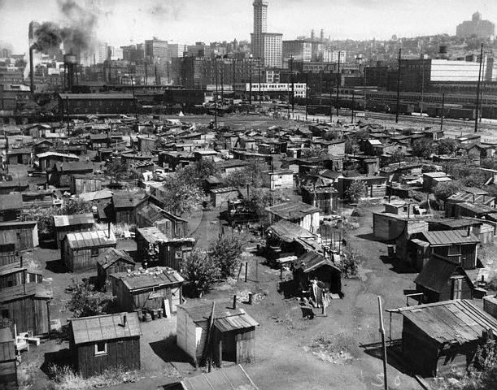

What was the bonus army? How did President Hoover respond?
- World War I __________________ nicknamed the “__________________ ” asking for President Hoover to give them their army bonuses early. Veterans of this war were promised a bonus not to be given until 1945, but 60,000 veterans marched on ____________________ asking for it to be given early. President Hoover __________________ their request, but paid for their railway tickets back home instead.
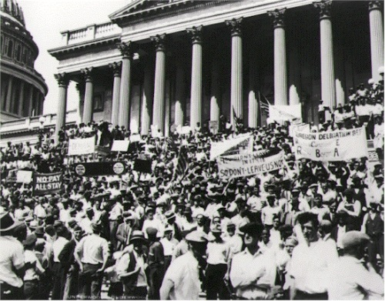

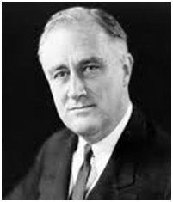
Franklin Delano Roosevelt
32nd President
1932-1945

Why did FDR win a landslide victory?

People were fed up with the lack of results from _________________ programs and Franklin Delano Roosevelt won a landslide victory in _________________. People were happy to see Roosevelt’s new programs started in his first __________________ in office. However not everyone was happy. Many ____________________ criticized FDR’s approach to taking over ___________________ This seemed too close to communism for some people. ___________________ didn’t pass several of FDR’s programs, but hundreds of others were still passed.

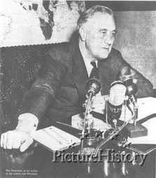
What were fireside chats?

Fireside Chats – President Roosevelt spoke to the American public over the _______________. “Tonight, (May 7, _______) I come to you for the second time to give you my report -- to tell you about what we are doing and what we _________ to do.”

Here are some examples of what FDR told people to make them feel better about their situation:
- Congress is about to pass legislation that will help __________________ and ___________________ pay their mortgage (money they owe on their homes)
- A grant of half a _________________ dollars is to be given to care for those who need direct and immediate relief.
- Congress authorized the sale of __________________ in such states as desired. This has already resulted in ____________________ and has provided much needed _____________ revenue.
What was the New Deal? (Definition)
FDR’s plan for getting the United States out of the __________________

Some of the New Deal Programs

Name of New Deal program | Describe the program
SSA – Social Security Act  *Still exists today* | It provided ____________, __________________ insurance, and _________ to the elderly and to the disabled.
TVA – Tennessee Valley Authority | Federal government built a series of _________ to prevent flooding, brought _______ supply and ___________ to rural areas.
CCC – Civilian Conservation  Corporation | Sent 250,000 young men to work camps to perform reforestation and ___________ tasks. Removed surplus of workers from __________. provided healthy conditions for boys, and provided __________ for families
AAA – Agricultural Adjustment Agency | Protected farmers from price _________ by reducing production, and starting ____________ programs to teach methods of preventing ___________ erosion
FDIC – Federal Deposit Insurance Corporation  *Still exists today* | Created federally insured bank ____________ ($________ per investor at first) to prevent bank ____________ Now protects up to $_____________ per investor.
PWA – Public Works Administration  Define Public Works: Projects built by the government for public use like parks, schools, highways, roads, government buildings, | States received $3.3 billion appropriation from ______________ for public works projects.  Provided ______________ to needy areas through public projects
SEC – Securities and Exchange Commission  *Still exists today* | Regulated the ____________ market and restricted ______________ buying
FERA – Federal Emergency Relief Act | Distributed millions of dollars of direct aid to unemployed workers, including food, _____________ shelter, and ______________ training.  - For example teaching woman to sew and providing sewing machines to make clothes for their families Also, creating a community garden projects where people work planting food and take home what they have produced

FDR’s New Deal programs helped __________________ some problems by giving people jobs, food, and shelter. It __________________ some problems, such as the banking system (FDIC) and pay for the elderly and handicapped (SSA). However it did not completely ___________________ America’s economy from the Great Depression before the start of World War II. Recovery from a depression takes a long time and the start of ___________________ will make this happen faster than the New Deal could have.
What programs still exist today?
The ____________________, _______________ and _______________ were so important that they still exist today

Explain some of the criticisms of the New Deal:
- Gave the _______________ government too much power
- Cost too much _______________
Was there good reason for these criticisms? Why or why not?

What pulled the United States out of the Great Depression so quickly?

Producing goods (such as weapons, _________________ tanks, __________________ and other supplies for the _______________ for WWII is what pulled the US out of the Great Depression. We had to mobilize all of our factories to help in the war effort producing new jobs all over the country.

Heroes and Entertainment

of the 1930’s

Popular movies of the 1930’s:
Gone with the __________________ about the Civil War
Snow White and the 7 _______________ Disney classic
Wizard of Oz- this is the story about Dorothy and her magical trip to OZ
___________________ : story of a giant ape that is captured from mysterious skull island then brought back to the mainland

Radio Programs:
War of the __________________ created by Orson Wells
FDR’s __________________ chats- done weekly from the White House to help inform the public of what the government was doing to fix the Great Depression

Legends and heroes of the 1930’s:
Jesse _______________ Olympic star of the 1936 games, won FOUR gold medals in track and field events in Berlin, Germany
Joe _______________ Baseball star on the New York Yankees, record
Amelia _______________ famous female pilot, went missing on her solo flight around the world in 1937

New Board Games:
Monopoly

Name __________________________________________________
Complete the chart using your NOTES – Tear off this page and hand in for homework

SUM UP THE GREAT DEPRESSION

CAUSES OF THE GREAT DEPRESSION:

1.)

2.)

3.)

4.)

EFFECTS ON THE AMERICAN PEOPLE:
List at least 4

FDR CREATES THE _______ _______.
WHICH DOES WHAT?

PROGRAMS MEANT TO HELP PEOPLE: (LIST ALL IN NOTES)

THE U.S. FINALLY GETS OUT OF THE GREAT DEPRESSION, BUT COMPLETELY BECAUSE OF FDR’S
_________ ________, BUT
BECAUSE OF ________.

